# What You Need To Know

The January 16th dance is at the Petroleum Club and features the Howard Solomon Band.

The cost is $85/couple (includes tax/tip).

No-host cocktail time is 6 pm & great dance music until 10 pm.

Dress code is semi-formal

Toppers Dinner Menu

Garden Green Salad  
Fresh seasonal vegetables Rolls and butter

Entree: Chicken Ballentine (baked boneless chicken breast stuffed with seasonal rice) or Grilled White Fish in Lemon Butter and Rice or Vegetarian selection

Dessert: Hot apple pie a’ la mode. Coffee, tea or decaffeinated coffee.

Mail your checks made out to “Toppers Dance Club” with dinner selections on the checks to:

Diane Schmitz

3475 Lilly Avenue

Long Beach Ca 90808-3214

# *Presidents Message…*

It’s a new year and Topper’s are ready to meet the challenge.

The Mistletoe Ball was a rousing success not only with the number of people but the new friendships that were made. Opening up to our sister dance clubs was a great experience and we learned about other clubs operations and traditions.

Of course, the Petroleum did their outstanding job. We heard many good reviews about the bacon wrapped filet and the surprise birthday cake was a hit! Chocolate at Christmas time is always good.

Alfred, Lord Tennyson said it well in 1833:

“Ring out wild bells to the wild sky,

The flying cloud, the frosty light:

The year is dying in the night;

Ring out, wild bells, and let him die.

Ring out the old, ring in the new,

Ring, happy bells, across the snow:

The year is going, let him go;

Ring out the false, ring in the true.”

Please join us on the 16th of January for our next dance and meet our newest members!

See you soon!

*Larry Isham,  
 President*

**

*￼￼*

Maybe Christmas, the Grinch thought, doesn't come from a store. ~ Dr. Seuss

It’s A Brand New Year!

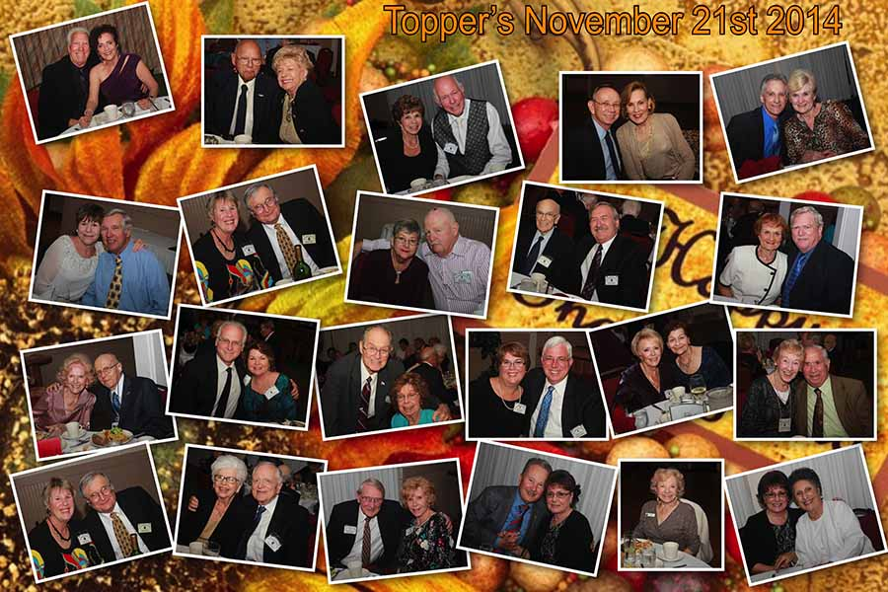

We started celebrating with our November pre-Thanksgiving dance

The February dance was excellent

It’s That Time Of Year

# Policy Notes

There are no refunds for cancellations made after the Tuesday before the dance as the arrangements are finalized Tuesday evening.

If you desire to sit with someone please note it with your check so we can attempt to satisfy your seating desires!

**Bit’s And Pieces**

New member contact information:

Dr. Richard Steiner and Frieda Mau  
3933 Via Solano  
Palos Verdes Estates, Ca 90274  
310-378-3086  
Rjsarrow@aol.com

Don and Linda Sebern  
11872 Martha Ann Dr  
Los Alamitos CA 90720  
562-596-0655  
dlsebern@msn.com

# Prepare To Be Greeted

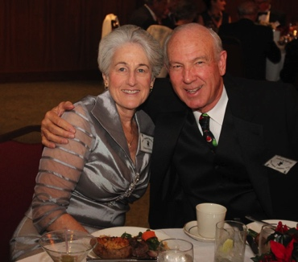

Diane and Dennis Schmitz

What A Great Dance!

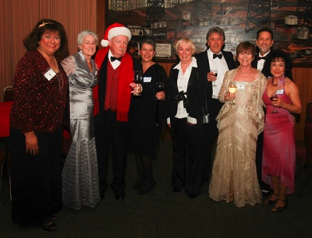

Meeting and greeting

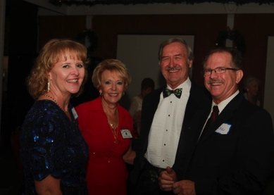

Welcome guests

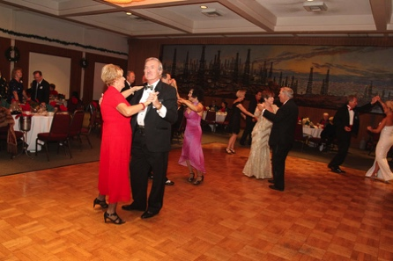  
The dancing gets under way

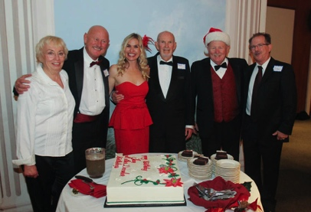  
December birthdays

# Upcoming Dance Schedule

02/20/2015 – Tony Carinio

03/20/2015 – Jim Gilman

04/17/2015 – The Batavia Band

# New Years Resolutions…

Come to the dance and bring friends.

We have a suggestion! Come to all of the 2015 Topper' dinner dances!

# Upcoming Year

“We will open the book. Its pages are blank. We are going to put words on them ourselves. The book is called Opportunity and its first chapter is New Year's Day.”

― Edith Lovejoy Pierce

# About Our Sister Clubs

As you probably know, there were many dance clubs started when the troops returned home after WWII. Several are still in existence including Topper’s and these great groups:

The Rondeliers Dance Club is meets and dances at the Altadena Town and Country Club every other month. Their membership is mostly from the Valley area down through Pasadena and Los Angeles. They always dance with a theme and are mostly formals. They are roughly 60 years old.

The Starlighters Dance Club is 60 years old and is centered in Orange County dancing every other month at various venues including country clubs and hotels and yacht clubs. They do two casuals, two semi-formals, and two formal dances a year. Bob and Donna Zaitz, their current Presidents, joined us for the Mistletoe Ball.

The Nightlighters Dance Club dances every other month at hotels located around LAX drawing people from the Valley as well as the greater LA area. They have themed dances and are mostly formal. As with the other clubs, the Nightlighter’s came out of WWII.

# About Our Website

Just Google “Toppers Dance Club” and our site will be the first on the search list!

**YOUR BOARD**

President Larry Isham

Vice President Dean Fronk

Past President Jerry Ellis

Secretary Lori Fronk

Treasurer Diane Schmitz

Hospitality Neil/Nita Woolston

Membership Vicky Kuhn

Roster Donnis Weygandt

Newsletter Paul/Sue Liles

Members At Large Gigi Isham, Dennis Schmitz, and Nancy Ellis.