What You Need To Know
The April 20th dance will be at the Petroleum Club and will feature the Tony Carinio Band!

The cost is $74/couple (includes tax/tip).

No-host cocktail time is at 6 p.m and the great dance music until 10 p.m.

Dress code is semi-formal.
Toppers Dinner Menu

Green Salad with dressings on the table
Grilled Chicken & Fettuccine or Fish of the Day with Potatoes and Vegetables or Vegetarian Pasta

Hot bread and butter, coffee and tea.

Cheesecake with Raspberry Sauce.

Mail your checks made out to “Toppers Dance Club” By April 13th With Dinner Selections on the checks To
Diane Schmitz
3475 Lilly Avenue
Long Beach CA 90808-3214

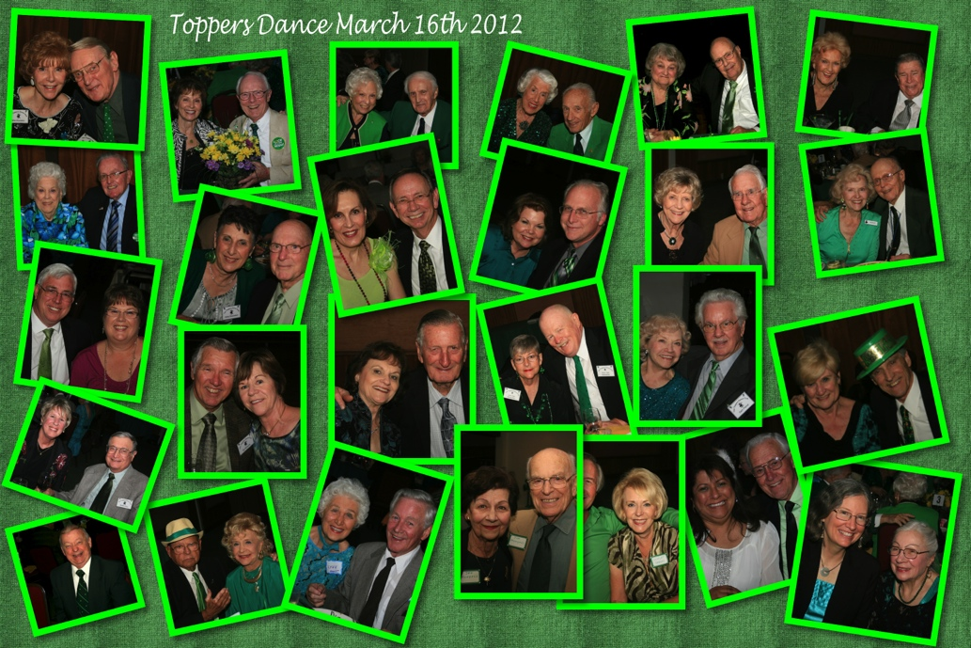
Who was there?

Presidents Message…

Last month we enjoyed our St. Patrick’s Day celebration. The room was a “sea of green”.

Two more dances (April and May) and we get the Summer off to recharge! Gigi and I hope your March showers were pleasant and that your gardens are growing well.

We are looking forward to another great dance and hope to see everyone there! Bring a guest, the more the merrier!

Remember - “Easter is a day of celebration followed by a week of egg salad!”

Larry Isham
President

April Fool’s Day

April Fools' Day is celebrated in different countries around the world on April 1 every year. Sometimes referred to as All Fools' Day, April 1 is not a national holiday, but is widely recognized and celebrated as a day when many people play all kinds of jokes and foolishness.

The day is marked by the commission of good-humored or otherwise funny jokes, hoaxes, and other practical jokes of varying sophistication on friends, family members, teachers, neighbors, work associates, etc.

  - “Spring is nature's way of saying, "Let's party!"

Put Spring Into Your Dance Steps!!
Prepare To Be Greeted
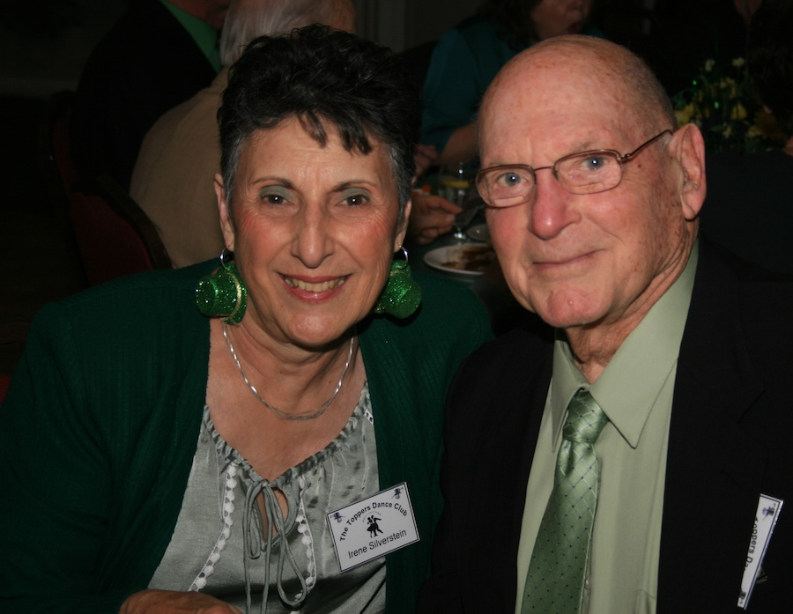
Be prepared to be welcomed with a big smile by Herb Silverstein & Irene Kosmetatos.

April? How Interesting!
April is the fourth month of the year in the Julian and Gregorian calendars, and one of four months with a length of 30 days.

April is commonly associated with the season of spring in the Northern hemisphere and autumn in the Southern hemisphere, where it is the seasonal equivalent to October in the Northern hemisphere and vice versa.

April starts on the same day of the week as July in all years, and January in leap years. April ends on the same day of the week as December every year. It became the fourth month of the Roman calendar, before January and February were added by King Numa Pompilius about 700 BC.

It became the fourth month of the calendar year (the year when twelve months are displayed in order) during the time of the decemvirs about 450 BC, when it also was given 29 days. The derivation of the name (Latin Aprilis) is uncertain. The traditional etymology is from the Latin aperire, "to open," in allusion to its being the season when trees and flowers begin to "open," which is supported by comparison with the modern Greek use of ἁνοιξις (anoixis) (opening) for spring. Since some of the Roman months were named in honor of divinities, and as April was sacred to the goddess Venus, the Festum Veneris et Fortunae Virilis being held on the first day, it has been suggested that Aprilis was originally her month Aphrilis, from her equivalent Greek goddess name Aphrodite (Aphros), or from the Etruscan name Apru. Jacob Grimm suggests the name of a hypothetical god or hero, Aper or Aprus.

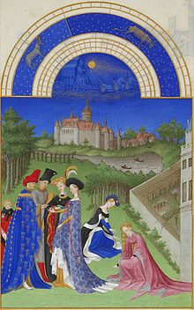
April, from the Très Riches Heures du Duc de Berry

Texas Two Step
The two-step is a partner dance, consisting of a "leader" (traditionally a man) and a "follower" (traditionally a woman). The leader determines the movements and patterns of the pair as they move around the dance floor. It is a progressive dance that proceeds counterclockwise around the floor.

Your Board

President Larry Isham
Vice President Dean Fronk
Past President Jerry Ellis
Secretary Lori Fronk
Treasurer Diane Schmitz
Hospitality Neil/Nita Woolston
Membership Bob Potthast
Roster Joyce Rothrock
Newsletter Paul & Sue Liles
Member At Large Gigi Isham, Dennis Schmitz, Nancy Ellis, Jack Taylor, and Meretta Potthast

The Executive Board meets at 5:30 p.m. before each dance. Need a Toppers name badge? Call Earl Eakle at 310-375-8134.

Spotlight On A Topper

Spring Quotes
No winter lasts forever; no spring skips its turn. ~Hal Borland
Spring shows what God can do with a drab and dirty world. ~Virgil A. Kraft
April is a promise that May is bound to keep. ~Hal Borland
Where man sees but withered leaves, God sees sweet flowers growing. ~Albert Laighton
Every spring is the only spring - a perpetual astonishment. ~Ellis Peters
Spring is sooner recognized by plants than by men.

The first day of spring is one thing, and the first spring day is another. The difference between them is sometimes as great as a month. ~Henry Van Dyke

Our Dance Schedule
5/18/2012 – Howard Solomon

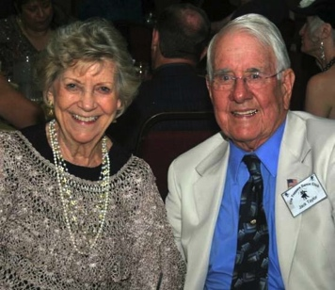
Joyce Rothrock and Jack Taylor
As reported to Vicky Kuhn

Jack and Joyce have been a couple in Toppers for the past ten years. Jack’s home is on the Canal in Naples Island, Long Beach. Joyce’s home is at the Fountains on Atherton St.in Long Beach.

Although they live in separate homes, they spend time together every day in each other’s home.
They enjoy dining in and out. Trying out new restaurants is always fun. Also, they like to celebrate special occasions at favorite restaurants.

Family is very important to both of them Jack’s family prefers to cook and entertain in Jack’s home.
Joyce’s family often plan barbeques and family dinners in their home in Costa Mesa.

Joyce has always loved to cook and entertain friends and family at her home. Dinner parties have always been an important part of her life.

Summer fun is patio time together in Naples,watching various kinds of boats, paddle boards, and Gondolas passing by. Brave swimmers can also be observed!

The two of them also enjoy theatre, Community Concerts, Long Beach Municipal Band Concerts, and church concerts. They attend Christ Lutheran Church in Long Beach.

Jack practiced Dentistry in Long Beach for 45 years after 3 years as a Naval Dentist. He retired in 1991. He received his Dental Degree from USC.

GO TROJANS!! They don’t plan any Saturday activity during football season!!

Joyce taught Elementary Education in Minnesota and Long Beach for nearly 30 years. She was educated at Moorhead State University, Long Beach State University, completing a Masters Degree in Education from St. Thomas at St. Paul, Minnesota. She also retired in 1991.

Because they both have experienced many immediate family losses in their lives, each day is truly a blessing, and families and friends are so very, very special! We say thank you everyday for our love relationship!

Topper’s Dances and meeting new couples, is truly an appreciated happening!

Joyce was a teacher to children who had special needs such as autism and she has applied creative arts such as music, dance and movement in their lives.

Dancing Makes You Smarter (Part 1)
For centuries, dance manuals and other writings have lauded the health benefits of dancing, usually as physical exercise. More recently we've seen research on further health benefits of dancing, such as stress reduction and increased serotonin level, with its sense of well-being.

Then most recently we've heard of another benefit: Frequent dancing apparently makes us smarter. A major study added to the growing evidence that stimulating one's mind can ward off Alzheimer's disease and other dementia, much as physical exercise can keep the body fit. Dancing also increases cognitive acuity at all ages.

You may have heard about the New England Journal of Medicine report on the effects of recreational activities on mental acuity in aging. Here it is in a nutshell.
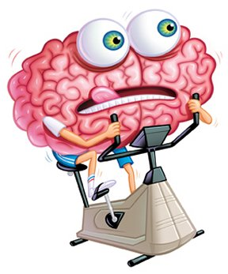

The 21-year study of senior citizens, 75 and older, was led by the Albert Einstein College of Medicine in New York City, funded by the National Institute on Aging, and published in the New England Journal of Medicine. Their method for objectively measuring mental acuity in aging was to monitor rates of dementia, including Alzheimer's disease.

The study wanted to see if any physical or cognitive recreational activities influenced mental acuity. They discovered that some activities had a significant beneficial effect. Other activities had none.

They studied cognitive activities such as reading books, writing for pleasure, doing crossword puzzles, playing cards and playing musical instruments. And they studied physical activities like playing tennis or golf, swimming, bicycling, dancing, walking for exercise and doing housework.

One of the surprises of the study was that almost none of the physical activities appeared to offer any protection against dementia.

There can be cardiovascular benefits of course, but the focus of this study was the mind. There was one important exception: the only physical activity to offer protection against dementia was frequent dancing.

Reading - 35% reduced risk of dementia

Bicycling and swimming - 0%

Doing crossword puzzles at least four days a week - 47%

Playing golf - 0%

Dancing frequently - 76%. Was
the greatest risk reduction of any activity studied, cognitive or physical.

Quoting Dr. Joseph Coyle, a Harvard Medical School psychiatrist who wrote an accompanying commentary:
"The cerebral cortex and hippocampus, which are critical to these activities, are remarkably plastic, and they rewire themselves based upon their use."

And from the study itself, Dr. Katzman proposed these persons are more resistant to the effects of dementia as a result of having greater cognitive reserve and increased complexity of neuronal synapses. Like education, participation in some leisure activities lowers the risk of dementia by improving cognitive reserve.

Our brain constantly rewires its neural pathways, as needed. If it doesn't need to, then it won't.

More in the next issue…

Dance Quotes To Remember…

"Beginning dancers prefer to take
"intermediate" level classes.

Intermediate dancers prefer to take
"advanced" level classes.

Advanced dancers take private lessons to work on their basics."

The March Dance!
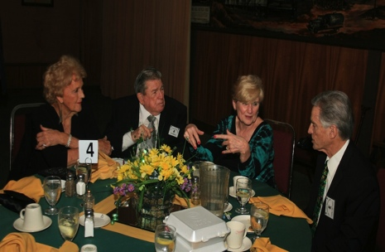
Visiting is underway
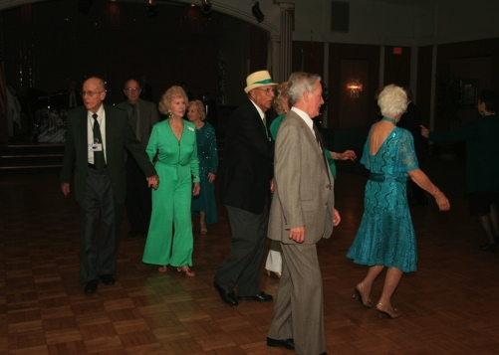
Around and around we go!

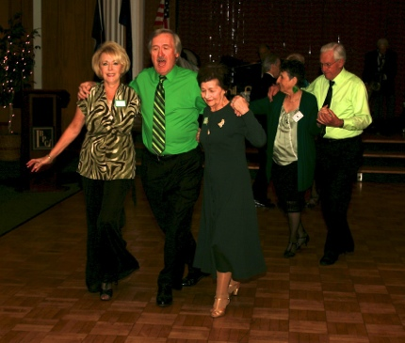
A little polka?
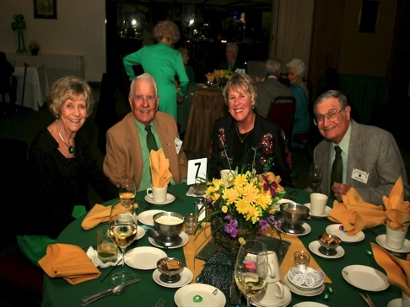
Dinner time

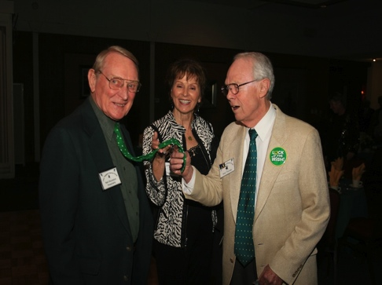
Comparing ties
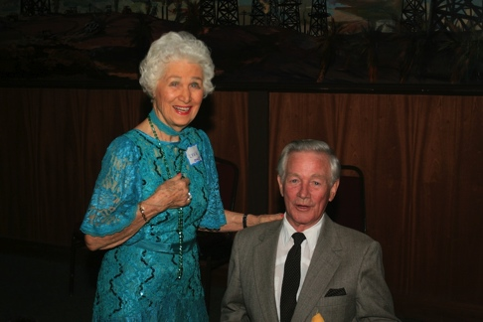
Having a great time
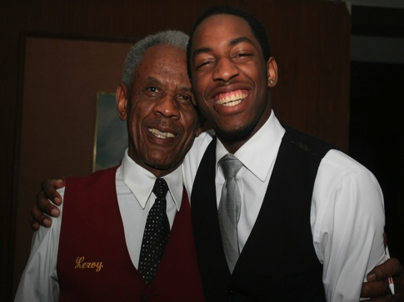
Leroy & Grandson Jonathan

