­

# Payments

Mail your checks to “Toppers Dan­ce Club” with dinner selections and seating requests on the checks by April 10th to:

Craig Colby

13047 San Jacinto Street

La Mirada Ca 90638

Please note seating desires with your check. We will attempt to satisfy them.

# What You Need To Know

The April 19th dance is at the Long Beach Grand and featuring Arnie Rios. The cost is $120/couple (includes tax/tip).

No-host cocktail time is 6 pm & great dance music until 10 pm.

**Dress code is Semi-Formal** (Men, Dark Suits/Sport Coats. Ladies, cocktail attire.)

Toppers Dinner Menu

**Salad:** Tossed Greens with Cucumber, Tomato, Carrot. Choice of Ranch and Balsamic Dressing

**Starch/Vegetables:** Scalloped Potatoes & Vegetable Medley

**Entrées:** Spiced Pork Loin, Roasted Poblano Ancho Chile **OR**

Asian Inspired Salmon,

Shitake Mushrooms, Bok Choy, & Sweet Soy Reduction **OR**

Chef’s Selected Vegetarian

**Dessert:** 6" Individual Fruit Tarts

President’s Message…

We have been working to find a new venue for our dances and let me tell you, it is not easy to find venues with reasonable sized dance floors. I was told by one venue that industry standard is 9 square feet per couple (I don’t know what kind of dancing you do in a square yard, but it’s not ballroom).

We have booked the Grand Event Center, on Willow in Long Beach for the April and May Dances. If we get good feedback, we may book more in the future.

Based on the quotes we have received, it is quite evident that we were getting a sweet deal from the Petroleum Club; so sorry about the price increase, but that’s the best we could do for now. We’ll continue to explore options.

Hope you all can make it to the new venue. Please feel free to let me know what you think.

Craig

Looking forward to seeing you all on the 15th.💕

Craig

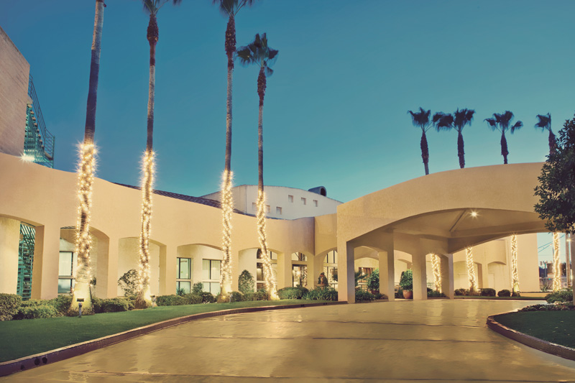

Everything is in a state of flux, including the status quo!

Hello New Venue – The Long Beach Grand

Goodbye

**Bits and Pieces**

We toured the yet to be opened new Santa Ana Elks Lodge and it will be one fantastic facility. Likely to be opened for dancing and dinner in late June/early July. It has a huge high tech dance floor in the mail ballroom.

Coming home from the market, Paul Liles saw Vicky’s grandkids in the front yard. Paul had found some great strawberries and planned to take them next door. When he called the kids over, they said “Do you have Easter decorations Mr. Paul”. Paul responded with “Yes! I ran into a big red Easter Bunny and he gave me these funny looking eggs…take them to Grandma!”. I don’t think they really believed me!

**Snaps From   
Our Last Dance**

**Time Are Changin’**

It’s goodbye to the Petroleum Club and hello new venues

For the remainder of this year, we will be meeting at GRAND LONG BEACH EVENTS CENTER. It is located at 4101 E Willow St, Long Beach, CA 90815..

A map is provided for your convenience but do not worry, the Grand is easy to find!

Their website is https://thegrandlb.com/ for more information.

We are working to determine our long term plan for the venue for Toppers and any ideas would be appreciated.

More details will be provided at the upcoming dance.

**Saying Goodbye To The Club…**

We caught a photo of the “last ones out” and they indeed did close the door. Thank you Neal and Nita for the years of great decorations and nice cards to our members going through their life situations.

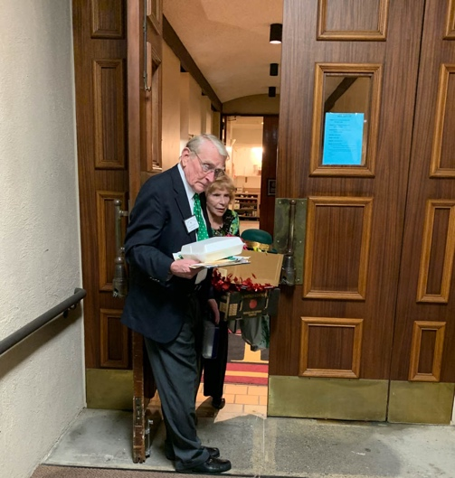



Wonder if they will notice my tie?

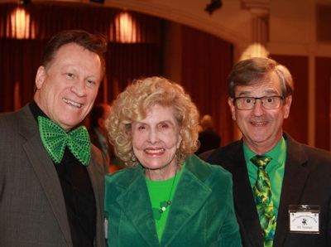

All in green!

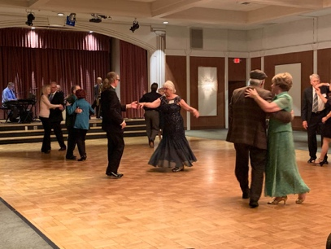

Kicking up our heels

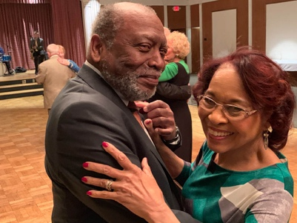  
No green hair?

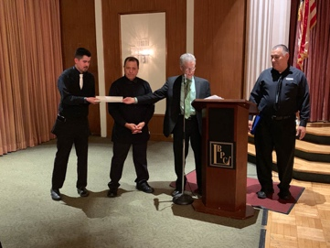

Thank You for years of  
Service!

ccasion!

# Upcoming Dance Schedule

We have a busy season coming up! Get your calendars marked up now. Remember, we will be at The Grand in Long Beach.

5/10/2019 – Time Machine

We will probably send out an abbreviated newsletter mid-summer just to keep you up to date on the fall plans and reaffirm the dates/bands.

**YOUR BOARD**

President Craig Colby

Vice President Lucky Harrington

Secretary Sandy Slater

Treasurer Open

Hospitality Neil/Nita Woolston

Membership Vicky Kuhn

Roster Donnis Weygandt

Newsletter Paul/Sue Liles