­

Dreaming might happen in the clouds, but living them needs to be done firmly on the ground, for us dancers on the dance floor. – Jean Dorff

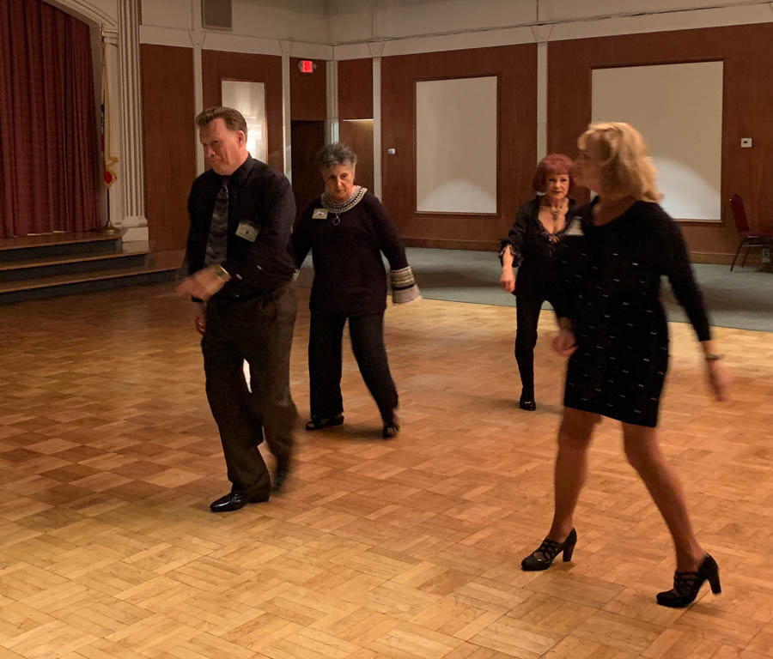

We do country… Yes we do!

Happy New Year Toppers!

Spring is around the corner (at least here in Southern California) and love is in the air. Valentine’s is a day for romantic love, but should be a reminder of paternal, maternal, parental, sororal and fraternal love too. I feel like I developed that brotherly love for many of the Toppers members I’ve come to know. As Al Arauj often told me, we are a friendly group.

On a business note: we have calling cards for each of you to carry around and give out when you meet a dancing couple who might want to come as guest or become a member. There is space for you to add your name and telephone number plus an email address where they can leave a message or inquiry for the club. Be sure you pick up a few at the greeter’s table.

Looking forward to seeing you all on the 15th.💕

Craig

# Policy Notes

There are no refunds for cancellations made after the Tuesday before the dance as the arrangements are finalized Tuesday evening.

If you desire to sit with someone please note it with your check so we can attempt to satisfy your seating desires!

# What You Need To Know

The February 15th dance is at the Petroleum Club and featuring Tropic Starr. The cost is $85/couple (includes tax/tip).

No-host cocktail time is 6 pm & great dance music until 10 pm.

**Dress code is Semi-Formal** (Men, Dark Suits/Sport Coats. Ladies, cocktail attire.)

Toppers Dinner Menu

Garden Green Salad  
Fresh seasonal vegetables   
Hot Bread and Butter

Roast Tri-tip w/scalloped potatoes OR

Baked Salmon w/rice OR

Veggie Selection

Dessert: Chef’s Choice

Mail your checks to “Toppers Dance Club” with dinner selections and seating requests on the checks by February 11th to:

Diane Schmitz  
3475 Lilly Avenue

Long Beach Ca 90808-3214

Only Eleven Months To New Years Eve!

**Bits and Pieces**

Russell Gill has returned after a brief medical situation. We are happy to see he and Lily back on the dance floor.

We are sad to report that Mickey Arauj had a stroke. Al Arauj reported she is not doing well. She has 24x7 care taking at home but recently has been unresponsive. Al appreciates thoughts, prayers, and cards. Cards to 11771 Loara St Garden Grove, Ca 92840  
  
Many of us dance at the local Elks Lodge on Fridays and Saturdays. If you are interested call Paul & Sue Liles for additional information!

**Snaps From   
Our Last Dance**

**Valentine’s Day Can Be Celebrated Several Days In A Row**

There are seven days which are celebrated before Valentine’s Day. Each day is celebrated in different ways and manner. The seven days before Valentine’s Day are:

February 7th: Rose Day

February 8th: Propose Day

February 9th: Chocolate Day

February 10th: Teddy Day

February 11th: Promise Day

February 12th: Kiss Day

February 13th: Hug Day

February 14th: Valentine’s Day



**Thoughts To Ponder…**

* If you only have one smile in you, give it to the people you love!
* Because of your smile, you make life more beautiful.
* There's a long life ahead of you and it's going to be beautiful, as long as you keep loving and hugging each other.
* If love is blind, why is lingerie so popular?

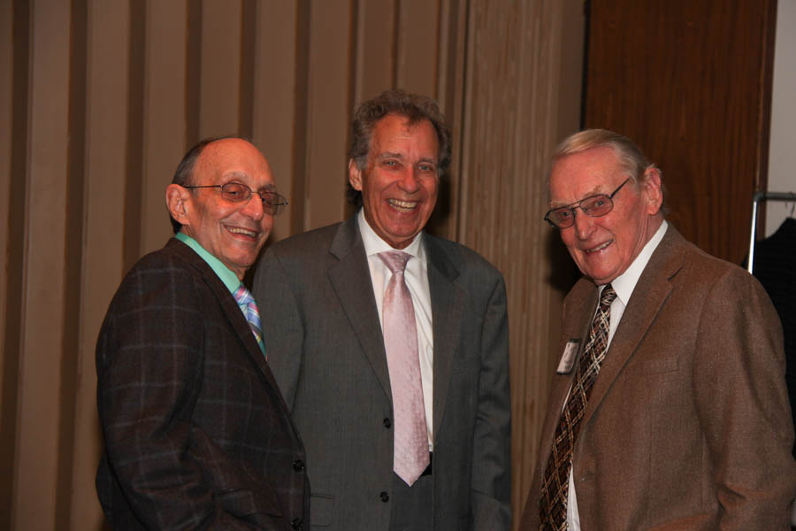

Meeting & Greeting

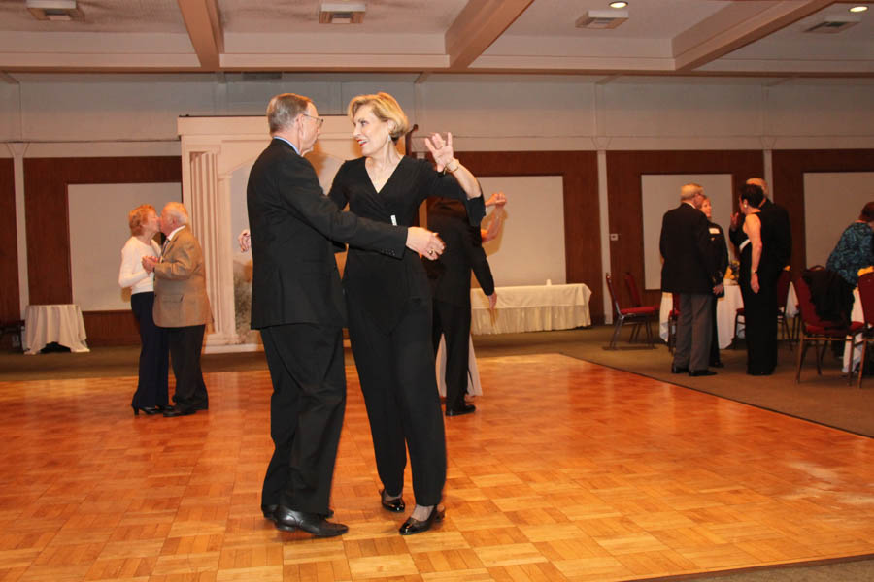

Dancing begins the moment music starts!

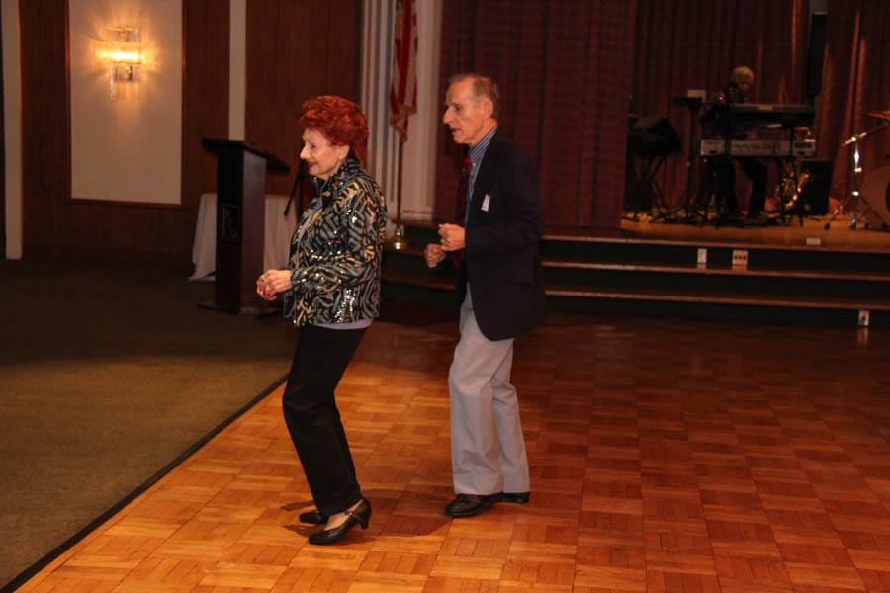

Dancing together for 63+ years

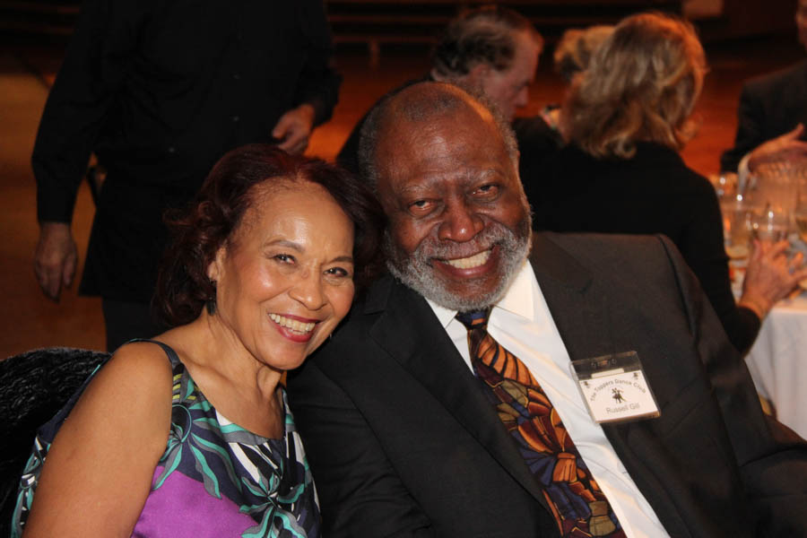Welcome back Lily & Russell

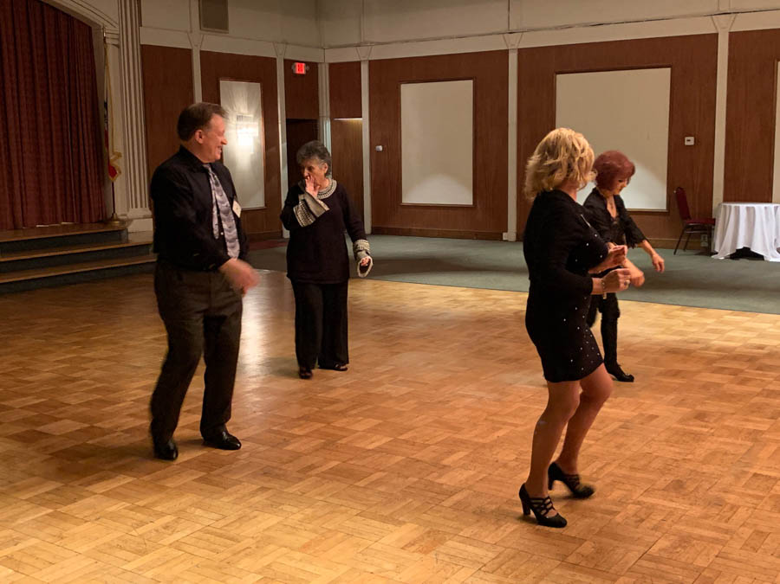

Line dancing lives

ccasion!

# Upcoming Dance Schedule

We have a busy season coming up! Get your calendars marked up now.

2/15/2019 – Tropic Starr

3/15/2019 – Sam Conti

4/19/2019 – Arnie Rios

5/10/2019 – Time Machine

# Anyone interested in a Sunday afternoon tea dance during the summer when we are “off”? Let Paul & Sue Liles know and perhaps we can trip the light fantastic under the summer stars at Old Ranch Country Club.

**YOUR BOARD**

President Craig Colby

Vice President Lucky Harrington

Secretary Sandy Slater

Treasurer Open

Hospitality Neil/Nita Woolston

Membership Vicky Kuhn

Roster Donnis Weygandt

Newsletter Paul/Sue Liles