Presidents Message: President’s Message for October Newsletter (2018)

Nice to see those of you who came to our September dance. I’m sorry that I let Russell’s episode rattle me and forgot to do the summer and September birthdays and anniversaries. If you were present in September, you know we are in need of a new Treasurer and are really looking for someone to step up to support the group. Thank you Diane Schmitz for temporarily performing the task!

Russell was advised to get a heart pacemaker which he did soon after the event. He is home and is feeling pretty good. When you get a chance, drop him a line and say hello. Paul Liles says it is “OK” to tease him about his green hair from the St Patrick’s Day Dance!

I took the President position, somewhat reluctantly, but recognized I enjoy our dinner dances and felt the need to be willing to do my part in helping out.

I sincerely hope one our great members will see the need to do their part too (yes, I’m trying to guilt you - hope it’s working).

Looking forward to seeing you on the 19th.

Craig.

So, do you have your candy ready?

# Policy Notes

There are no refunds for cancellations made after the Tuesday before the dance as the arrangements are finalized Tuesday evening.

If you desire to sit with someone please note it with your check so we can attempt to satisfy your seating desires!

# What You Need To Know

The October 19th dance is at the Petroleum Club and featuring Jim Gilman. The cost is $85/couple (includes tax/tip).

No-host cocktail time is 6 pm & great dance music until 10 pm.

**Dress code is Semi-Formal** (Dark suits for the guys)

Toppers Dinner Menu

Garden Green Salad  
Fresh seasonal vegetables   
Hot Bread and Butter

Stuffed Pork Chops with Scalloped Potatoes or

Baked Salmon with Rice or

Vegetarian Selection.

Dessert: Chef’s Choice

Mail your checks to “Toppers Dance Club” with dinner selections and seating requests on the checks by September 14th to:

Diane Schmitz  
3475 Lilly Ave.   
Long Beach, CA 90808-3214

Ghosts & Goblins Beware



A super evening even without pictures!

**Bits and Pieces**

Paul & Sue are sponsoring a New Years Eve Dinner Dance at Old Ranch Country Club… Space is limited so please let them know! Music is a nine piece Big Band, Nine Carrot Gold!

Come to the Phoenix Club on Thursday evenings for a dance with the Big Bands, 7:00 PM to 10:00 PM.

Email Paul & Sue with any news or other tidbits so they can be put into the newsletter!

Sue

**Previous  
Dances**

**Oops! No Pictures** – Due to an unforeseen situation the Liles’ had to miss the recent dance and therefore no pictures are available. So, if you can…bring your “pocket camera” or cell phone and capture the moments next time so we have a backup and can remember the events of the evening!

So, we decided to go back to 2009 and show some of the pictures from our October dances in past years.

You can always check back on our dances using the website. It goes back ten years now!

**Halloween One Liners:**

What do sea monsters eat for lunch? Fish and ships

What do ghosts serve for dessert? I Scream

I want to be something really scary for Halloween this year so I'm dressing up as a phone battery at 2%.

I remember when Halloween was the scariest night of the year. Now, it's Election night.

**The Holiday Season Is Upon Us:** The next two dances center around Thanksgiving on 11/16 and finally the Mistletoe Ball on the 21st of December. Where did the year go?

Remember, we often invite people from other dance clubs to join us for the Christmas Dance so send Paul & Sue names and addresses, so we can send out a newsletter and invite!

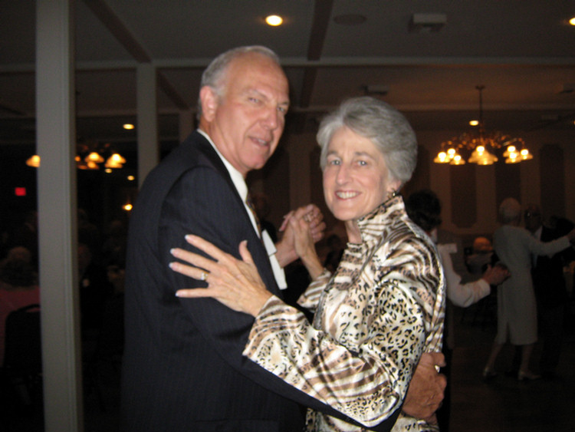

2009

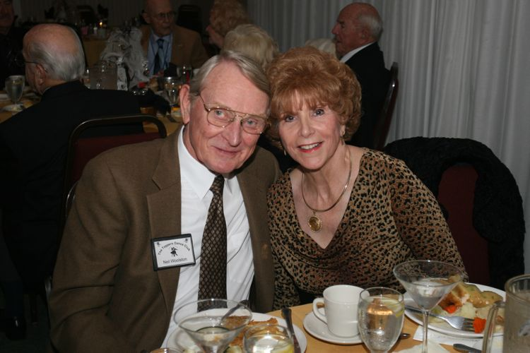

2010

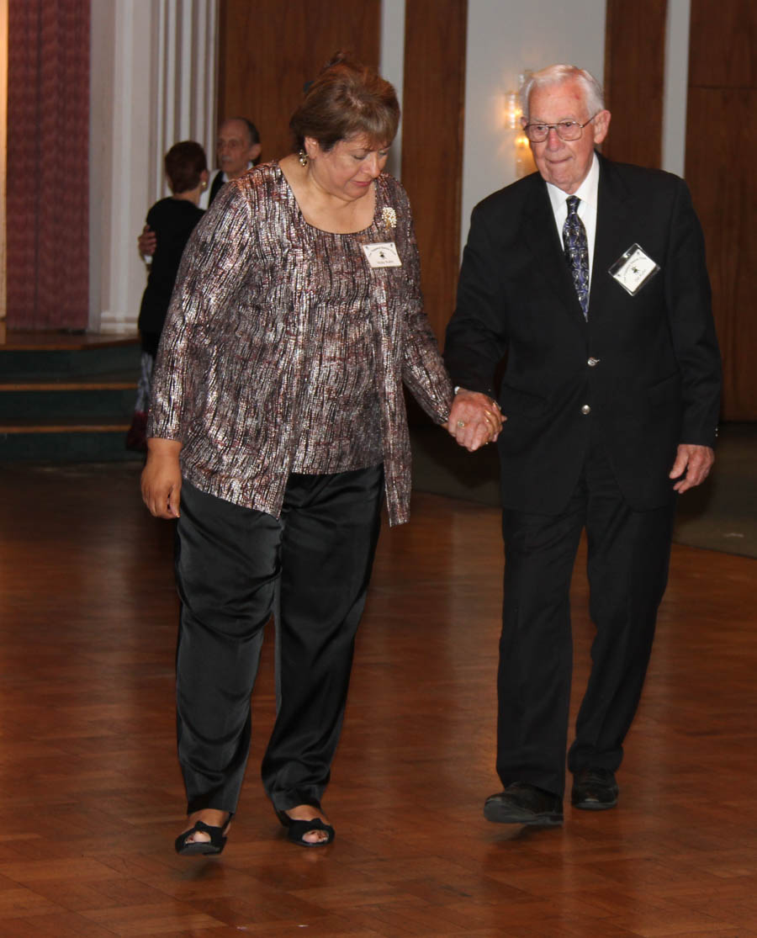

2011 - Polka Man at work

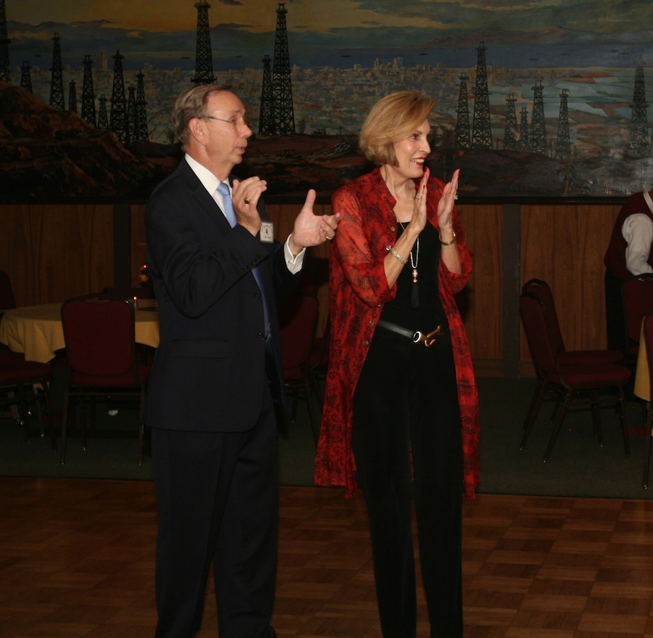2012

ccasion!

# Upcoming Dance Schedule

We have a busy season coming up! Get your calendars marked up now.

11/16/2018 – Arnie Rios

12/21/2018 – Time Machine

To keep the club thriving, we are always looking for new friends to join in and participate in our great parties and keep social dancing alive and well in Long Beach!

# 

Thank you Donnis Weygandt for the effort to put together the new roster which we will be seeing soon.

**YOUR BOARD**

President Craig Colby

Vice President Lucky Harrington

Secretary Sandy Slater

Treasurer Open

Hospitality Neil/Nita Woolston

Membership Vicky Kuhn

Roster Donnis Weygandt

Newsletter Paul/Sue Liles

Members At Linda Colby, Ed Roberts, and Del Kuhn.