­

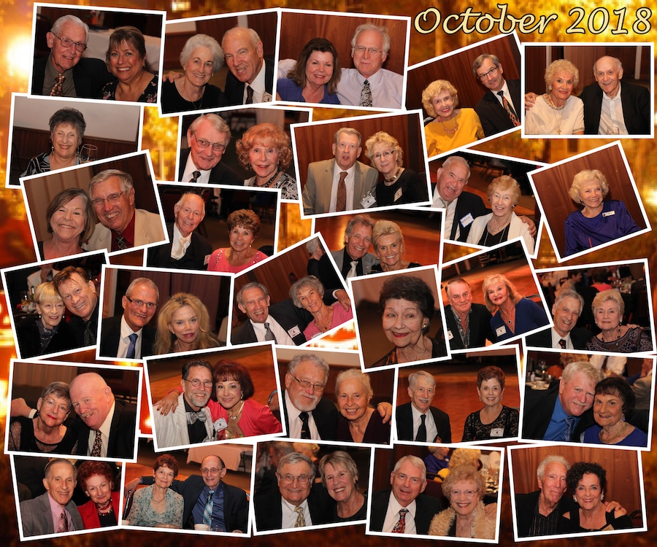

Holidays with friends!

Presidents Message

Friends,

The Holidays are upon us. My wife, Linda, says Thanksgiving is her favorite one of the seasons and a reminder to count her blessings. Thankfulness for me is emotional rather than contemplative and I think it’s a driving force in my life.

Thankfulness draws me to want to give back with the gifts that I’ve been granted. Mostly that has been teaching and training my technical staff at work, but also one of the reasons I volunteered for the position of President at Toppers. I am thankful for the friends I have found at Toppers and happy to serve them. Hope you all enjoy a great Thanksgiving Holiday.

Looking forward to seeing you all on the 16th.

Craig.

Thanksgiving is the day men start getting in shape, to play Santa Claus

# Policy Notes

There are no refunds for cancellations made after the Tuesday before the dance as the arrangements are finalized Tuesday evening.

If you desire to sit with someone please note it with your check so we can attempt to satisfy your seating desires!

# What You Need To Know

The November 16th dance is at the Petroleum Club and featuring Arnie Rios. The cost is $85/couple (includes tax/tip).

No-host cocktail time is 6 pm & great dance music until 10 pm.

**Dress code is Semi-Formal** (Dark suits for the guys)

Toppers Dinner Menu

Garden Green Salad  
Fresh seasonal vegetables   
Hot Bread and Butter

Turkey Breast with mashed potatoes or Baked White Fish with rice or

Vegetarian Selection.

Dessert: Chef’s Choice

Mail your checks to “Toppers Dance Club” with dinner selections and seating requests on the checks by November 11th to:

Caig Colby  
13047 San Jacinto Street.   
La Mirada Ca 90638

Look Out For Mr. Turkey!

**Bits and Pieces**

Paul & Sue are sponsoring a New Years Eve Dinner Dance at Old Ranch Country Club… Space is limited so please let them know! Music is a nine piece Big Band, Nine Carrot Gold!

The Finch’s are now in the UK but plan to return before the New Year.

Brian and Jan Finch are coming back to the US in early December and said they are looking forward to seeing everybody at the Mistletoe Ball!

**Our Previous  
Dance**

**New Rosters Available** – Thanks to Donnis Weygandt, we have new rosters! We also had two new members. Their information is provided on a separate sheet in this mailing so please add the information to your roster. We tried using mailing labels to see if it works…just stick them in the back of your roster!



**The Holiday Season Is Upon Us:** The Mistletoe Ball on the 21st of December with Time Macine. Where did the year go?

Remember, we often invite people from other dance clubs to join us for the Christmas Dance so send Paul & Sue names and addresses, so we can send out a newsletter and invite!

# Treasurer Needed

Diane Schmitz kindly offered to step in as Treasurer but has done the job before and travels a lot. Please see Craig or Diane and step right up…. Your help is needed!

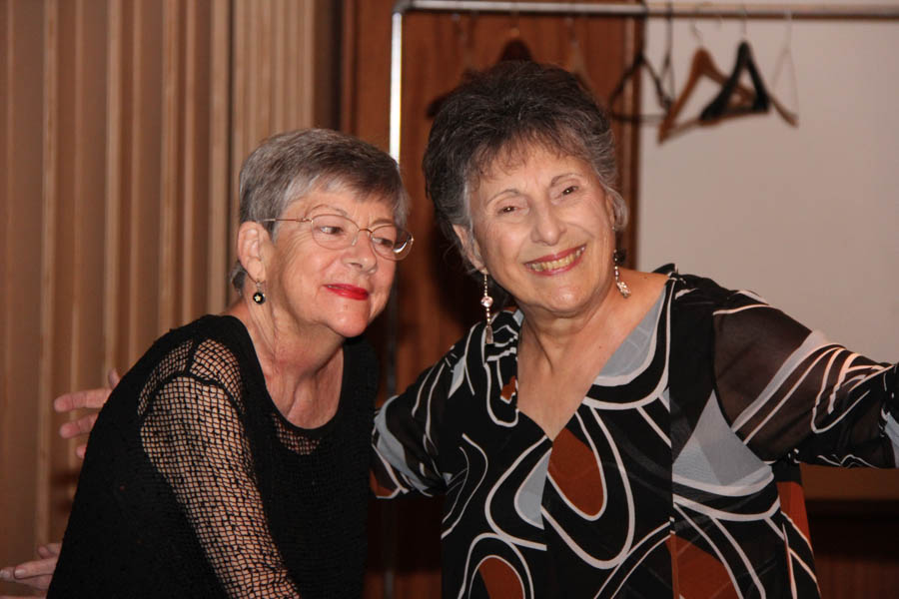

All Smiles

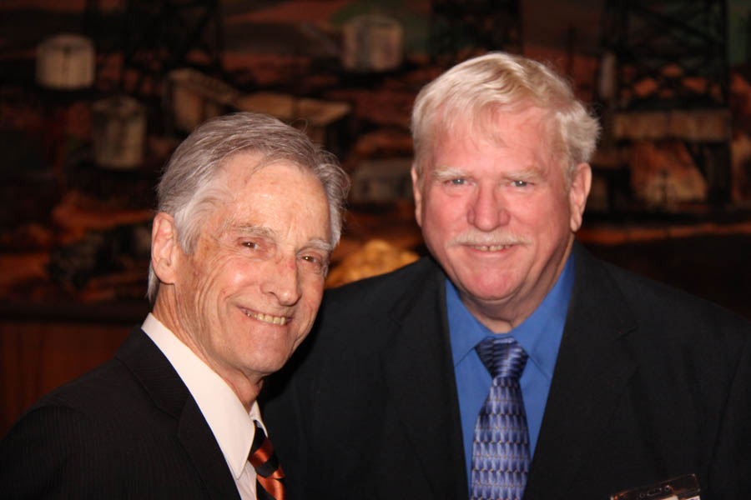

Checking out the dance floor

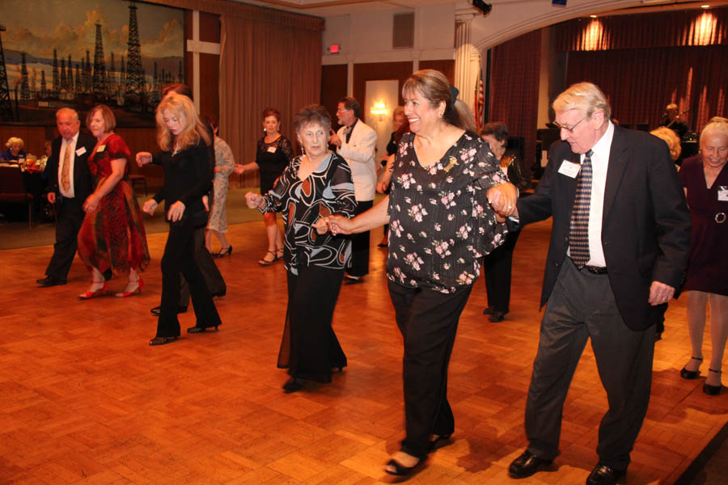

Line dance anyone?

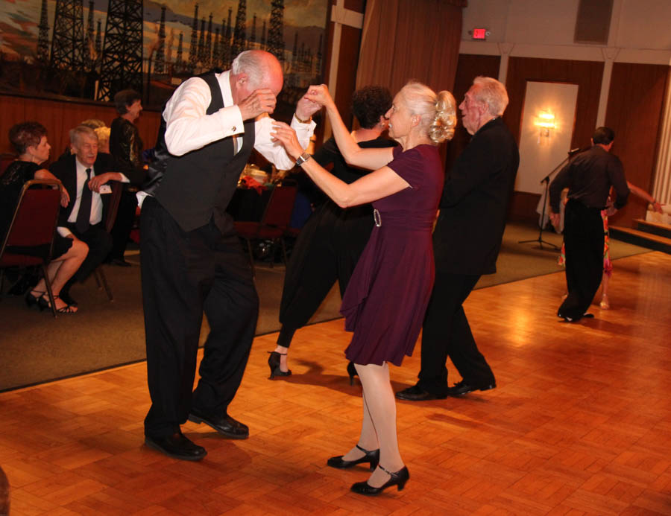Rockin’ and Rollin’

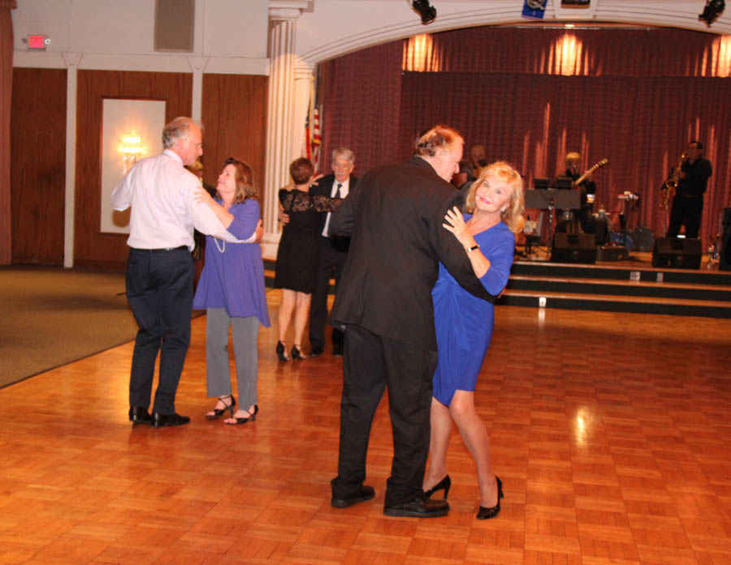

ccasion!

# Upcoming Dance Schedule

We have a busy season coming up! Get your calendars marked up now.

12/21/2018 – Time Machine  
1/18/2019 – Tony Carinio

2/15/2019 – Tropic Star

To keep the club thriving, we are always looking for new friends to join in and participate in our great parties and keep social dancing alive and well in Long Beach!

# 

Let Donnis Weygandt know if you have any changes for the Topper’s Roster!

**YOUR BOARD**

President Craig Colby

Vice President Lucky Harrington

Secretary Sandy Slater

Treasurer Open

Hospitality Neil/Nita Woolston

Membership Vicky Kuhn

Roster Donnis Weygandt

Newsletter Paul/Sue Liles

Members At Linda Colby, Linda Colby, and Del Kuhn.