­

Hang Up The Mistletoe… It’s Cristmas

I will honor Christmas in my heart, and try to keep it all the year - Charles Dickens

# *Presidents Message…*

The turkey has had its day and the calendar keeps on moving. Christmas is just a few short weeks away! Are you ready? Let’s get into the season and celebrate with the 71st Mistletoe Ball.

There are 1,300 mistletoe species worldwide. The continental United States and Canada are home to more than 30 species, and Hawaii harbors another six.

Invite your friends to the Mistletoe Ball as a big turnout is helpful since the Petroleum Club members no longer attend.

For those of you in other dance clubs, please invite other members in your dance clubs to join us to celebrate this time of year!

Thanks to Donnis Weygant for the latest Topper’s Membership Roster! It is so handy to have it by the phone ready to call your friends and visit between dances.

We hope your Christmas plans are well underway and that your get Everything on your Christmas List!

*Larry Isham,  
 President*



# What You Need To Know

The December 15th dance is at the Petroleum Club features The Time Machine. The cost is $76/couple (includes tax/tip). No-host cocktail time is 6 pm & great dance music until 10 pm.

**Dress Code Is Formal.** Reds and greens are always a super Christmas selection!

Toppers Dinner Menu

Garden Green Salad  
Fresh seasonal vegetables   
Hot Bread and Butter

Entrée: Roast Tri-tip with au gratin potatoes or

Grilled White Fish with rice or

Vegetarian selection.

Dessert: Chef’s choice

Mail (please do not bring them to the dance) your checks made out to “Toppers Dance Club” **with dinner selections on the checks** by December 11th. Mail them to our chief Elf:

Kathy Roberts

12021 Kibbee Ave

La Mirada CA 90638

# ****Here Comes Santa Claus, Here Comes Santa Claus…****

# Policy Notes

There are no refunds for cancellations made after the Tuesday before the dance as the arrangements are finalized Tuesday evening.

If you desire to sit with someone please note it with your check so we can attempt to satisfy your seating desires!



You Are About To Have A Visitor!

Meet & Greet Goes On For Hours!

# Prepare To Be Greeted By

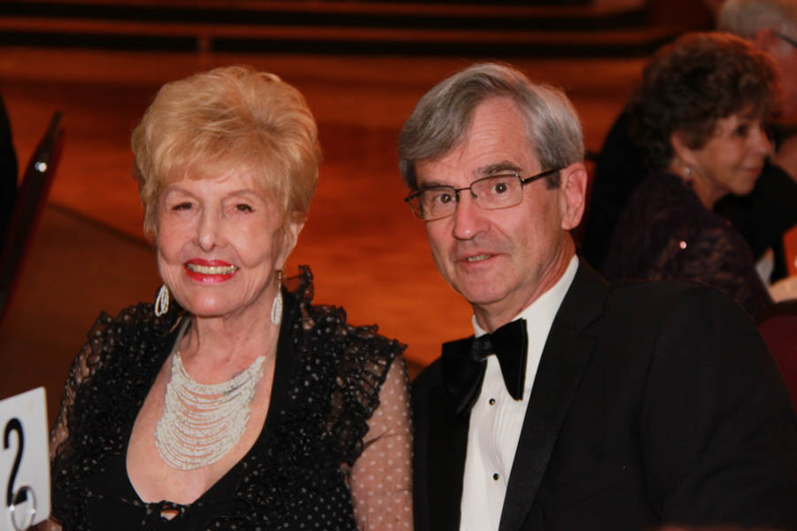

Iris Feltenbery & Will Tomkeil

Fun With Friends!

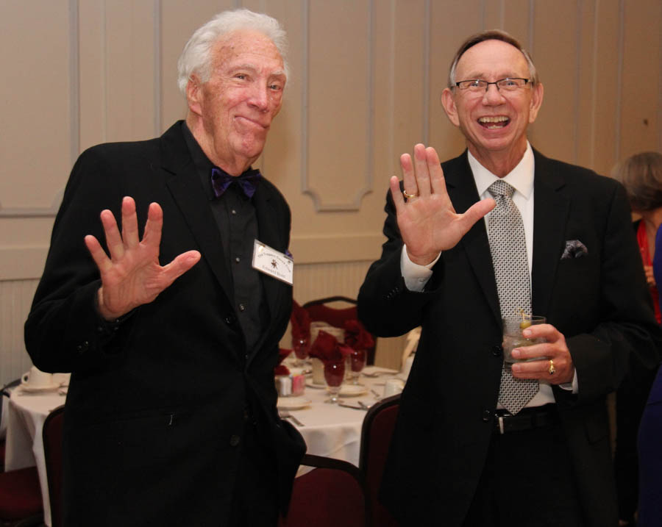

Meeting & Greeting

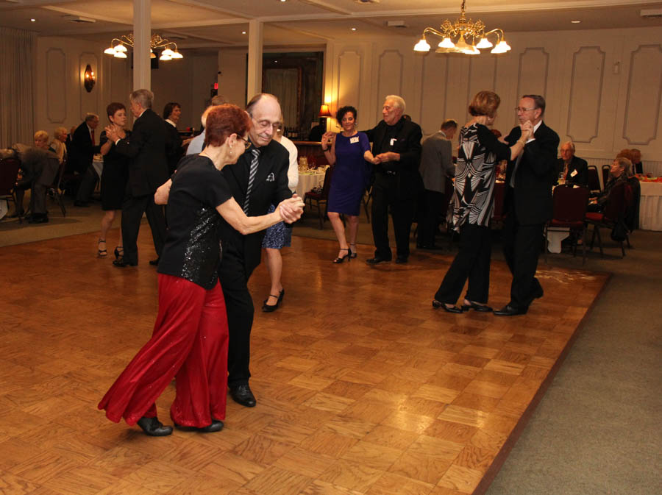

Kicking up the Dust!

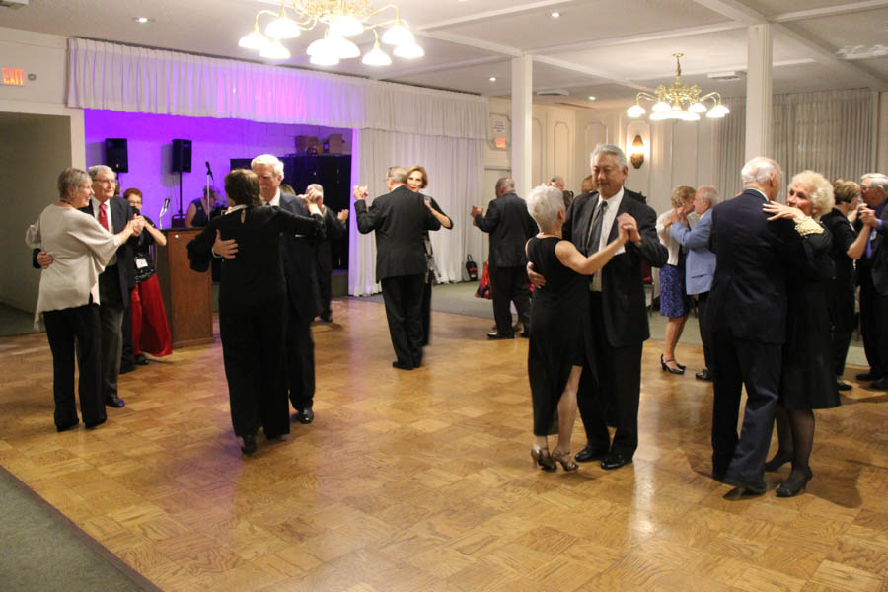  
Great music all night  
  
Dancers watching the dancers dance

# Upcoming Dance Schedule

One more dance until 2018! Where did the year go?

1/19/2018 – Sam Conti

2/16/2018 – Tony Corinio

3/16/2018 – Liz Holmes

4/20/2018 – Sam Conti

To keep the club thriving, we are always looking for new friends to join in and participate in our great parties and keep social dancing alive and well in Long Beach!

# Christmas Is Here!

It’s amazing how the weather has changed from HH (horribly hot) to CC (crazy cool). The 50 degree mornings are not quite like the East Coast but it is a reminder of the time of year!

# Did You Know?

Fact #1: Mistletoe (Viscum album) is from the Anglo-Saxon word misteltan, which means “little dung twig” because the plant spreads through bird droppings.

Fact #2: All mistletoes grow as parasites on the branches of trees and shrubs. The genus name of North America’s oak mistletoe—by far the most common species in the eastern United States—is Phoradendron, Greek for “tree thief.”

Fact #3: As they mature, mistletoes grow into thick, often rounded masses of branches and stems until they look like baskets, sometimes called “witches’ brooms,” which can reach 5-feet wide and weigh 50 pounds



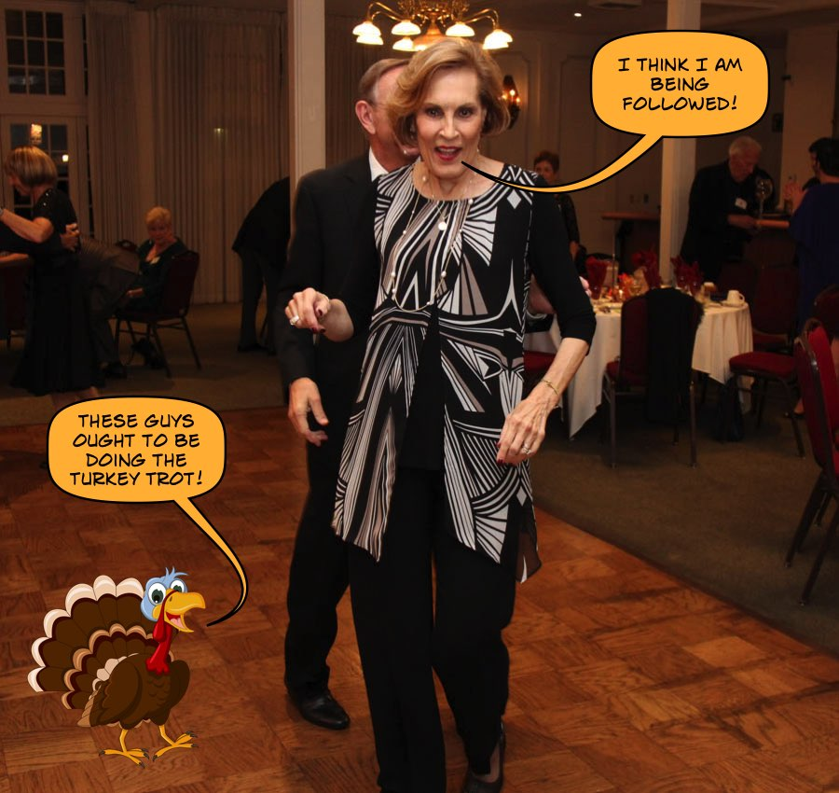

Ready to dance the night away!

Paul & Sue are arranging a New Year Eve dinner and dance party at Old Ranch Country Club in Seal Beach. 8:00 PM to 1:00 Am dancing to Nine Carat Gold. Seating is limited so call soon. Cost is $150/couple.

**YOUR BOARD**

President Larry Isham

Vice President Lucky Harrington

Secretary Sandy Slater

Treasurer Kathy Roberts

Hospitality Neil/Nita Woolston

Membership Vicky Kuhn

Roster Donnis Weygandt

Newsletter Paul/Sue Liles

Members At Large Gigi Isham, Ed Roberts, Del Kuhn, and Charlie Slater.