# ****Our 71st Fall Season Is Underway!****

Welcome Fall… The Holiday Season Is Here

# Policy Notes

There are no refunds for cancellations made after the Tuesday before the dance as the arrangements are finalized Tuesday evening.

If you desire to sit with someone please note it with your check so we can attempt to satisfy your seating desires!

“O’ pumpkin pie, your time has come ‘round and I am autumnrifically happy!” - Terri Guillements

# *Presidents Message…*

Summer is gone and Autumn has arrived. This year was a smooth transition with the weather changing slowly and leaves just beginning to turn to the magical golds of Autumn.

It was great to see the Lums back to dancing and we were pleased to meet Colleen’s parents, Sue and Jimmy.

Is it Autumn or Fall? "Autumn," a Latin word, first appears in English in the late 14th century, and gradually gained on "harvest." In the 17th century, "Fall" came into use, almost certainly as a poetic complement to "Spring," and it competed with the other terms. Use whichever one you want…

It’s hard to believe that Halloween is just ten days away! That means Thanksgiving and Christmas are not far behind.

Please try and bring friends so we can expand the club and meet new dancers. It is essential to grow so we can keep our venue and share the wonderful experiences we have.

*Larry Isham,  
 President*



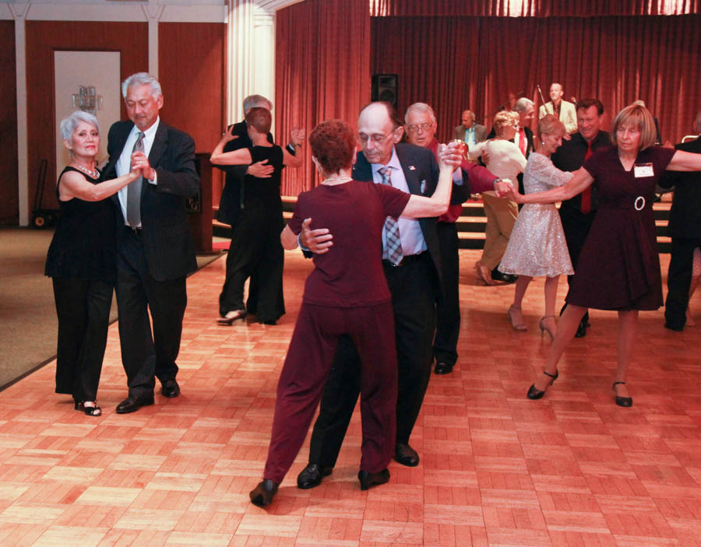

Everybody is up and dancing!

# What You Need To Know

The October 20th dance is at the Petroleum Club and featuring Sam Conti. The cost is $76/couple (includes tax/tip).

No-host cocktail time is 6 pm & great dance music until 10 pm.

**Dress code is Semi-Formal.**

Toppers Dinner Menu

Garden Green Salad  
Fresh seasonal vegetables   
Hot Bread and Butter

Entrée: Stuffed Pork Chop with scalloped potatoes OR

Grilled Salmon with rice. OR

Vegetarian selection.

Dessert: Chef’s Choice

Mail (please do not bring them to the dance) your checks made out to “Toppers Dance Club” **with dinner selections on the checks** by October 20th to:

Kathy Roberts

12021 Kibbee Ave

La Mirada CA 90638

# Prepare To Be Greeted By

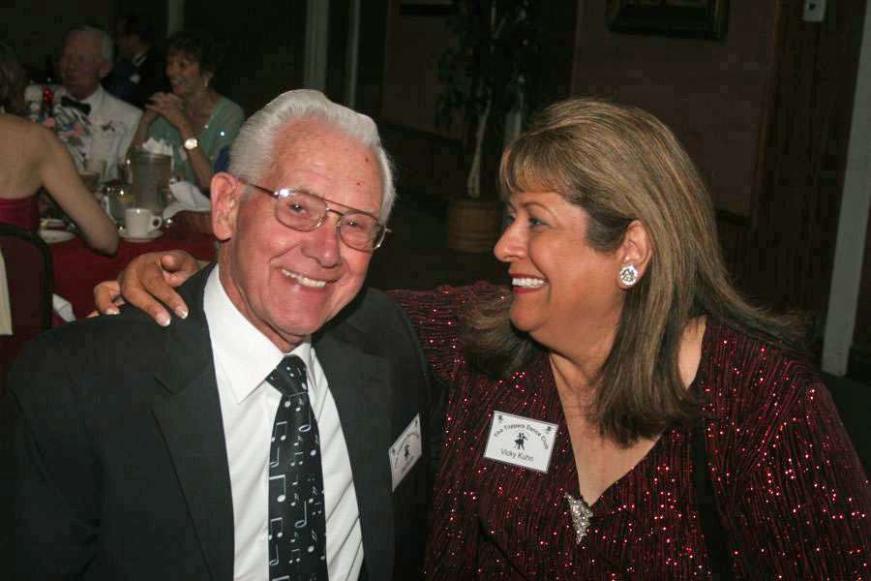

Del & Vicky Kuhn

Fun With Friends!

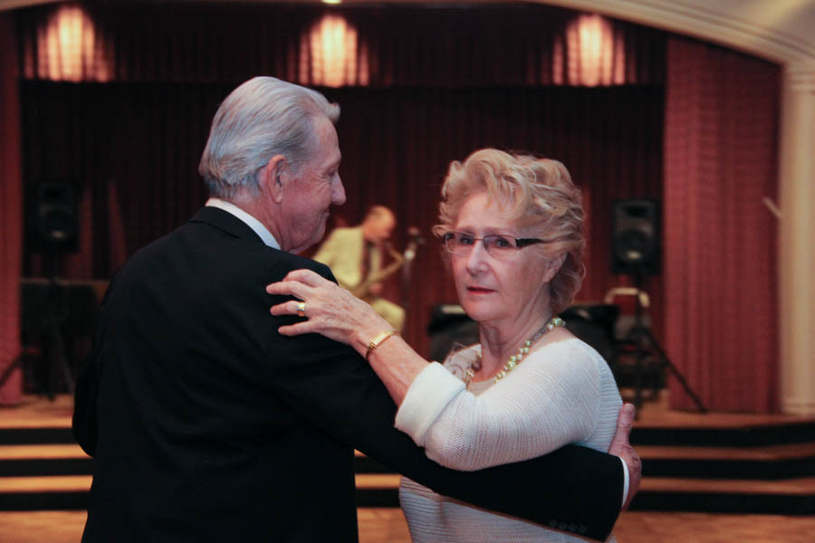

Romance is in the air

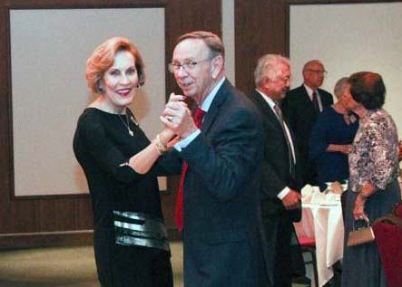

Kicking up the dust!

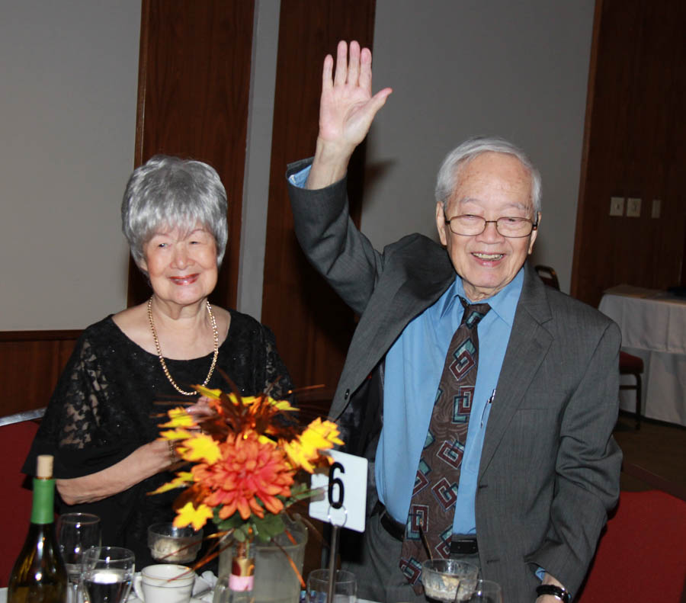  
Welcome Sue and Jimmy

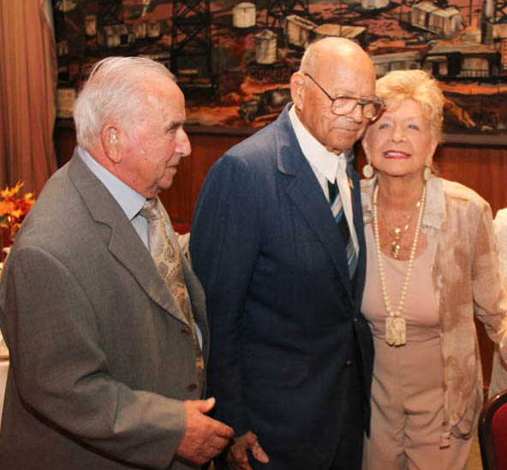  
Meet Bernie, Al, and Micky, our Nonagenarians

# Upcoming Dance Schedule

Two more dances until Christmas! Where did the year go?

11/17/2017 – Gil Gilman

12/15/2017 – Time Machine at the Mistletoe Ball!

To keep the club thriving, we are always looking for new friends to join in and participate in our great parties and keep social dancing alive and well in Long Beach!

# Fall Is Here!

“What good is the warmth of summer, without the cold of winter to give it sweetness.”

― John Steinbeck,

# Did You Know?

Fact #1: Americans typically refer to this time of year as “fall,” while the British use the word “autumn.” Both terms date back to the 16th century but before that it was called “harvest.

Fact #2: Fall was called “harvest” because of the “harvest moon” that occurs when the full moon is closest to the autumn equinox. Before man-made lighting, this moonlight was essential to a prosperous harvest.

Fact #3: Weight gain around this time of year may not only be due to comforting fall foods like pumpkin pie and cider, researchers have found that lack of vitamin D reduces fat breakdown and triggers fat storage.

**It’s Time To Vote At The November Dance**

Proposed change to the Toppers Dance Club Constitution and Bylaws:

Article III, Section 3 currently reads:

“Members on leave-of-absence attending a dance will pay the fee set for that dance.”

Proposed wording:

“Members on leave-of-absence ***and former members*** attending a dance will pay the fee set for that dance plus $20 per couple.”

Note: Added language is in bold italics.

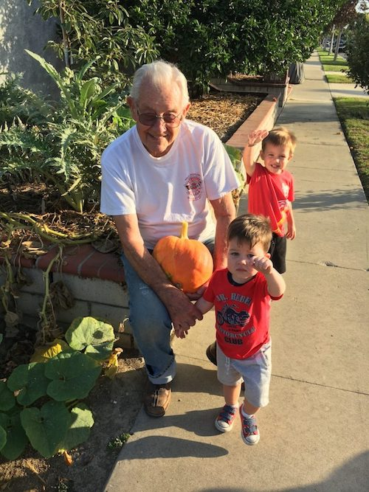

Del goes pumpkin picking with the grandkids!

**YOUR BOARD**

President Larry Isham

Vice President Lucky Harrington

Secretary Sandy Slater

Treasurer Kathy Roberts

Hospitality Neil/Nita Woolston

Membership Vicky Kuhn

Roster Donnis Weygandt

Newsletter Paul/Sue Liles

Members At Large Gigi Isham, Ed Roberts, Del Kuhn, and Charlie Slater.