# "Being 70 is not a sin." –Golda Meir

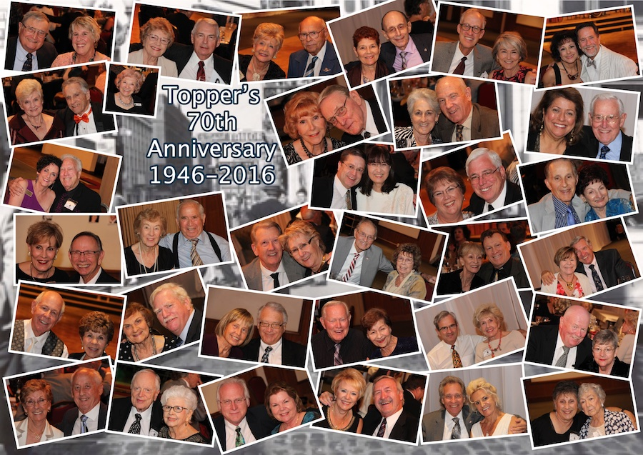

The Topper’s Seventieth Birthday Bash was a success!

The problem with getting old isn't so much that you slow down, it's that the rest of the world doesn't.

We Are Seventy And Going Strong!

# *Presidents Message…*

What a party! Imagine… Seventy years of dining and dancing! It would be amazing for the founders to see us tonight… Color pictures, instant communications and the music “almost” the same!

We were happy to have officers from Nightlighter’s and Starlighter’s joining us to celebrate.

We are now indeed into the holiday season with Thanksgiving and Christmas only a few short weeks away! Get your formals out as the Mistletoe Ball is occurring on December 15th.

Looking for a member? The website has always maintained a “visual roster” where you can see the pictures of our members online. You can get to it from the Topper’s Homepage.

Looking forward… Happy Thanksgiving! We are having slow roasted turkey as an entrée just to get you warmed up for the 24th!

*Larry Isham,  
 President*

*￼*

# What You Need To Know

The November 18th dance is at the Petroleum Club and featuring The Time Machine. The cost is $74/couple (includes tax/tip).

No-host cocktail time is 6 pm & great dance music until 10 pm.

Dress code is Semi-Formal.

Toppers Dinner Menu

Garden Green Salad  
Fresh seasonal vegetables   
Hot Bread and Butter

Entree: Slow Roasted Turkey Breast with home made cornbread stuffing, cranberry sauce and supreme sauce and mashed potatoes. Or

Baked White Fish in lemon sauce and rice. Or

Vegetarian Selection

Dessert: Chefs Choice

Mail your checks made out to “Toppers Dance Club” with dinner selections and seating requests on the checks by November 14th to:

Kathy Roberts

12021 Kibbee Ave

La Mirada Ca 90638

# Policy Notes

There are no refunds for cancellations made after the Tuesday before the dance as the arrangements are finalized Tuesday evening.

If you desire to sit with someone please note it with your check so we can attempt to satisfy your seating desires!

# Prepare To Be Greeted



Irene Kosmetatos

Fun With Friends!

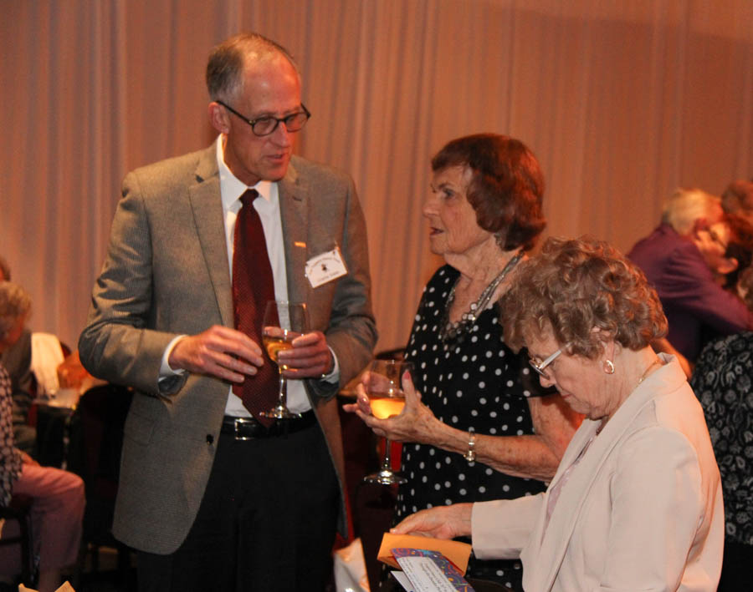

Catching up on the latest!

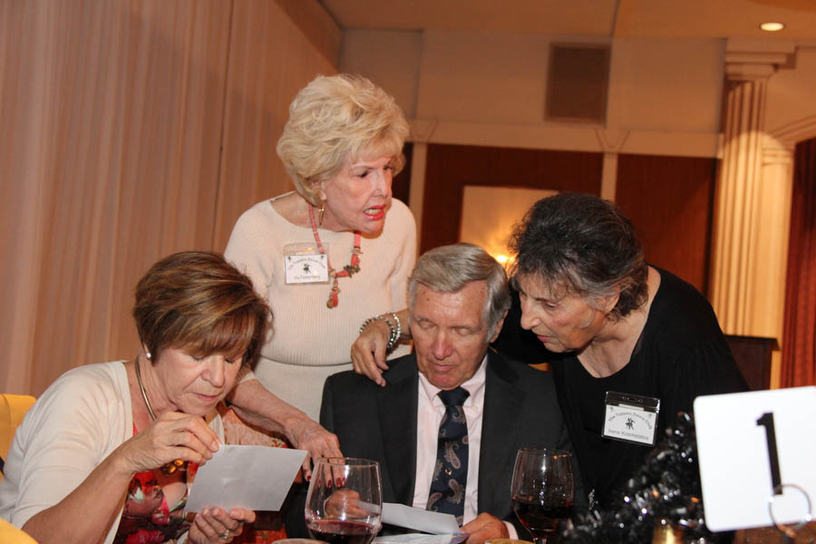

Guessing who is who!

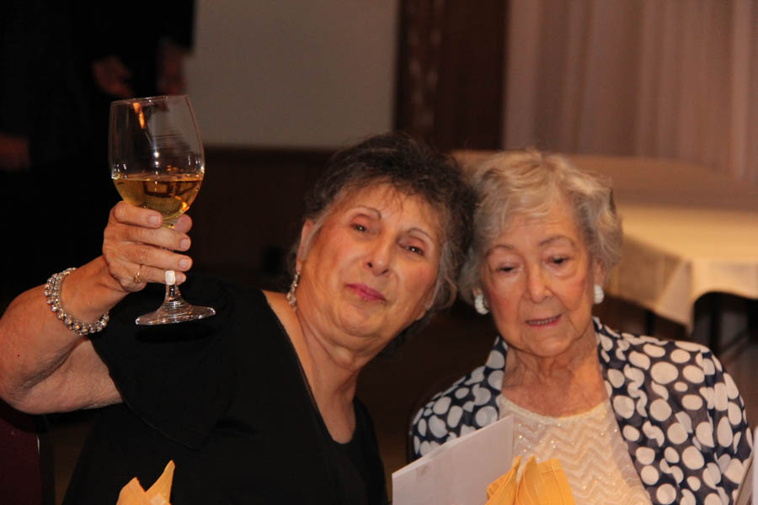  
Welcome Alice Smith…  
President 1986

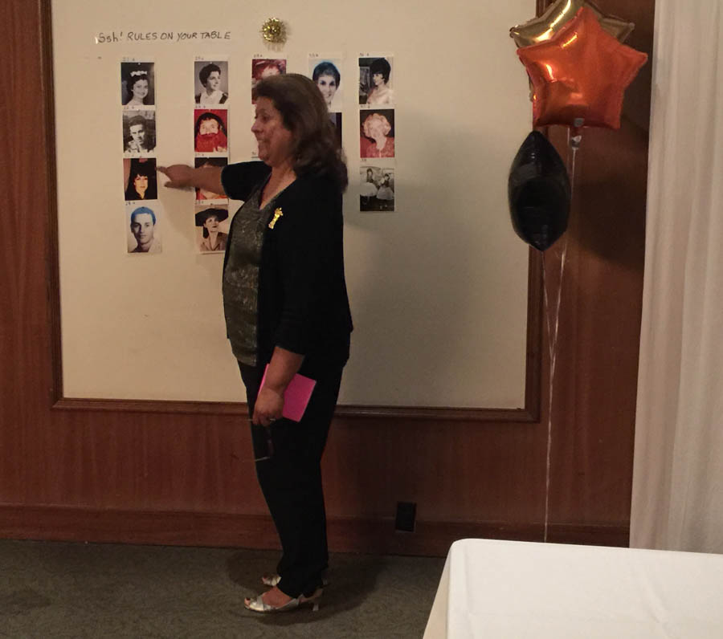  
And the answer is…..

**Bits And Pieces**

Diane won the Old Picture contest identifying 23 correctly!

Thank you Vicky Kuhn and Kathy Roberts for putting together the Old Photos game! Great fun.

It is our understanding that two Starlighter’s couples will be joining Topper’s.

We had three past presidents of Topper’s at the dance! Terey Kroy, Alice Smith, and Jerry Ellis

# Upcoming Dance Schedule

We have a busy season ahead! Get your calendars marked up now.

11/18/2016 with Sam Conti

12/15/2016 with The Time Machine

1/20/2016 with Tony Carinino

2/17/2017 with Howard Solomon

3/17/2017 with Jim Gilman

4/21/2017 with Sam Conti

5/12/2017 with The Time MAchine

To keep the club thriving, we are always looking for new friends to join us and participate in our great parties!

# Korny Indeed!

What kind of music did the Pilgrims like? Plymouth Rock

If April showers bring May flowers, what do May flowers bring? Pilgrims

Why can't you take a turkey to church? They use FOWL language.

Why was the Thanksgiving soup so expensive? It had 24 carrots.

What happened when the turkey got into a fight? He got the stuffing knocked out of him!

What do you get when you cross a turkey with a banjo? A turkey that can pluck itself!

We Lost A Friend

It was announced that long time member Ray Ashcroft passed early this month.

Ray was our Vice President and we always looked forward to him singing the Anniversary Waltz. Our thoughts go out to Mary Ruth.

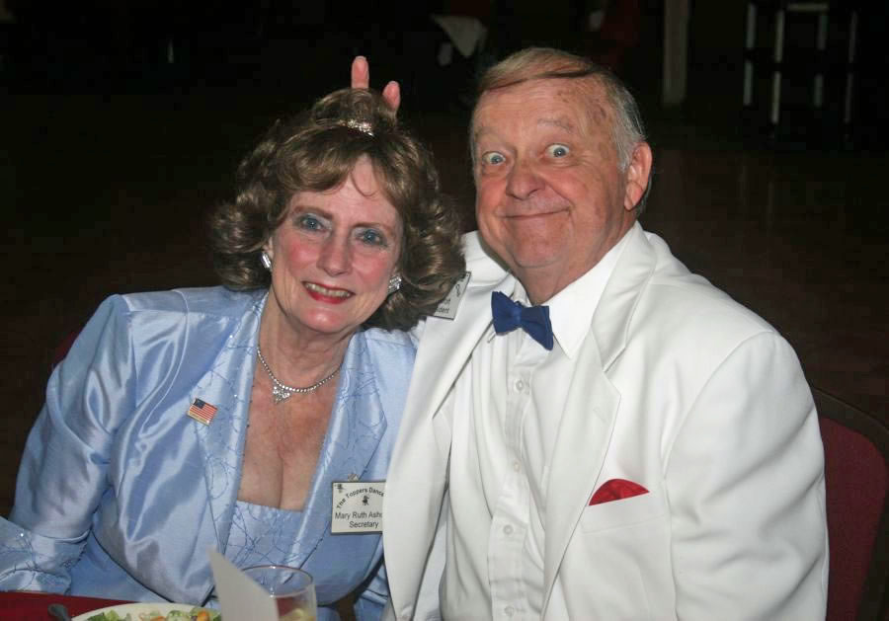

# New Roster Available

Thank you Donnis Weygandt for the effort to put together the new roster!

If you did not get one, call or see Donnis to get your copy.

**YOUR BOARD**

President Larry Isham

Vice President Lucky Harrington

Past President Jerry Ellis

Secretary Sandy Slater

Treasurer Kathy Roberts

Hospitality Neil/Nita Woolston

Membership Vicky Kuhn

Roster Donnis Weygandt

Newsletter Paul/Sue Liles

Members At Large Gigi Isham, Ed Roberts, and Nancy Ellis.