# *Presidents Message…*

Wow! What a milestone! Seventy years of dining and dancing and the amazing thing you ask… Much of the music is the same as it was in 1946!

The war is over and our troops are coming home anxious to return to civilization. Many dinner-dance clubs start including Nightlighters and Starlighters (under previous names). It’s time to have fun!

The great war machine of the USA now turns to peaceful production and we are off and running into the Space Age along with the Cold War.

It is a time of change. The first bikini was modeled in Paris and the USA blew up Bikini Atoll with an atomic weapon. We kept dancing.

The Flamingo Hotel opens on the Las Vegas Strip and Frank Capra's releases “It's a Wonderful Life”. It was and we kept dancing.

Please enjoy this special dance and great memories of many dance seasons gone bye!

For us, it was a very good year!

*Larry Isham,  
 President*

**

*￼*

# A life without love is like a year without summer.

Happy 70th Birthday Toppers!

On a Winter’s evening seventy years ago our club was started. Move back your clocks and visit times gone by!

# What You Need To Know

The May 20th dance is at the Petroleum Club and featuring The Time Machine. The cost is $74/couple (includes tax/tip).

No-host cocktail time is 6 pm & great dance music until 10 pm.

Dress code is Semi-Formal.

Toppers Dinner Menu

Garden Green Salad  
Fresh seasonal vegetables   
Hot Bread and Butter

Entree: New York Cut Steak, broiled steak servied with au jus ad baked potatoe OR

Grilled Salmon with Hollandaise sauce and rice OR

Vegetarian Selection

Dessert: Chefs Choice

Mail your checks made out to “Toppers Dance Club” with dinner selections and seating requests on the checks by May 12th to:

Kathy Roberts

12021 Kibbee Ave

La Mirada Ca 90638

# Policy Notes

There are no refunds for cancellations made after the Tuesday before the dance as the arrangements are finalized Tuesday evening.

If you desire to sit with someone please note it with your check so we can attempt to satisfy your seating desires!

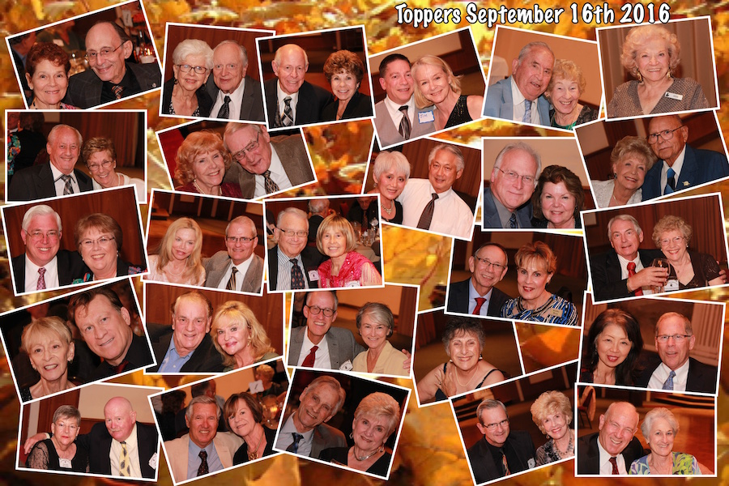

The Topper’s Return After Our Summer Vacation

# Prepare To Be Greeted

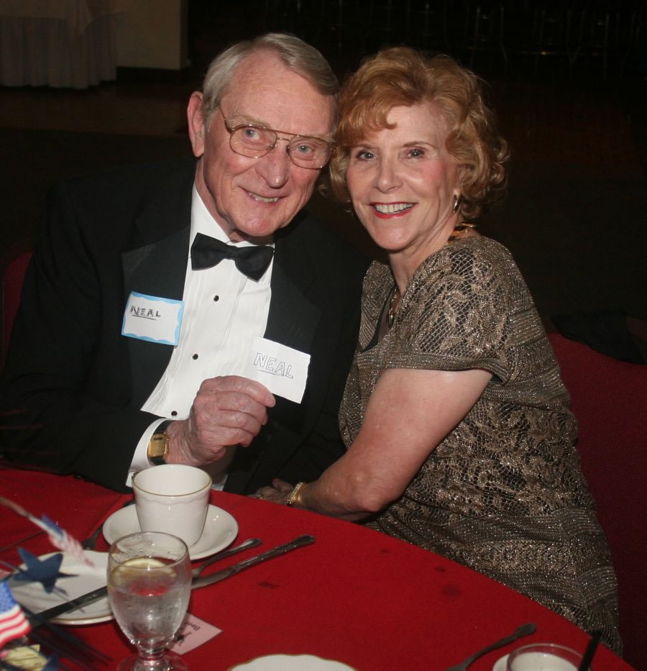

Neal and Nita Woolston

Fun With Friends!

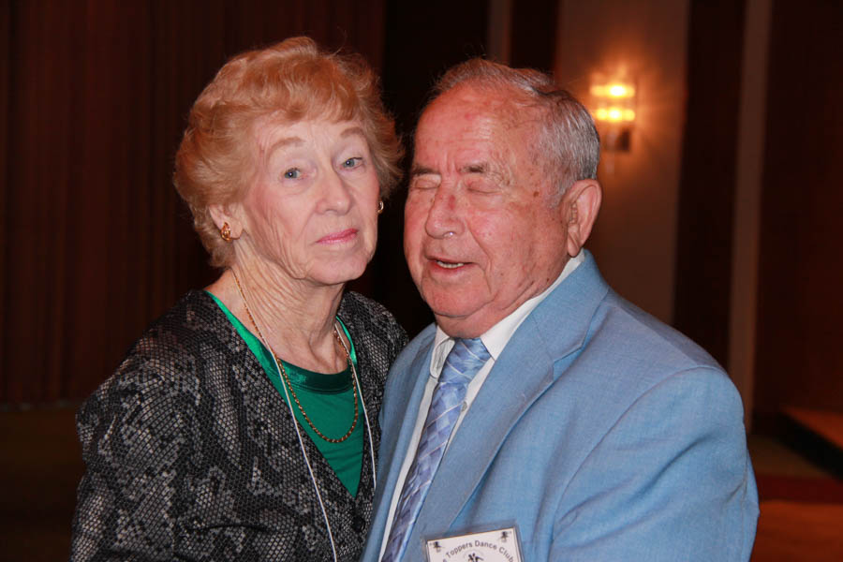

A Special Couple!

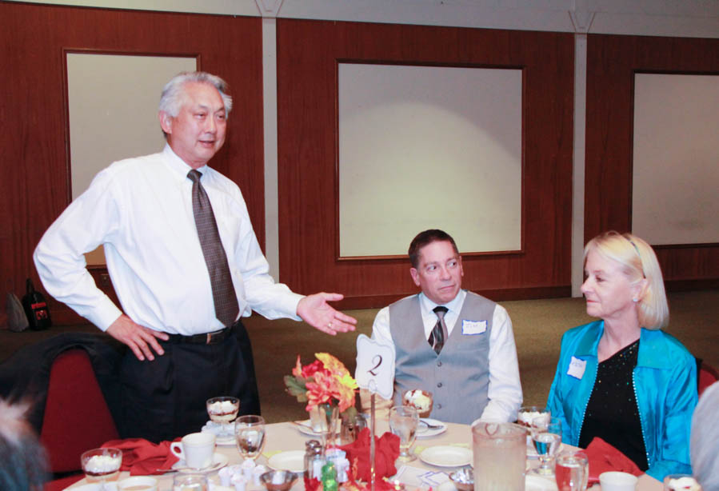

Al Introduces Guests

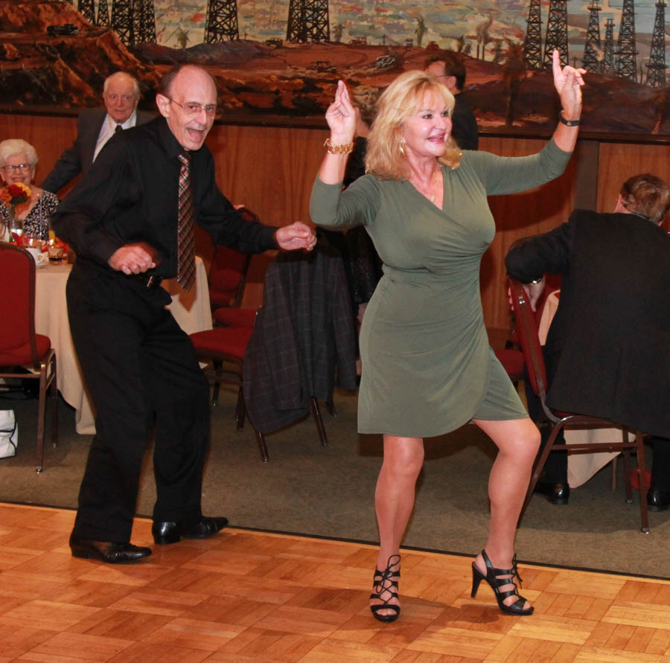  
Dancing The Twist

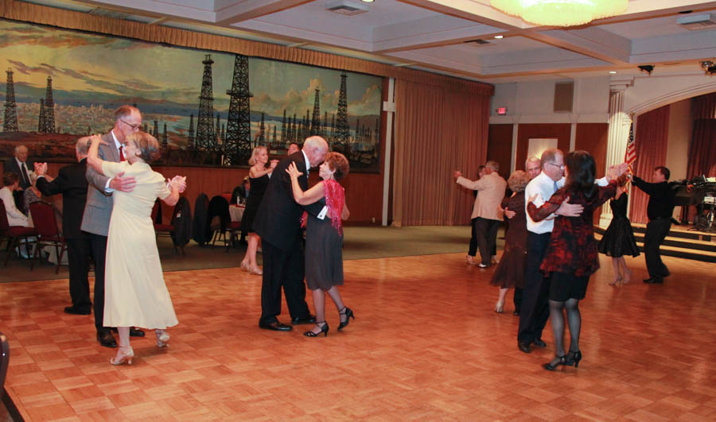  
The dance music was great this evening! The floor was rocking!

**Bits And Pieces**

Many of our dance clubs are coming up on their 70th birthday (just like us). You might be receiving an invite to other dance clubs… If you can, come join the celebration, meet some new interesting people, and help celebrate 70 years of dancing!

The Roberts went off to Washington DC to celebrate their Anniversary and a birthday!

# Upcoming Dance Schedule

**Have a wonderful summer and we will see you again next year to celebrate our 70th year of dining and dancing!**

09/16/2016 with Tony Carinino

10/21/2016 with Howard Solomon

11/18/2016 with Sam Conti

We are off for the summer (June, July, and August). Talk to Paul & Sue for other places to dance during the summer.

To keep the club thriving, we are always looking for new friends to join us and participate in our great parties!

# In The Beginning!

Upon arriving home, soldiers and their families wanted a “social life” and the dance clubs were born all over the USA.

In Long Beach we formed the Topper’s Dance Club and although many of our historical artifacts are gone now, we are sure that we meet and members homes for several years.

The cub began to grow and we soon had to find other venue’s. A search of our historical document reveal we used



**YOUR BOARD**

President Larry Isham

Vice President Dean Fronk

Past President Jerry Ellis

Secretary Lori Fronk

Treasurer Kathy Roberts

Hospitality Neil/Nita Woolston

Membership Vicky Kuhn

Roster Donnis Weygandt

Newsletter Paul/Sue Liles

Members At Large Gigi Isham, Ed Roberts, and Nancy Ellis.