# Winter is dead; spring is crazy; summer is cheerful and autumn is wise!

# *Presidents Message…*

Wow! What a milestone! Seventy years of dining and dancing. One of the amazing things is much of the music is the same as it was in 1946!

The war was over and our troops were coming home anxious to return to “civilization”. Many dinner-dance clubs were starting including Topper’s, Nightlighters and Starlighters (under previous names).

The great war machine of the USA then turned to peaceful production and we were off and running into the Space Age along and the Cold War.

It was a time of change. The first bikini was modeled in Paris and the USA blew up the Bikini Atoll with an atomic weapon. We kept dancing.

The Flamingo Hotel opened on the Las Vegas Strip and Frank Capra released “It's a Wonderful Life”. It was that and we kept dancing.

Please enjoy this special dance in October and the great memories of many dance seasons gone bye!

You may see some new faces of people who came to celebrate with us. Please welcome them to our anniversary celebration.

*Larry Isham,  
 President*

**

Happy 70th Anniversary Toppers!

On a Winter’s evening seventy years ago our club was started. Move back your clocks and visit times gone by!

# What You Need To Know

The October 21st dance is at the Petroleum Club and featuring Howard Solomon. The cost is $74/couple (includes tax/tip).

No-host cocktail time is 6 pm & great dance music until 10 pm.

Dress code is Semi-Formal.

Toppers Dinner Menu

Garden Green Salad  
Fresh seasonal vegetables   
Hot Bread and Butter

Entree: Stuffer Pork Chops seasoned stuffing inside center cut pork chop with Scalloped Potatoes OR

Grilled Salmon with Hollandaise sauce and rice OR

Vegetarian Selection

Dessert: Chefs Choice

Mail your checks made out to “Toppers Dance Club” with dinner selections and seating requests on the checks by October 18th to:

Kathy Roberts

12021 Kibbee Ave

La Mirada Ca 90638

# Policy Notes

There are no refunds for cancellations made after the Tuesday before the dance as the arrangements are finalized Tuesday evening.

If you desire to sit with someone please note it with your check so we can attempt to satisfy your seating desires!

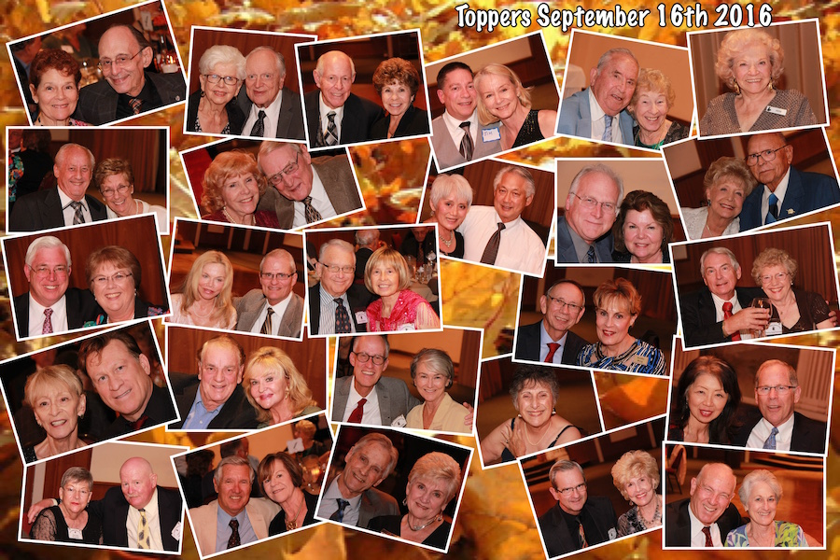

The Topper’s Return After Our Summer Vacation

**Bits And Pieces**

Many of our dance clubs are coming up on their 70th anniversary (just like us). You might be receiving an invite to other dance clubs… If you can, come join the celebration, meet some new interesting people, and help celebrate 70 years of dancing!

Vicky Kuhn is standing guard at the Pumpkin Patch in Paul Liles’ front yard to assure her grandkids get to have their pumpkins to carve for Halloween.

Bernie Myers celebrated his 95th birthday!

# Prepare To Be Greeted

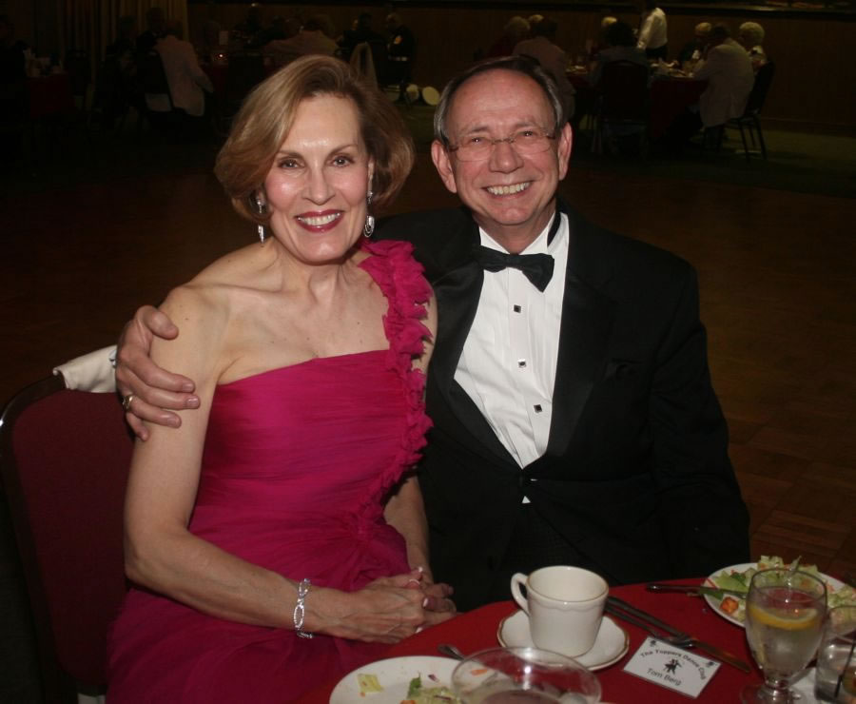

Kathy and Tom Berg

Fun With Friends!

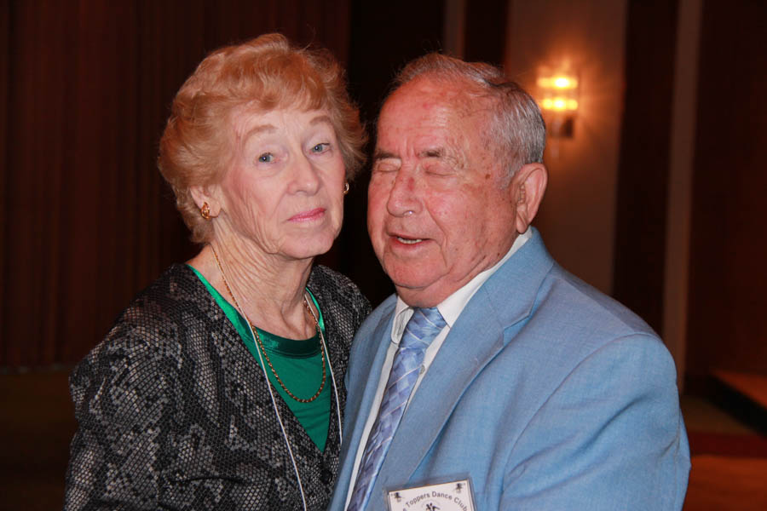

A Special Couple!

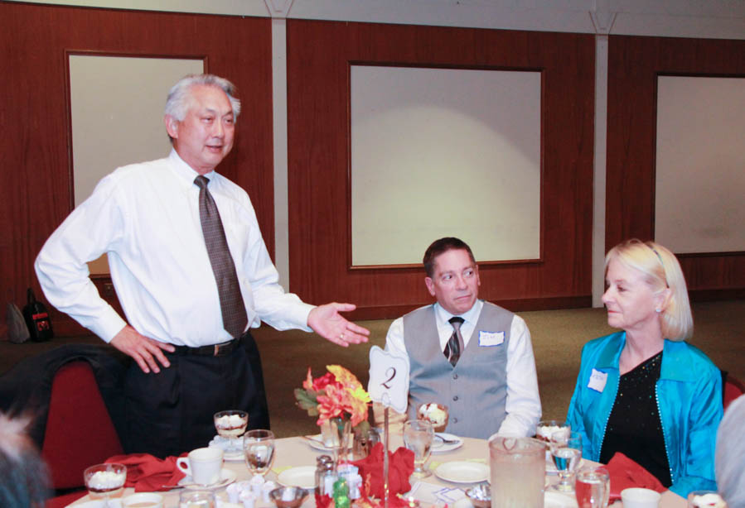

Al Introduces guests   
Jim and Kathi

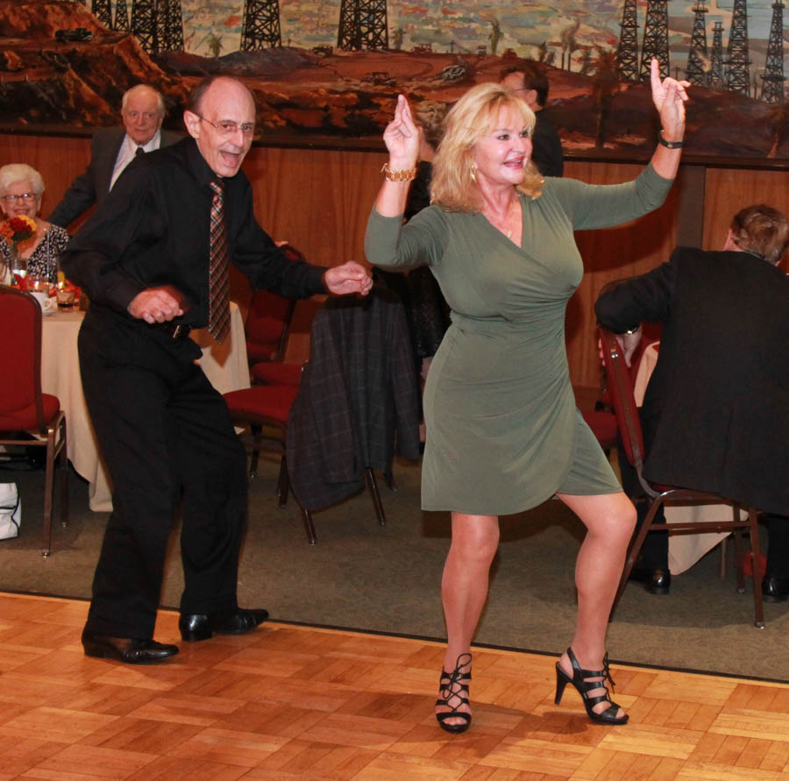  
Dancing The Twist

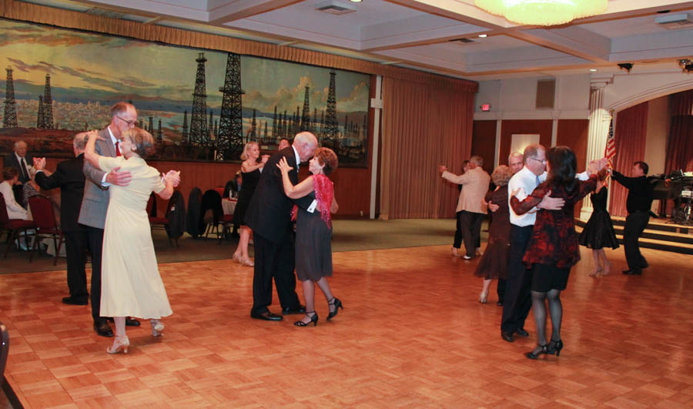  
The dance music was great this evening! The floor was rocking!

**YOUR BOARD**

President Larry Isham

Vice President Lucky Harrington

Secretary Sandy Slater

Treasurer Kathy Roberts

Hospitality Neil/Nita Woolston

Membership Vicky Kuhn

Roster Donnis Weygandt

Newsletter Paul/Sue Liles

Members At Large Gigi Isham, Ed Roberts, carolyn harrington, Del Kuhn, and Charlie Slater.

# Upcoming Dance Schedule

**Our new membership book will contain the dates for the 2017 upcoming dances.**

11/18/2016 with Sam Conti

12/16/2016 with The Time Machine

The first day of Fall has occurred and we are now into the holiday season. Halloween, Thanksgiving, Christmas, and New Years are coming up!

Looking for great music for New Years Eve? **Nine Carat Gold** is playing at the Santa Ana Elks and they are excellent.

# In The Beginning!

Upon arriving home from the war, soldiers and their families wanted a “social life”. Dance clubs were born all over the USA.

In Long Beach, the Topper’s Dance Club was formed in 1946. Although many of our historical artifacts are gone now, we are sure that we met at members homes for several years.

The club expanded in membership and new venues were needed.

In the 1950’s and 1960’s the club went on bus rides to remote venues including San Diego and Temecula!

In the 1980’s the club went to Virginia Country Club, Long Beach Yacht Club, Laguna Country Club, San Pedro Elks, Santa Ana Elks, and many more. Remember, it was 1957 when the first lanes of the 405 were opened for business and in the 1980’s traffic was not nearly as “bad” as today!

The Petroleum Club opened in the mid 1950’s and by the 1990’s Topper’s Dance Club became a regular group at the Petroleum Club!

Today we are 40 couples strong and trying to keep a flow of new members into the club as others leave.

We understand that several members of Nightlighter’s, Rondelier’s and Starlighter’s will be joining us to celebrate. Welcome to Topper’s

