# *Presidents Message…*

We had a great time at the St. Patrick’s dance… The floor was awash in green!

Welcome Spring! The flowers and trees are coming out of their winter uniforms and showing their glorious colors to all!

If you get a chance, visit the Sherman Gardens in Corona del Mar. It’s quite small but contains an amazing variety of flowers. It’s a great place to “see” Spring in action! Easy walk and an outstanding small café on the grounds.

This newsletter is Volume 69. That means our October 2016 dance with be our 70th birthday! We plan to invite other dance clubs to join us (Nightlighters, Starlighters, and Rondeliers). Bring your ideas on how to celebrate to the next dance… Let’s do something special!

Looking forward to seeing all of you on the 15th!

*Larry Isham,  
 President*

*￼*

Better three hours too soon than a minute too late.

Only Two Dances Remain This Season Anyone?

Yesterday's the past, tomorrow's the future, but today is a gift. That's why it's called the present.

Read more at: http://www.brainyquote.com/quotes/quotes/b/bilkeane121860.html?src=t_time

Read more at http://www.brainyquote.com/quotes/keywords/halloween.html#THt5bFJqK9iSTBHG.99

# What You Need To Know

The April 15th dance is at the Petroleum Club and featuring Sam Conti. The cost is $74/couple (includes tax/tip).

No-host cocktail time is 6 pm & great dance music until 10 pm.

Dress code is Semi-Formal.

Toppers Dinner Menu

Garden Green Salad  
Fresh seasonal vegetables   
Hot Bread and Butter

Entree: Stuffed Pork Chop (Seasonal stuffing inside center-cut pork chop) with Scalloped Potatoes OR

Grilled White Fish in Lemon Sauce with Rice OR

Vegetarian Selection

Dessert: Chefs Choice

Mail your checks made out to “Toppers Dance Club” with dinner selections and seating requests on the checks by April 12th to:

Kathy Roberts

12021 Kibbee Ave

La Mirada Ca 90638

# Policy Notes

There are no refunds for cancellations made after the Tuesday before the dance as the arrangements are finalized Tuesday evening.

If you desire to sit with someone please note it with your check so we can attempt to satisfy your seating desires!



The Topper’s Irish Dance Club in action!

# Prepare To Be Greeted



Irene Kosmetatos

Fun With Friends!

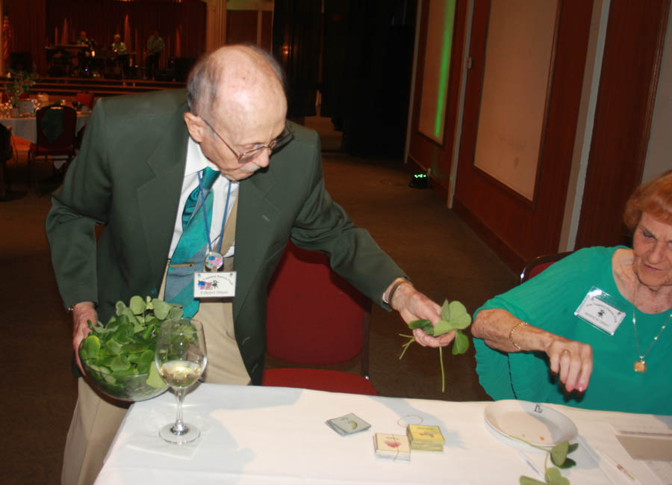

Our own Leprechaun

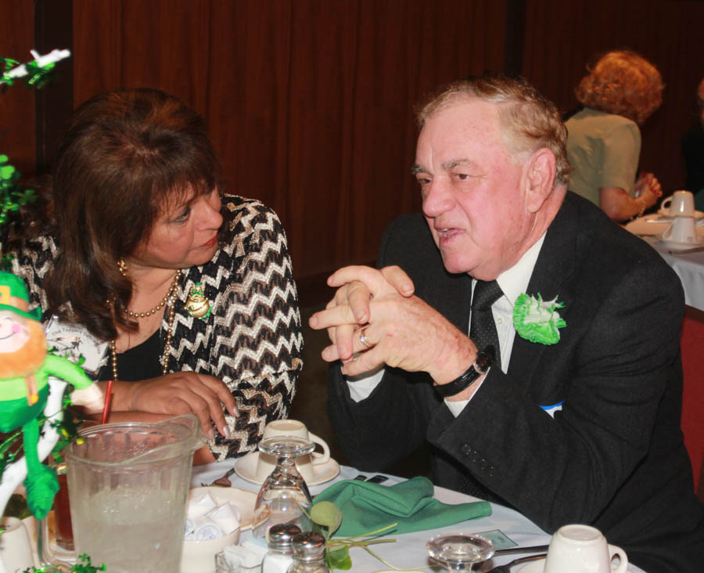

Wally is an expert in malarkey

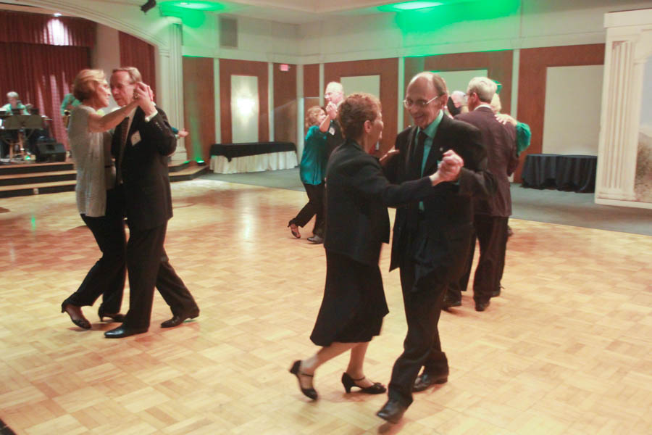  
Dancing the night away

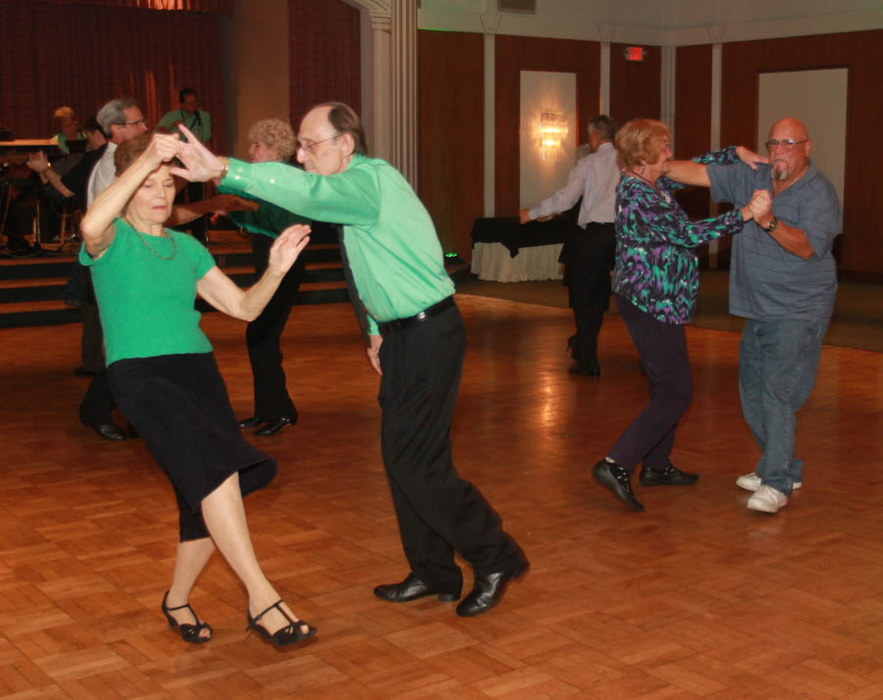  
The dance music was great this evening! The floor was rocking!

**Bits And Pieces**

Many of our dance clubs are coming up on their 70th birthday (just like us). You might be receiving an invite to other dance clubs… If you can, come join the celebration, meet some new interesting people, and help celebrate 70 years of dancing!

Irene visited her daughter in Seattle for two weeks and they attended many of the International Track and Field Games. Ask her about it!

# Upcoming Dance Schedule

Only one more dance this year and then we celebrate our 70th year!

05/20/2016 – Time Machine  
(Formal Attire!)

We are off for the summer (June, July, and August). Talk to Paul & Sue for other places to dance during the summer.

# Bring A Friend!

To keep the club thriving, we are always looking for new friends to join us and participate in our great parties!

# Spring Is Here!

Spring is one of the four conventional temperate seasons, following winter and preceding summer. There are various technical definitions of spring, but local usage of the term varies according to local climate, cultures and customs.

When it is spring in the Northern Hemisphere, it will be autumn in the Southern Hemisphere. At the spring equinox, days are approximately 12 hours long with day length increasing as the season progresses. Spring and "springtime" refer to the season, and also to ideas of rebirth, rejuvenation, renewal, resurrection and regrowth

.

# Q and A’s

Q: Can February March?

A: No, but April May!

Q: Why is everyone so tired on April 1?

A: Because they've just finished a long, 31 day March!

Q: What season is it when you are on a trampoline?

A: Spring-time!

# We Need A Secretary

We are still looking for a club secretary to step in for Lori Fronk.

It’s an easy task taking only an hour a month. See how your club works! Call Larry Isham and volunteer.



**YOUR BOARD**

President Larry Isham

Vice President Dean Fronk

Past President Jerry Ellis

Secretary Lori Fronk

Treasurer Kathy Roberts

Hospitality Neil/Nita Woolston

Membership Vicky Kuhn

Roster Donnis Weygandt

Newsletter Paul/Sue Liles

Members At Large Gigi Isham, Ed Roberts, and Nancy Ellis.