Christmas isn't a season. It's a feeling.

It’s A New Year!!! More Dancing Needed!

# *Presidents Message…*

Where did that last year go? It seems to have passed in a flash! That’s OK because we have another great dance year ahead of us!

The Petroleum Club was beautifully decorated for the Mistletoe Ball and we had 79 people. Thank’s to several other dance clubs, we achieved our goal and also have two new members!

Special thanks to Kathy Roberts for the efforts to assure we had more the seventy people with us for the ball.

We had a camera in action at the dance so please visit our website to remember the fun you had at the dance.

It also seems summer finally went away! This year it went from summer to winter in about one week.

We are looking forward to seeing you January 22nd and bring a friend.

Remember: A year from now, you're gonna weigh more or less than or the same as you do right now.

*Larry Isham,  
 President*

*￼￼*

“Tomorrow, is the first blank page of a 365 page book. Write a good one.”

― Brad Paisley--Irv Kupcine

Read more at http://www.brainyquote.com/quotes/keywords/halloween.html#THt5bFJqK9iSTBHG.99

# What You Need To Know

The January 22nd dance is at the Petroleum Club and featuring Howard Solomon. The cost is $74/couple (includes tax/tip).

No-host cocktail time is 6 pm & great dance music until 10 pm.

Dress code is Semi-Formal.

Toppers Dinner Menu

Garden Green Salad  
Fresh seasonal vegetables   
Hot Bread and Butter

Entree: Chicken Ballentine, Baked Boneless Breast Of Chicken Stuffed with Seasonal Rice OR Grilled White Fish in Lemon Sauce with Rice Vegetarian Selection

Dessert: Chefs Choice

Mail your checks made out to “Toppers Dance Club” with dinner selections and seating requirements on the checks by January 19th to:

Kathy Roberts

12021 Kibbee Ave

La Mirada Ca 90638

# Policy Notes

There are no refunds for cancellations made after the Tuesday before the dance as the arrangements are finalized Tuesday evening.

If you desire to sit with someone please note it with your check so we can attempt to satisfy your seating desires!

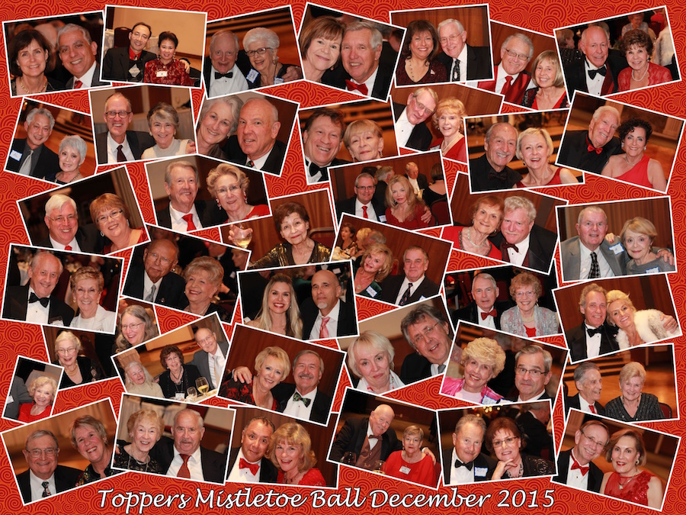

The Mistletoe Ball 2015 had several Starlighters join us

# Prepare To Be Greeted

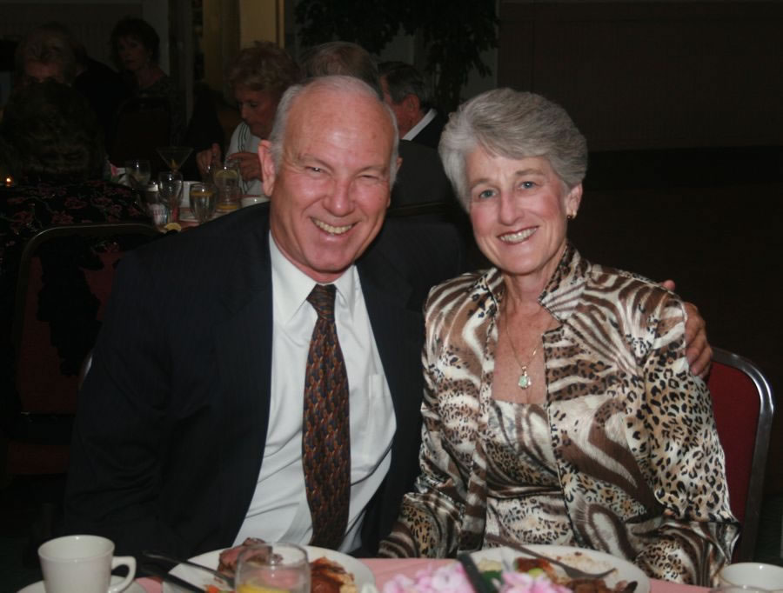

Dennis and Diane Schmitz

Fun With Friends!

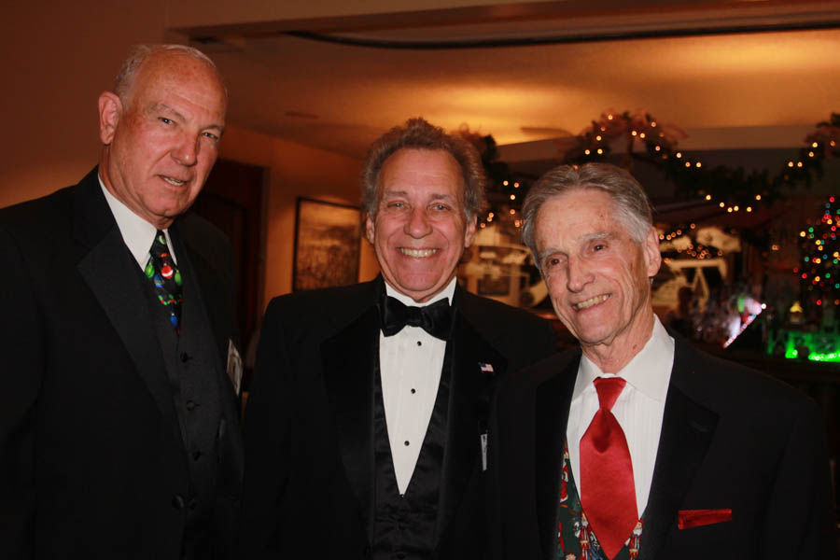

A dapper trio indeed!

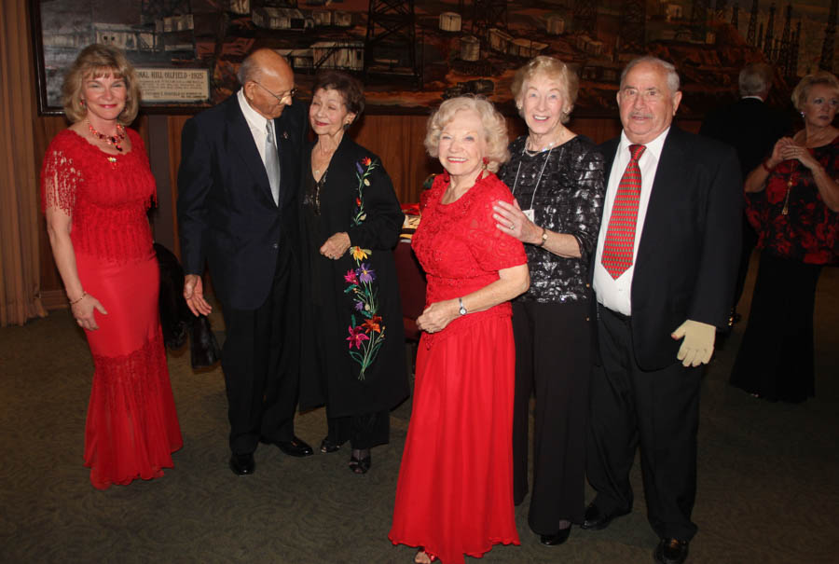

Met new friends from other dance clubs at the Mistletoe Ball

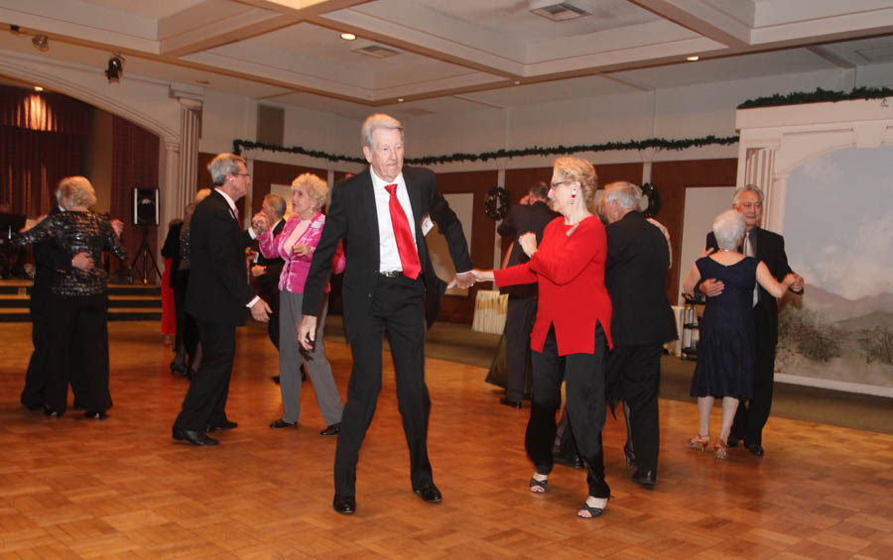  
Decorated for Christmas

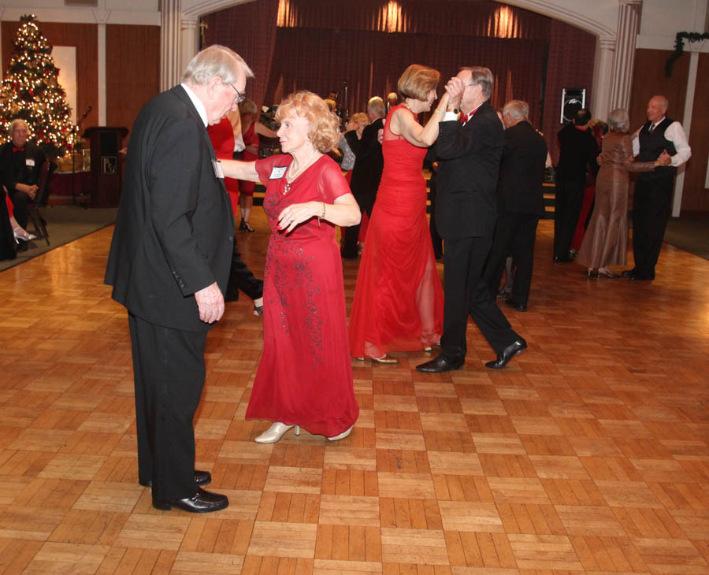  
The Mistletoe Ball brings out the red gowns and ties

**Bits And Pieces**

Many of your fellow members enjoyed a great time with Tracy Wells at the Long Beach Airport Marriott Hotel this New Years Eve!

It’s time to start planning for the May Avalon Ball held in Catalina at the Catalina Casino. Details to follow!

Sue celebrated Christmas Eve at Disneyland for her 52nd consecutive year! Quite a tradition!

The Liles’ Great Granddaughter Lilly celebrated her first Disneyland Christmas Eve!

# Upcoming Dance Schedule

02/19/2016 – Tony Carinio

03/18/2016 – Jim Gilman

04/15/2016 – Sam Conti

# Bring A Friend!

To keep the club thriving, we are always looking for new friends to join us and participate in our great parties!

# Your New Year’s Eve??

We had a great time at the **Tracy** **Wells** **Long Beach Marriott Airport Hotel** New Years Eve Party**.** The evening was magical beginning at 6:00 and was still going after midnight.

**New Years Resolutions?**

A New Year's resolution is a tradition, most common in the Western Hemisphere but also found in the Eastern Hemisphere, in which a person makes a promise to do an act of self-improvement or something slightly nice, such as opening doors for people beginning from New Year's Day.

A 2007 study by Richard Wiseman from the University of Bristol involving 3,000 people showed that 88% of those who set New Year resolutions fail despite the fact that 52% of the study's participants were confident of success at the beginning.

Men achieved their goal 22% more often when they engaged in goal setting, (a system where small measurable goals are being set; such as, a pound a week, instead of saying "lose weight"), while women succeeded 10% more when they made their goals public and got support from their friends.

# About Our Website

Just Google “Toppers Dance Club” and our site will be the first on the search list!

# We Need A Secretary

We are still looking for a club secretary to step in for Lori Fronk. It’s an easy task taking only an hour a month. See how your club works! Call Larry Isham and volunteer.

**YOUR BOARD**

President Larry Isham

Vice President Dean Fronk

Past President Jerry Ellis

Secretary Lori Fronk

Treasurer Kathy Roberts

Hospitality Neil/Nita Woolston

Membership Vicky Kuhn

Roster Donnis Weygandt

Newsletter Paul/Sue Liles

Members At Large Gigi Isham, Ed Roberts, and Nancy Ellis.