# *Presidents Message…*

We are now into the holiday season with Halloween, Thanksgiving, and Christmas just around the corner.

Fall has arrived but it forgot to bring the weather along with it! Our dancing is COOL so perhaps that will help lower the temperatures.

Our next dance features Howard Solomon and is a semi-formal affair with emphasis on celebrating Halloween.

We enjoyed Sandy and Bob as guests and hope they hurry back.

Several of our members are going to the Elks Santa Ana Halloween Ball on the 31st. That could be scary!

As always, please take some time and ask friends to join us and become members of the club.

Remember – “True love is like ghosts, which everyone talks about but few have seen. ~ Anonymous.“

We are looking forward to seeing you October 16th and bring your scariest ghost stories to share!

*Larry Isham,  
 President*



*￼￼*

Halloween Is Right Around The Corner!

A grandmother pretends she doesn't know who you are on Halloween. Erma Bombeck

Read more at http://www.brainyquote.com/quotes/keywords/halloween.html#THt5bFJqK9iSTBHG.99

On Halloween, the parents sent their kids out looking like me. - Rodney Dangerfield

Read more at http://www.brainyquote.com/quotes/keywords/halloween.html#THt5bFJqK9iSTBHG.99

# What You Need To Know

The October 16th dance is at the Petroleum Club and features Howard Solomon. The cost is $74/couple (includes tax/tip).

No-host cocktail time is 6 pm & great dance music until 10 pm.

Dress code is semi-formal.

Toppers Dinner Menu

Garden Green Salad  
Fresh seasonal vegetables   
Hot Bread and Butter

Entree: Stuffed Pork Chops, seasonal stuffing inside center cut pork chop and scalloped potatoes OR Grilled White Fish in lemon sauce and rice OR Vegetarian selection

Dessert: Chefs Choice, Coffee, tea or decaffeinated coffee.

Mail your checks made out to “Toppers Dance Club” with dinner selections on the checks by September 13th to:

Kathy Roberts

12021 Kibbee Ave

La Mirada Ca 90638

Note: If you can’t get the check in by the 13th call Kathy.

# Policy Notes

There are no refunds for cancellations made after the Tuesday before the dance as the arrangements are finalized Tuesday evening.

If you desire to sit with someone please note it with your check so we can attempt to satisfy your seating desires!

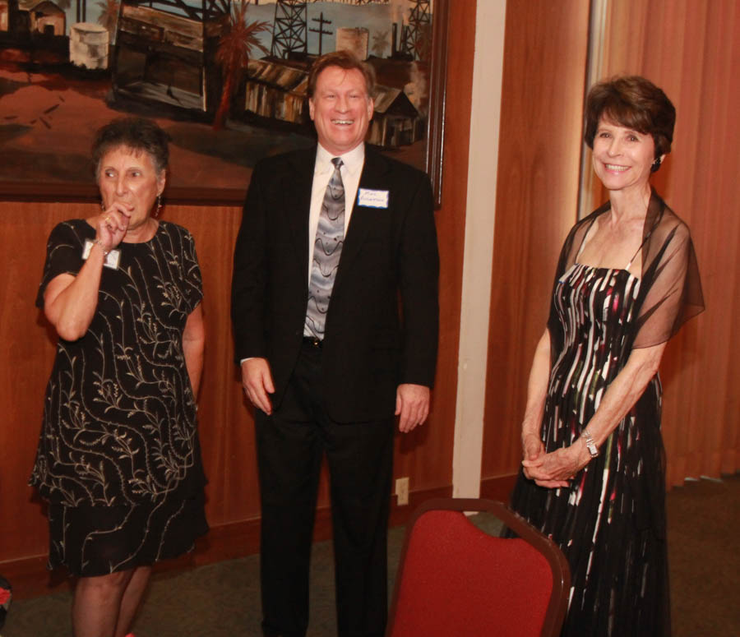

Irene with Guest Mike and Sandy (Guest of the Liles’)

**Bits And Pieces**

Bernie celebrated his 94th birthday with Donnis and the Liles’ and dined on extra-hot jambalaya.

The Roberts just returned from a two week vacation in Florida enjoying mild temperatures and a lot of sun!

We are still looking for a Secretary for the club. It simply involves takes notes at the 30 minute meeting and writing them up. Easy Pizzy!

# Prepare To Be Greeted

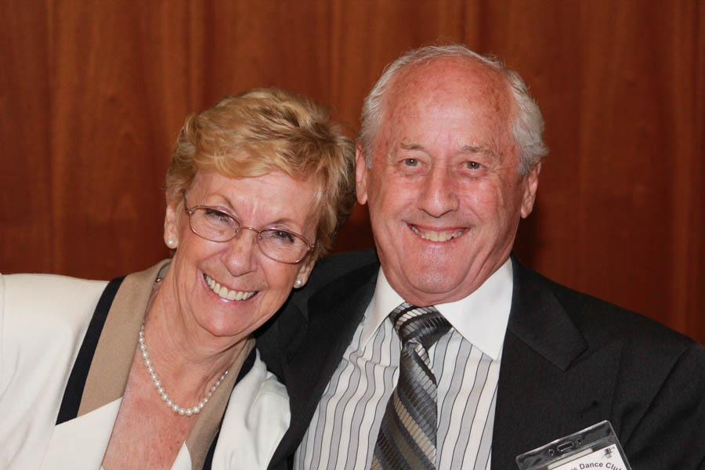

Gilles & Gisele Mongeau

What A Great Dance!

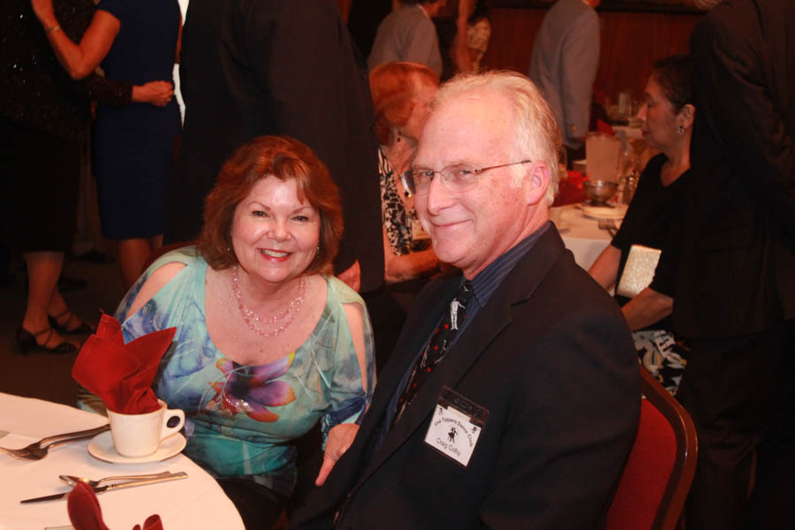

Linda & Craig Colby

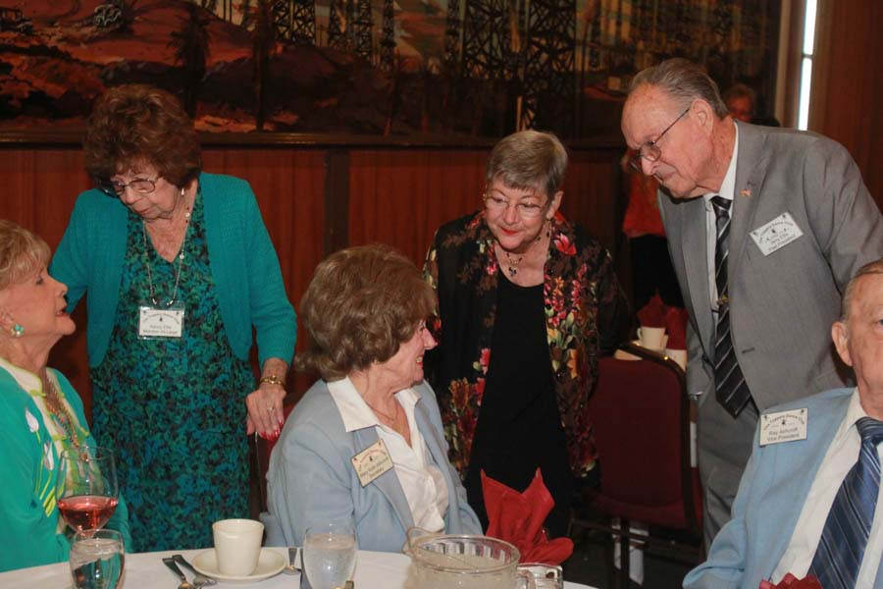

Meeting and Greeting

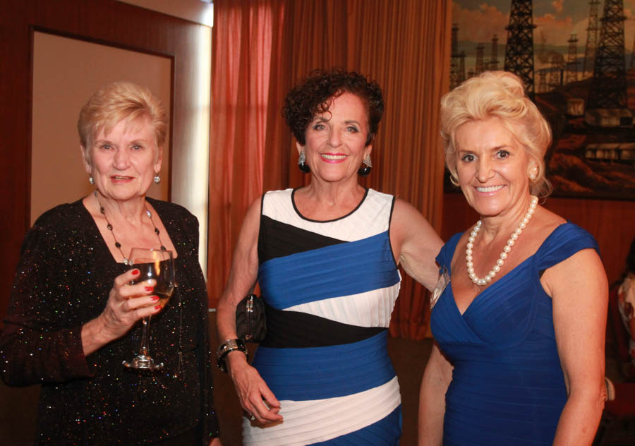  
Ready to dance!

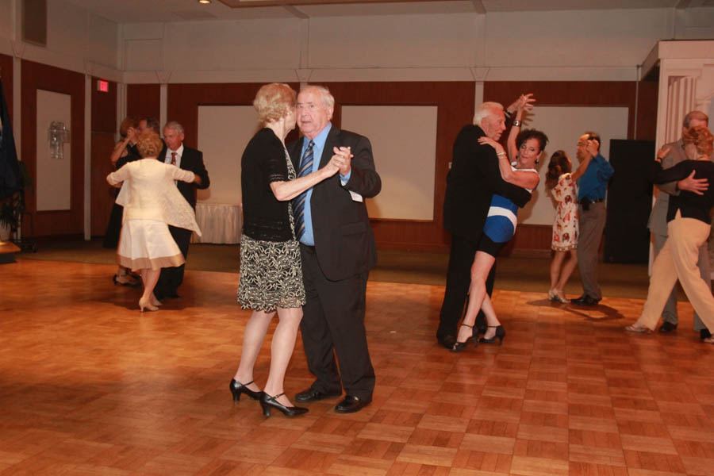Dancing the night away

# Upcoming Dance Schedule

11/20/2015 – Sam Conte

12/18/2015 – The Time Machine

# Bring A Friend!

To keep the club thriving, we are always looking for new friends to join us and participate in our great parties!

# Do You Remember?

When I was a little kid, there was one house in my neighborhood which I both loved and feared trick-or-treating at. Just two blocks over from mine, this home was an unassuming bungalow 364 days of the year.

Come Halloween night, however, and it was transformed.

The family who lived here clearly loved Halloween, and it showed. On walking up the driveway trick-or-treaters were greeted with the usual assortment of cobwebs, tombstones and creepy music.

After knocking (tentatively) on the door, you'd wait with bated breath until it began to open ever-so-slowly, a mangled warlock's hand emerging through the door frame.



This (fake) hand in fact belonged to a friendly, candy-touting suburban dad, but before this was revealed, you were never entirely sure that you weren't about to be snatched off the porch and locked up in a dungeon of terror.

Did you have a favorite Halloween house as a kid? What made it so scary/special?

# About Our Website

Just Google “Toppers Dance Club” and our site will be the first on the search list!

**YOUR BOARD**

President Larry Isham

Vice President Dean Fronk

Past President Jerry Ellis

Secretary Lori Fronk

Treasurer Kathy Roberts

Hospitality Neil/Nita Woolston

Membership Vicky Kuhn

Roster Donnis Weygandt

Newsletter Paul/Sue Liles

Members At Large Gigi Isham, Dennis Schmitz, and Nancy Ellis.