Maybe Christmas, the Grinch thought, doesn't come from a store. ~ Dr. Seuss

# *Presidents Message…*

Time is flying… It seems like Halloween and Thanksgiving were just yesterday.

The Time Machine kept us dancing and chased away those pesky calories.

The Mistletoe Ball is open to all friends. Please invite family and friends to enjoy this wonderful evening. Remember that the dress code is relaxed and is festive holiday attire or black tie.

The Ball will be in the big room and our menu looks wonderful. The more the merrier.

There are many opportunities for New Years Eve celebrations this year. If you have not already made plans, our own member Tracy Wells and his sixteen piece big band will be playing at the Long Beach Airport Marriott Hotel. The evenings theme is “The Roaring Twenties”. The new Modernaires will be the guest vocal group! Swing era and 20’s attire optional.

The dance includes a complete gourmet dinner. Overnight packages are available. Several of our members have been and are planning to be there this year.

*Larry Isham,  
 President*

**

*￼￼*

Merry Christmas & Happy Holidays

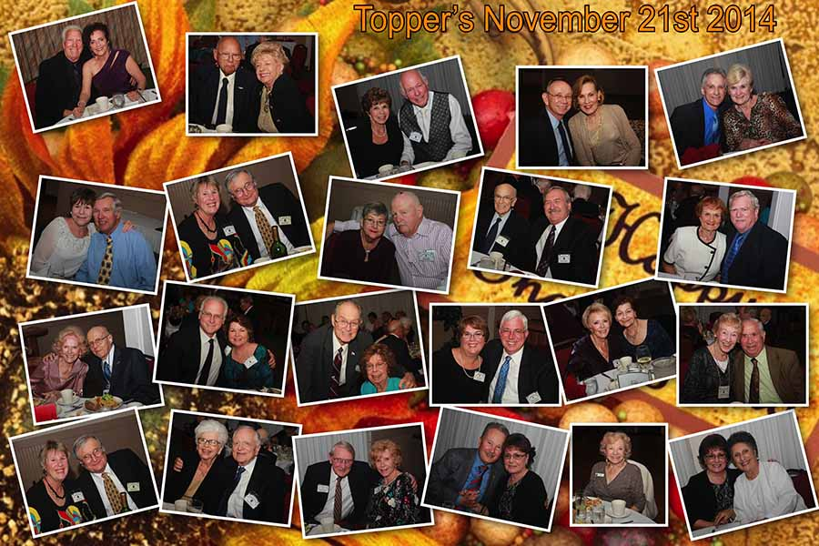

We started celebrating with our November pre-Thanksgiving dance

The February dance was excellent

It’s That Time Of Year

# Policy Notes

There are no refunds for cancellations made after the Tuesday before the dance as the arrangements are finalized Tuesday evening.

If you desire to sit with someone please note it with your check so we can attempt to satisfy your seating desires!

# What You Need To Know

The December 12th Mistletoe Ball is at the Petroleum Club and features the Batavia Band.

The cost is $110/couple (includes tax/tip).

No-host cocktail time is 6 pm & great dance music until 10 pm.

**Dress code is festive holiday attire OR black tie optional**

Toppers Dinner Menu

Garden Green Salad  
Fresh seasonal vegetables Rolls and butter

Entree: Bacon Wrapped Filet Mignon or Crab Crusted Salmon both with Twice Baked Potatoes or Vegetarian selection

Dessert: Chefs Selection. Coffee, tea or decaffeinated coffee.

# Mail your checks made out to “Toppers Dance Club” With Dinner Selections on the checks To

Diane Schmitz

3475 Lilly Avenue

Long Beach Ca 90808-3214

**Bit’s And Pieces**

New member contact information:

Dr. Richard Steiner and Frieda Mau  
3933 Via Solano  
Palos Verdes Estates, Ca 90274  
310-378-3086  
Rjsarrow@aol.com

Don and Linda Sebern  
11872 Martha Ann Dr  
Los Alamitos CA 90720  
562-596-0655  
dlsebern@msn.com

The Mistletoe Ball is open to members and guests. Please ask your friends to join the fun and help celebrate the holidays.

# Prepare To Be Greeted

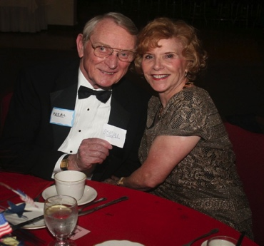

Neal & Nita Woolston

What A Great Dance!

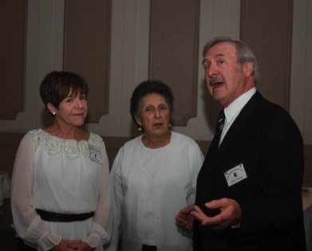

Meeting and greeting

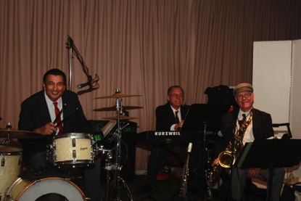

Time Machine

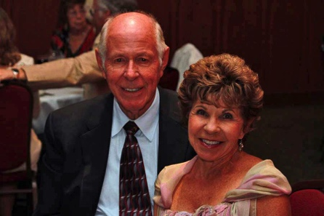  
Richard & Frieda  
New Members

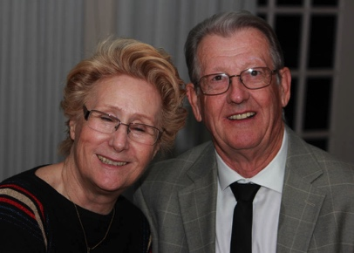  
Linda & Don Sebern   
New Members

# Upcoming Dance Schedule

01/16/2015 – Howard Solomon

02/20/2015 – Tony Carinio

03/20/2015 – Jim Gilman

# New Years Is Upon Us…

Goodness… It is time to get the resolution list out and start writing!

We have a suggestion! Come to all the 2015 Topper' dinner dances!

# Remember…

Christmas is a time when you get homesick - even when you're home. ~Carol Nelson

He who has not Christmas in his heart will never find it under a tree. ~Roy L. Smith



# Hanukkah…

Hanukkah is the festival of lights, commemorating the rededication of the Temple in Jerusalem after a successful revolt against the Seleucid Greeks. As part of the rededication, the victorious Jews needed to light the Temple's menorah (candelabrum), but they had only enough oil to last one day and it would take eight days to prepare more oil. Miraculously, the one-day supply of oil lasted for eight days. The miracle of the oil is commemorated with this eight-day candle lighting holiday.

# A Christmas Prayer……

May the spirit of Christmas bring you peace,

The gladness of Christmas give you hope,

The warmth of Christmas grant you love.

~Author Unknown

# About Our Website

Just Google “Toppers Dance Club” and our site will be the first on the search list!

**YOUR BOARD**

President Larry Isham

Vice President Dean Fronk

Past President Jerry Ellis

Secretary Lori Fronk

Treasurer Diane Schmitz

Hospitality Neil/Nita Woolston

Membership Vicky Kuhn

Roster Donnis Weygandt

Newsletter Paul/Sue Liles

Members At Large Gigi Isham, Dennis Schmitz, and Nancy Ellis.