An optimist is a person who starts a new diet on Thanksgiving Day. ~Irv Kupcinet

# *Presidents Message…*

The holiday season is here! Thanksgiving and Christmas are right around the corner. That means it is time to dance!

Please begin to think about the Mistletoe Ball as people make plans for the holidays well in advance.

December 12th is the Mistletoe Ball and the Petroleum Club will not be co-sponsoring it this year and to make it a viable dance, we need to have 75 people join in our fun.

So please think about friends, neighbors, or family that would like to partake in the Mistletoe Ball this year. Open invitation to anyone who would like to join us!

So plan to join us for our pre-Thanksgiving festivities on November 21st. The Time Machine will keep us dancing and shoo away those pesky calories.

Tony Carinino was hospitalized just before the last dance and we were fortunate to have Sam Conti and his band to fill in!

We also welcome two new member couples, Don and Linda Sebern of Rossmoor and Dr. Richard Steiner and Frieda Mau, all friends of the Liles’.

*Larry Isham,  
 President*

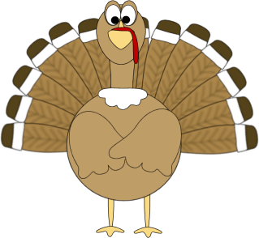

*￼￼*

Beware Of The Turkey

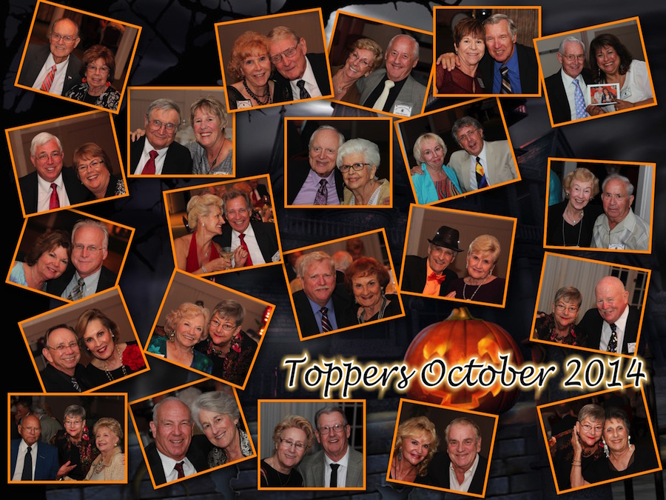

We all made it through the spooky dance…!

The February dance was excellent

It’s Invite A Calorie To Dinner Season… Must Dance!

# Policy Notes

There are no refunds for cancellations made after the Tuesday before the dance as the arrangements are finalized Tuesday evening.

If you desire to sit with someone please note it with your check so we can attempt to satisfy your seating desires!

# What You Need To Know

The November 21st dance will be at the Petroleum Club and will feature Time Machine.

The cost is $75/couple (includes tax/tip).

No-host cocktail time is 6 pm & great dance music until 10 pm.

**Dress code is Semi-Formal**

Toppers Dinner Menu

Garden Green Salad  
Fresh seasonal vegetables Rolls and butter

Entree: Turkey Breast with Dressing, Mashed Potatoes OR Grilled White Fish with Lemon Butter and Rice OR a Vegetarian Selection.

Dessert: Chefs Selection. Coffee, tea or decaffeinated coffee.

# Mail your checks made out to “Toppers Dance Club” With Dinner Selections on the checks To

Jerry Ellis

4507 Faculty Avenue

Long Beach, Ca 90808

**Bit’s And Pieces**

The Executive Board meets at 5:30 p.m. before each dance.

We currently have 65 members in the club as of 10/61/2014

Please see Donnis if did not get your new roster. She did an excellent job putting it together for us!

Remember to bring a guest as we love to meet new people and potentially increase the size of the club

We have two new couples: Don and Linda Sebern and Dr. Richard Steiner and Frita Mau joined.

Very happy to have you with us!

Their addresses and emails will be in the next Toppers Topics

# Prepare To Be Greeted

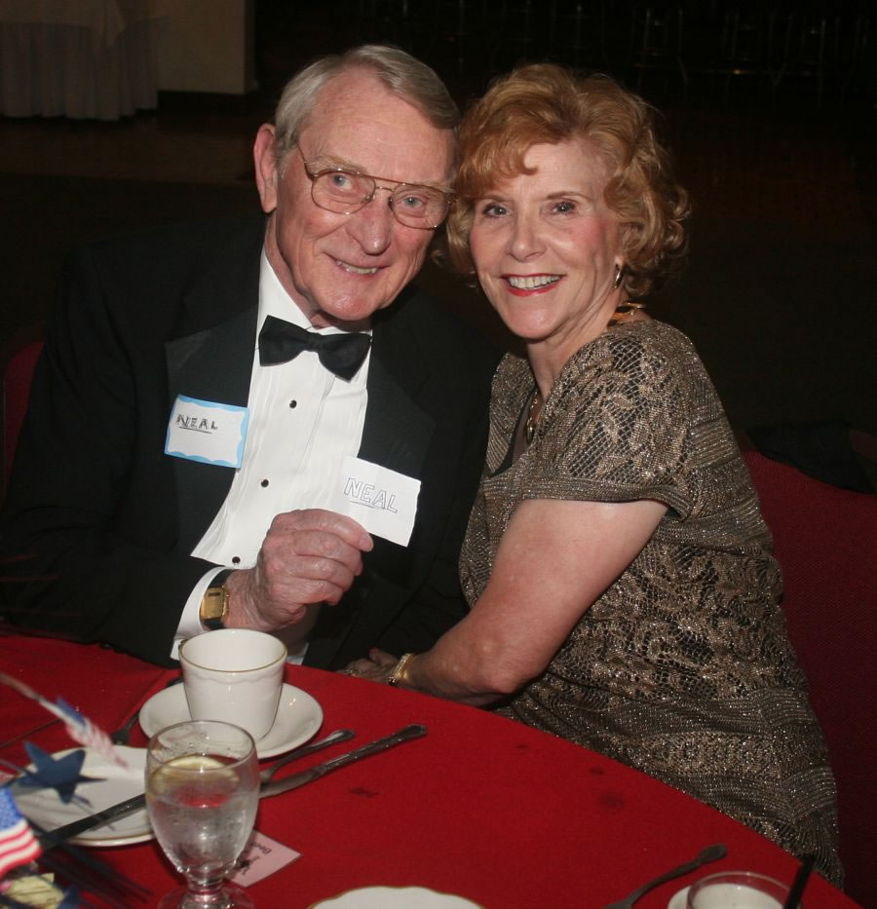

Neal & Nita Woolston

What A Great Dance!

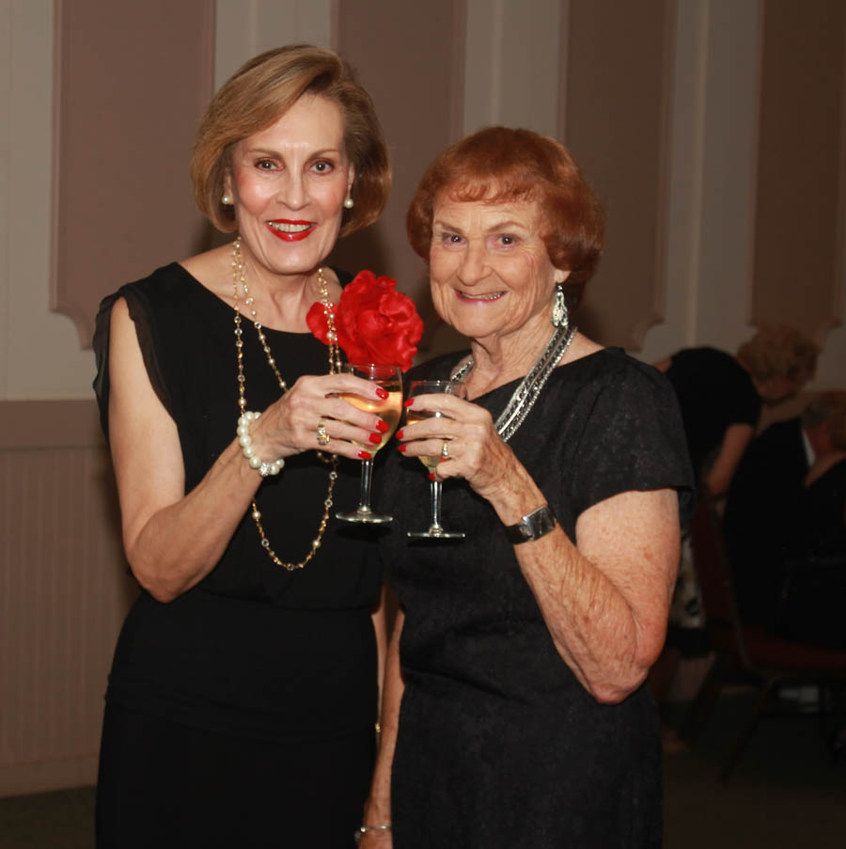

Meeting and greeting

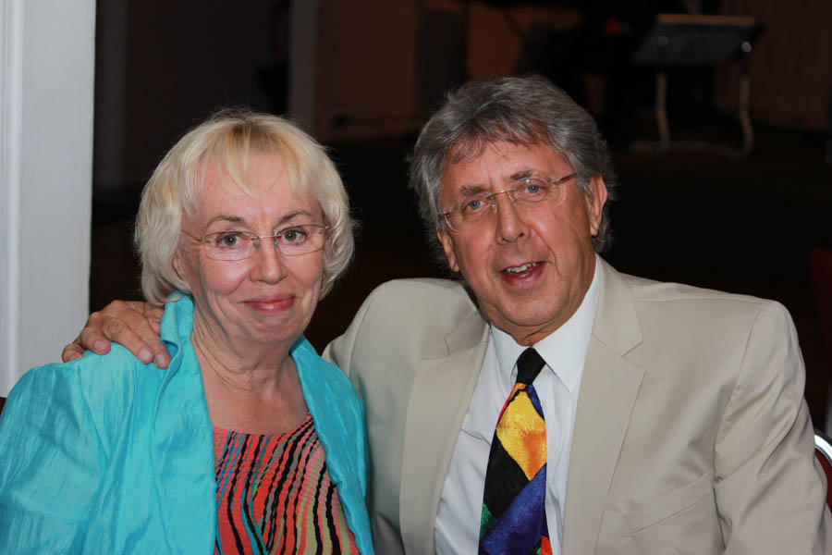

Jan & Brian from London

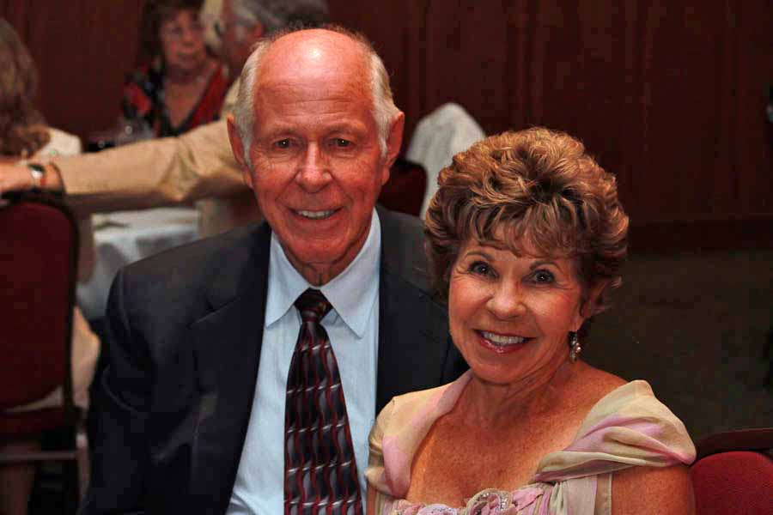  
Richard & Frieda  
New Members

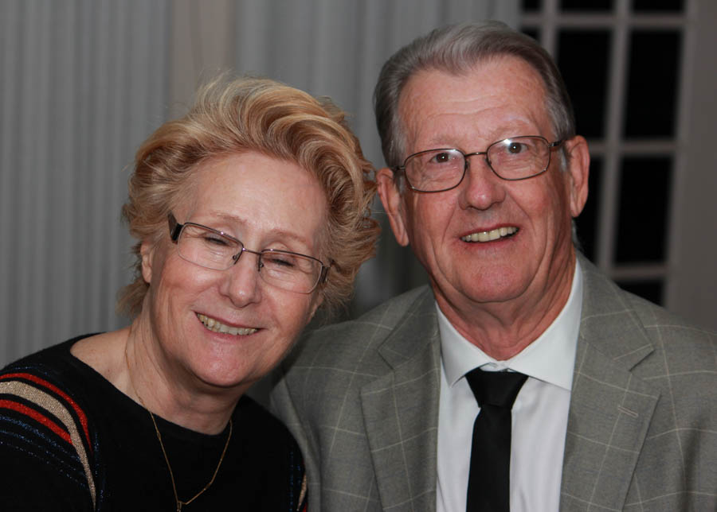  
Linda & Don Sebern   
New Members

# Upcoming Dance Schedule

11/21/2014 – Time Machine

12/12/2014 – The Mistletoe Ball will have the Batavia Band

The Mistletoe Ball will be a challenge as we need to guarantee 75 people! Please ask your friends!



# Thoughts About Thanksgiving

There is one day that is ours. There is one day when all we Americans who are not self-made go back to the old home to eat saleratus biscuits and marvel how much nearer to the porch the old pump looks than it used to. Thanksgiving Day is the one day that is purely American. ~O. Henry

# The Turkey Is Spared…

Since 1947, the National Turkey Federation has gifted a live Thanksgiving turkey to the White House, along with two butchered turkeys.

It's not known exactly when United States presidents began pardoning the White House Thanksgiving turkey, but the tradition is thought to be connected to Abraham Lincoln sparing a turkey named "Jack" from becoming the main dish in a holiday meal.

Today, the Annual Turkey Ceremony takes place in advance of Thanksgiving, and the public has the opportunity to name the spared turkey, who lives its remaining days at the Kidwell Farm, a petting zoo in Virginia.

# Looking For Safe And Sane Fun New Years Eve?

Our own Tracy Wells and his 16 piece big band will be at the Long Beach Airport Marriott Hotel New Years Eve. They have a fantastic sit down dinner and even have special stay over night packages!

# About Our Website

Just Google “Toppers Dance Club” and our site will be the first on the search list!

**YOUR BOARD**

President Larry Isham

Vice President Dean Fronk

Past President Jerry Ellis

Secretary Lori Fronk

Treasurer Diane Schmitz

Hospitality Neil/Nita Woolston

Membership Vicky Kuhn

Roster Donnis Weygandt

Newsletter Paul/Sue Liles

Members At Large Gigi Isham, Dennis Schmitz, Nancy Ellis, and Jack Taylor.