Autumn carries more gold in its pocket than all the other seasons.

# *Presidents Message…*

Where does the time go? It seems like summer went by in a flash… That is good because it means the dancing lamp is lit and we can get back to dancing!

Be prepared to regale us with your stories of summer vacation… Maybe we will pass around a piece of paper so you can share what you did and then put it in Topper’s Topics over the next several months!

Although Christmas is a long way off, we have a challenge ahead of us this year. The Petroleum Club will not be co-sponsoring the Mistletoe Ball this year and to make it a viable dance, we need to have 75 people join in our fun. So please think about friends, neighbors, or family that would like to partake in the Mistletoe Ball this year.

We are looking forward to seeing you on September 19th. Remember, try to bring a guest couple! We love to meet new friends and introduce them to the fun of a dance club!

See you soon!

*Larry Isham,  
 President*

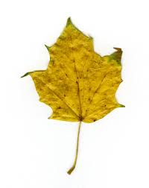

Fall Is Approaching

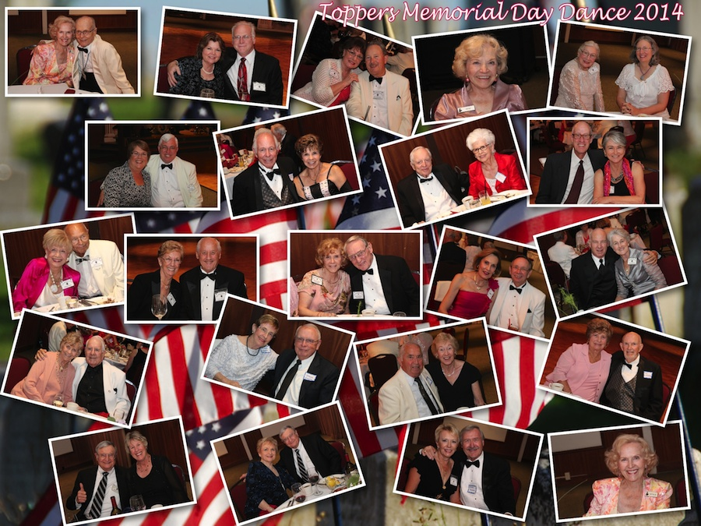

Great fun with great friends!

The February dance was excellent

Summer Is Almost Gone… Our First Dance This Season

# Policy Notes

There are no refunds for cancellations made after the Tuesday before the dance as the arrangements are finalized Tuesday evening.

If you desire to sit with someone please note it with your check so we can attempt to satisfy your seating desires!

# What You Need To Know

The September 19th dance will be at the Petroleum Club and will feature Howard Solomon.

The cost is $72/couple (includes tax/tip).

No-host cocktail time is 6 pm & great dance music until 10 pm.

**Dress code is Semi-Formal**

Toppers Dinner Menu

Garden Green Salad  
Fresh seasonal vegetables Rolls and butter

Entree: Chicken Piccata with Rice OR Grilled White Fish with Lemon Butter and Rice OR a Vegetarian Selection.

Dessert: Chefs Selection. Coffee, tea or decaffeinated coffee.

# Mail your checks made out to “Toppers Dance Club” With Dinner Selections on the checks To

Larry Isham  
2023 Ruhland Ave

Redondo Beach Ca 90278

**Bit’s And Pieces**

The Executive Board meets at 5:30 p.m. before each dance.

We currently have 61 members in the club as of 3/1/2014

The 11th annual Avalon Ball was quite fun. An evening of dancing in the great Avalon Ball Room with a 24-piece orchestra.

Remember to bring a guest as we love to meet new people and potentially increase the size of the club

Vicky and Del Kuhn became grandparents to Logan Delmar and they could not be happier!

Paul and Sue Liles became great grandparents to Lilliana Elizabeth Lind

# Prepare To Be Greeted

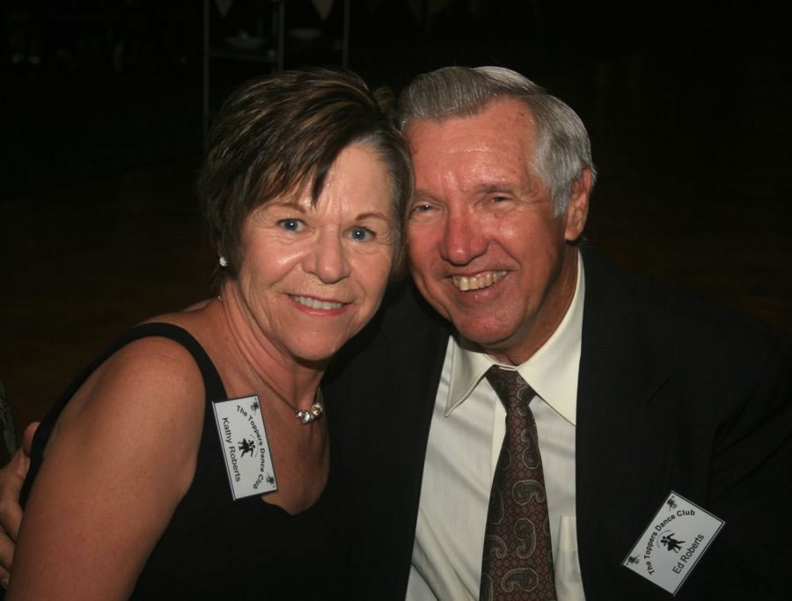

Kathy & Ed Roberts

What A Great Dance!

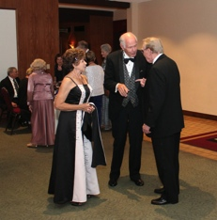

Meeting and greeting

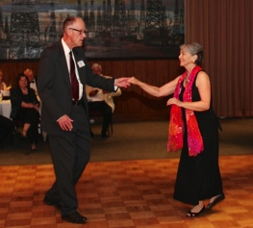

Rockin’ and Rollin’

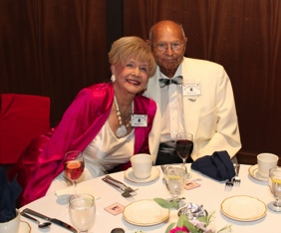  
Just watching

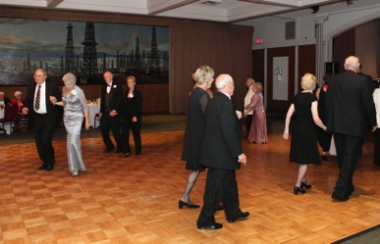  
Time for the mixer

# Upcoming Dance Schedule

We will be dark during the summer (June-July-August) but will return in September with the great sounds of Howard Solomon.

10/17/2014 – Tony Carinio

11/21/2014 – Time Machine

12/12/2014 – The Mistletoe Ball

The Mistletoe Ball will be a challenge as we need to guarantee 75 people! Please ask your friends!

THOUGHTS ABOUT AUTUMN

Is not this a true autumn day? Just the still melancholy that I love — that makes life and nature

harmonize. The birds are consulting about their migrations, the trees are putting on the hectic or the pallid hues of decay, and begin to strew the ground, that one’s very footsteps may not disturb the repose of earth and air, while they give us a scent that is a perfect anodyne to the restless spirit.

Delicious autumn! My very soul is wedded to it, and if I were a bird I would fly about the earth seeking the successive autumns. ~George Eliot, letter to Miss Lewis, 1st October 1841

# The Turkey Trot…

The turkey trot was a dance made popular in the early 1900s. The Turkey Trot was done to fast ragtime music popular in the decade from 1900 to 1910 such as Scott Joplin's Maple Leaf Rag. It lost favor to the Foxtrot in 1914.

The basic step consisted of four hopping steps sideways with the feet well apart, first on one leg, then the other with a characteristic rise on the ball of the foot, followed by a drop upon the heel. The dance was embellished with The whole room is moving

scissor-like flicks of the feet and fast trotting actions with abrupt stops.

# About Our Website

Just Google “Toppers Dance Club” and our site is first on the search list!

**YOUR BOARD**

President Larry Isham

Vice President Dean Fronk

Past President Jerry Ellis

Secretary Lori Fronk

Treasurer Diane Schmitz

Hospitality Neil/Nita Woolston

Membership Vicky Kuhn

Roster Donnis Weygandt

Newsletter Paul/Sue Liles

Members At Large Gigi Isham, Dennis Schmitz, Nancy Ellis, and Jack Taylor.