True friendship comes when silence between two people is comfortable. ~Dave Tyson Gentry

# *Presidents Message…*

May means Memorial Day and our formal dance prior to going dark during June, July, and August! It seems the year went so fast but it brought us great memories of dining and dancing with friends.

Please bring a friend to our dances and let’s continue to grow the club. The more the merrier!

Memorial Day this year is especially important as we are reminded almost daily of the great sacrifices that the men and women of the Armed Services make to defend our way of life.

Although Christmas is a long way off, we have a challenge ahead of us this year. The Petroleum Club will not be co-sponsoring the Mistletoe Ball this year and to make it a viable dance, we need to have 75 people join in on our fun. So please think about friends, neighbors, or family that would like to partake in the Mistletoe Ball this year.

We are looking forward to seeing you on May 16th with Time Machine. Remember, try to bring a guest couple! We love to meet new friends and introduce them to the fun of a dance club!

See you soon!

*Larry Isham,  
 President*

**

Spring Has Sprung!



Great fun with great friends!

The February dance was excellent

Summer Is On It’s Way… Our Last Dance This Season

# Policy Notes

There are no refunds for cancellations made after the Tuesday before the dance as the arrangements are finalized Tuesday evening.

If you desire to sit with someone please note it with your check so we can attempt to satisfy your seating desires!

# What You Need To Know

The May 16th dance will be at the Petroleum Club and will feature Time Machine.

The cost is $86/couple (includes tax/tip).

No-host cocktail time is 6 pm & great dance music until 10 pm.

**Dress code is Formal**

Toppers Dinner Menu

Garden Green Salad  
Fresh seasonal vegetables Rolls and butter

Entree: Broiled New York Cut Steak served Au Jus with Scalloped Potatoes OR Grilled Salmon with Hollandaise Sauce with Rice OR a Vegetarian Selection.

Dessert: Chefs Selection. Coffee, tea or decaffeinated coffee.

# Mail your checks made out to “Toppers Dance Club” With Dinner Selections on the checks To

Diane Schmitz  
3475 Lilly Ave  
Long Beach, CA 90808

**Bit’s And Pieces**

The Executive Board meets at 5:30 p.m. before each dance.

We currently have 61 members in the club as of 3/1/2014

May 17th is the 11th annual Avalon Ball. Enjoy an evening of dancing in the great Avalon Ball Room with a 24-piece orchestra. See Paul or Sue Liles for details.

If you are interested in serving on the board, please see the job descriptions for the President and Vice-President.

Remember to bring a guest as we love to meet new people and potentially increase the size of the club

# Prepare To Be Greeted

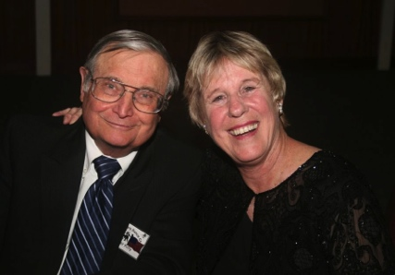

Walter & Terey Kroy

What A Great Dance!

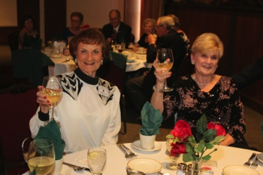

Here’s to you!



Guests Beverly & George

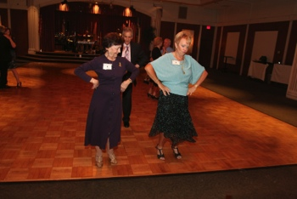  
Our Hula champs

  
Great to see Irene join us



Thanks you Greeters

Thoughts About Memorial Day…

On thy grave the rain shall fall from the eyes of a mighty nation! ~Thomas William Parsons

Although no sculptured marble should rise to their memory, nor engraved stone bear record of their deeds, yet will their remembrance be as lasting as the land they honored. ~Daniel Webster

With the tears a Land hath shed

Their graves should ever be green.

~Thomas Bailey Aldrich

Are they dead that yet speak louder than we can speak, and a more universal language? Are they dead that yet act? Are they dead that yet move upon society and inspire the people with nobler motives and more heroic patriotism? ~Henry Ward Beecher

# The Office Of President…

In case you are interested in volunteering to join the board, consider these offices:

The President shall carry on the business of the Club as required by the Executive Board and may call a meeting before each dance, or whenever necessary with seven days’ notice to the board members. Along with the other business, final arrangements for the next scheduled dance on the calendar will be made.

In the absence of the President, the Vice President shall preside. The Vice President shall act as Master of Ceremonies at the dances.

# About Our Website

Just Google “Toppers Dance Club” and our site is first on the search list!

# Upcoming Dance Schedule

We will be dark during the summer (June-July-August) but will return in September with the great sounds of Howard Solomon.

9/19/2014 – Howard Solomon

10/17/2014 – Tony Carinio

11/21/2014 – Time Machine

The Mistletoe Ball date will be provided in the next newsletter and remember to plan to bring family and friends!

**YOUR BOARD**

President Larry Isham

Vice President Dean Fronk

Past President Jerry Ellis

Secretary Lori Fronk

Treasurer Diane Schmitz

Hospitality Neil/Nita Woolston

Membership Vicky Kuhn

Roster Donnis Weygandt

Newsletter Paul/Sue Liles

Members At Large Gigi Isham, Dennis Schmitz, Nancy Ellis, and Jack Taylor.