

The January dance was excellent

“Welcome to the New Year…..”

# *Presidents Message…*

We hope your Valentines Day was very special! Our dance this month is in between St. Valentines Day and St. Patrick’s Day. That means red and green so you can wear your Christmas outfits!

Remember to update your Toppers Membership Roster. The new members are Tracy & Carmen Wells, and Gilles & Gisele Mongeau. Their addresses, phone numbers and emails are on page two! Welcome to Toppers!

Thinking about St. Valentines Day, we found this quote to share with you:

“Love - a wildly misunderstood although highly desirable malfunction of the heart which weakens the brain, causes eyes to sparkle, cheeks to glow, blood pressure to rise and the lips to pucker.”

I have had the honor of being the president for the past two years and hope someone will volunteer to take the reins next year! It’s a fun job but it is time to share with others! Do you have a suggestion?

We are looking forward to seeing you on the 21st and if you can, bring a guest couple! The more the merrier!

*Larry Isham,  
 President*

**

It’s Time For Valentines Day

# Policy Notes

There are no refunds for cancellations made after the Tuesday before the dance as the arrangements are finalized Tuesday evening.

If you desire to sit with someone please note it with your check so we can attempt to satisfy your seating desires!

# What You Need To Know

The February 21st dance will be at the Petroleum Club and will feature Howard Solomon.

The cost is $78/couple (includes tax/tip).

No-host cocktail time is 6 pm & great dance music until 10 pm.

**Dress code is semi-formal**

Toppers Dinner Menu

Garden Green Salad  
Fresh seasonal vegetables. Rolls and butter.

Entree: Roast Tri-Tip Tender Beef served with Bordelaise Sauce and Mashed Potatoes OR Baked Salmon with Hollandaise Sauce and Rice OR a Vegetarian Selection.

Dessert: Chefs Selection. Coffee, tea or decaffeinated coffee.

# Mail your checks made out to “Toppers Dance Club” With Dinner Selections on the checks To

Larry Isham   
2023 Ruhland

Redondo Beach Ca 90278

# Your Board

President Larry Isham  
Vice President Dean Fronk  
Past President Jerry Ellis  
Secretary Lori Fronk  
Treasurer Diane Schmitz  
Hospitality Neil/Nita Woolston  
Membership Vicky Kuhn  
Roster Donnis Weygandt  
Newsletter Paul/Sue Liles  
Members At Large Gigi Isham, Dennis Schmitz, Nancy Ellis, and Jack Taylor.

The Executive Board meets at 5:30 p.m. before each dance. Need a Toppers name badge, let Neal Woolston know!

# Prepare To Be Greeted

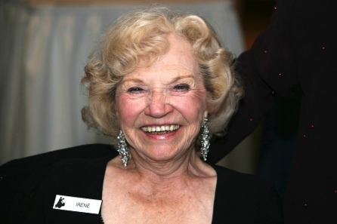

Irene Johnson

What A Great Dance!



Smiles and smiles

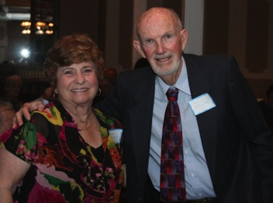

Welcome guests

  
Singing Happy Birthday

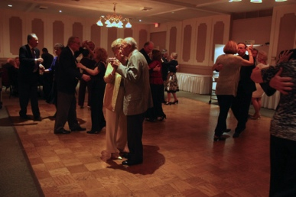  
Catching up with friends

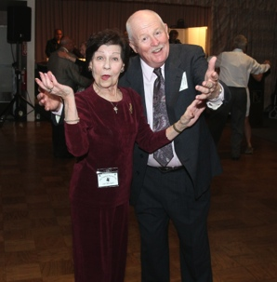

Dance time!

Join Up!

Invite a guest couple or come and meet a guest couple! Invite them back and enjoy seeing new people meld into the fabric of our great club.

Keeping the club viable is everybody’s responsibility.

Fun Dance Facts!

A world record for the longest conga dance line was set by 119,986 people in Miami in 1988.

In 2008, the world’s first “sustainable” dance floor opened at Club Watt in Rotterdam, Sweden. The floor’s tiles each sit on springs hooked up to generators. The harder people dance, the more the springs are compressed and this converts into energy, which runs the LED lights in the floor.

You may know Tupac Shakur as the late rapping legend of the late 80s and early 90s, but what you may not know is that he used to do ballet! He became a member of the 127th Street Ensemble, a Harlem based theater company.

Dancers have better average peripheral vision. Even If they do not turn their heads, they could clearly see what's on their peripheral vision.

# About Our Website

We keep a history of our dances “on-line” so we can go back in time and visit the good times.

Just Google “Toppers Dance Club” and our site is first on the search list!

# Upcoming Dance Schedule

3/21/2014 - Jim Gilman

4/18/2014 – Tony Carino

5/16/2014 – Time Machine

Jun – August – Dark

Note: Our new band for January was “FreeLance Express” featuring Dan Sigarlati

# Roster Updates

Add: Tracy & Carmen Wells

3116 Claremore

Long Beach, Ca 90808

562-596-8683

bigswingband@verizon.com

Add: Gilles & Gisele Mongeau

9725 Whiteland

Pico Rivera, Ca 90660

562-949-4264

ggmongeau@msn.com