# *Presidents Message…*

Fall has finally arrived and the time has changed. On the bright side we have the holiday season directly in front of us!

We hope you had a great Halloween and got your bags filled with candy or perhaps a glass of wine?

Remember to get your updated Roster which contains all the dates for this dance season. See Donnis.

We also have a new tri-fold brochure about the club. Great for potential members. See the Fronks.

Welcome Charlie and Sandy Slater, our newest members!

Come and join us at the November dance and put Friday the 13th of December on your calendar for the Mistletoe Ball! Bring a friend!

*Larry Isham, President*

*As O’Henry Would Say….*

There is one day that is ours.  There is one day when all we Americans who are not self-made go back to the old home to eat saleratus biscuits and marvel how much nearer to the porch the old pump looks than it used to.  Thanksgiving Day is the one day that is purely American.  ~O. Henry

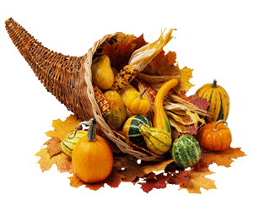

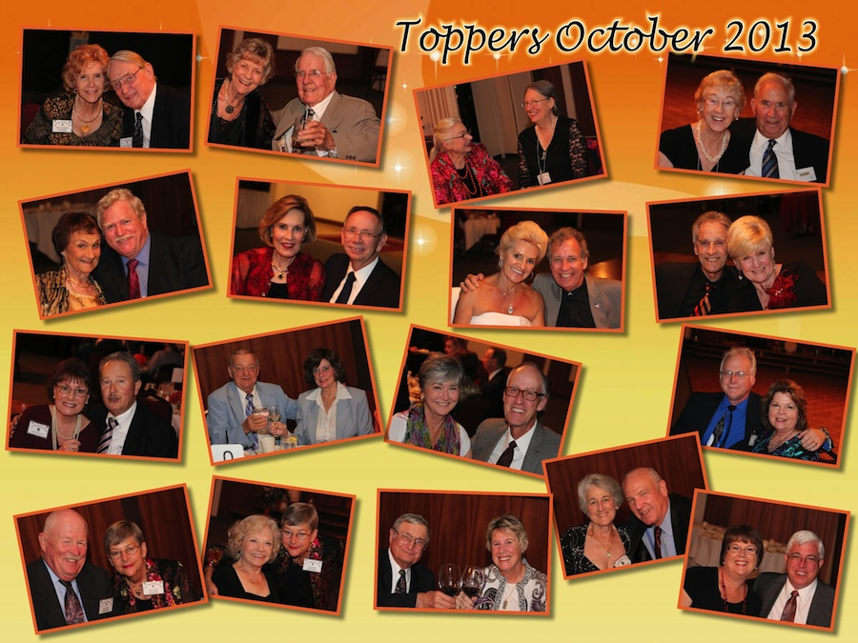

Fun with the Toppers

Remember our last dance?

“Autumn...the year's last, loveliest smile.”

Time To Give Thanks

# Policy Notes

There are no refunds for cancellations made after the Tuesday before the dance as the arrangements are finalized Tuesday evening.

If you desire to sit with someone please note it with your check so we can attempt to satisfy your seating desires!

# What You Need To Know

The November 15th dance will be at the Petroleum Club and will feature Tony Carinio.

The cost is $75/couple (includes tax/tip).

No-host cocktail time is 6 pm & great dance music until 10 pm.

Dress code is semi-formal

Toppers Dinner Menu

Fresh Green Garden Salad w/ Dressings

Roasted Turkey-Breast with Cornbread Stuffing and Cranberry Sauce or Grilled White Fish with Lemon Butter or Vegetarian Selection.

Warm bread and butter, Chef’s selection Dessert, coffee and tea.

# Mail your checks made out to “Toppers Dance Club” With Dinner Selections on the checks To

Diane Schmitz   
3475 Lilly Ave

Long Beach Ca 90808

# Prepare To Be Greeted

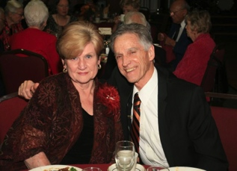

Lucky and Carolyn will greet everyone

What A Great Dance!

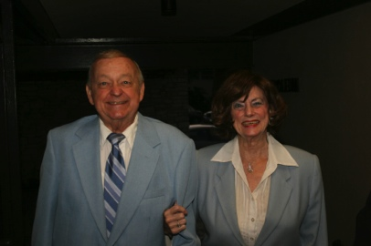

Smiles and smiles

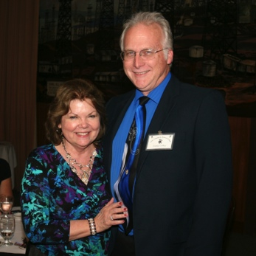

The Colbys

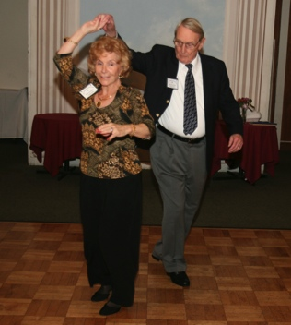  
Cutting the rug

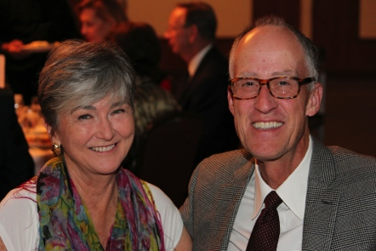  
Charlie and Sandy Slater

It’s Thanksgiving Time

Thanksgiving, or Thanksgiving Day, is a holiday celebrated in the United States on the fourth Thursday in November. It has been an annual tradition since 1863, when, during the Civil War, President Abraham Lincoln proclaimed a national day of "Thanksgiving and Praise to our beneficent Father who dwelleth in the Heavens", to be celebrated on Thursday, November 26. As a federal and popular holiday in the U.S., Thanksgiving is one of the major holidays of the year. Together with Christmas and New Year, Thanksgiving is a part of the broader holiday season.

The event that Americans commonly call the "First Thanksgiving" was celebrated by the Pilgrims after their first harvest in the New World in 1621.

This feast lasted three days, and was attended by about 53 Pilgrims and 90 American Indians.

The New England colonists were accustomed to regularly celebrating "thanksgivings"—days of prayer thanking God for blessings such as military victory or the end of a drought.

Centerpieces

Special thanks to Nita Woolston for getting our centerpieces that grace our tables.

# About Our Website

We keep a history of our dances “on-line” so we can go back in time and visit the good times.

Just Google “Toppers Dance Club” and our site is first on the search list!

# Your Board

President Larry Isham  
Vice President Dean Fronk  
Past President Jerry Ellis  
Secretary Lori Fronk  
Treasurer Diane Schmitz  
Hospitality Neil/Nita Woolston  
Membership Vicky Kuhn  
Roster Donnis Weygandt  
Newsletter Paul/Sue Liles  
Members At Large Gigi Isham, Dennis Schmitz, Nancy Ellis, and Jack Taylor.

The Executive Board meets at 5:30 p.m. before each dance. Need a Toppers name badge, let Neal Woolston know!

# Be A Greeter And Meet Everyone

See Neal or Nita and volunteer to be a greeter for one of the upcoming dances. It’s fun to meet everyone and a great way to remember names and faces!

# Bring A Guests

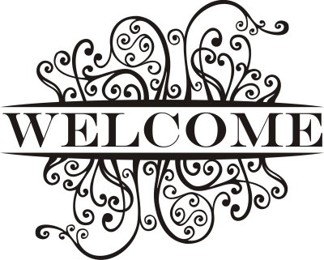

Guests are always welcome

Please consider inviting friends to our future dances as we want to meet new people.

# Upcoming Dance Schedule

12/13/2013 – It’s the Mistletoe Ball and time to drag out the formals. forrrrfoals.tuxedosowns