There are short-cuts to happiness, and dancing is one of them. ~Vicki Baum

# *Presidents Message…*

Welcome Kathy Strong, daughter of Bette and Gordon Rankin! We were delighted to meet you but so sorry you came to take Mom and Dad home to Texas! Our best wishes to the Rankins!

Be prepared for the Honor Guard to celebrate Memorial Day!

This is the last dance before the Summer break! We have had a great year of friendship, dancing, and adding new members. We are looking forward to everybody coming to the next dance.

See you on the 17th and be ready to dance to Jim Gilman…

*Larry Isham,  
 President*

*We Have New Members…*

Roy Mabee & Dori Miller  
2651 W. Lincoln Ave  
Anaheim, Ca 92801

714-860-8875  
No email  
  
Gary & Marion Gray  
2537 Nearcliff Street

Torrance, Ca 90505-7033

[Marion2537@aol.com](mailto:Marion2537@aol.com)

310-326-3241

Wallace & Ghislaine Rodecker  
6211 E. 6th Street

Long Beach, Ca 90803-2117

[rodeckerwg@msn.com](mailto:rodeckerwg@msn.com)

562-430-2476

*We Are On The Web…*

**http://tinyurl.com/caxumar**

The Summer Break Is Upon Us…



Remember our last dance?

# Policy Notes

There are no refunds for cancellations made after the Tuesday before the dance as the arrangements are finalized Tuesday evening.

If you desire to sit with someone please note it with your check so we can attempt to satisfy your seating desires!

# What You Need To Know

The May 17th dance will be at the Petroleum Club and will feature Jim Gilman.

The cost is $95/couple (includes tax/tip).

No-host cocktail time is 6 pm & great dance music until 10 pm.

Dress code is formal

Toppers Dinner Menu

Fresh Green Garden Salad w/ Dressings

New York Cut Steak Au Jus or Fish Of The Day or Vegetarian selection. Served with Chefs fresh seasonal vegetables and mashed potatoes. Warm bread and butter.

Chocolate Cream Pie, coffee and tea.

# Mail your checks made out to “Toppers Dance Club” With Dinner Selections on the checks To

Diane Schmitz   
3475 Lilly Ave

Long Beach Ca 90808

# Your Board

President Larry Isham  
Vice President Dean Fronk  
Past President Jerry Ellis  
Secretary Lori Fronk  
Treasurer Diane Schmitz  
Hospitality Neil/Nita Woolston  
Membership Bob Potthast  
Roster Joyce Rothrock  
Newsletter Paul/Sue Liles  
Members At Large Gigi Isham, Dennis Schmitz, Nancy Ellis, and Jack Taylor.

The Executive Board meets at 5:30 p.m. before each dance. Need a Toppers name badge, let Neal Woolston know!

# Prepare To Be Greeted

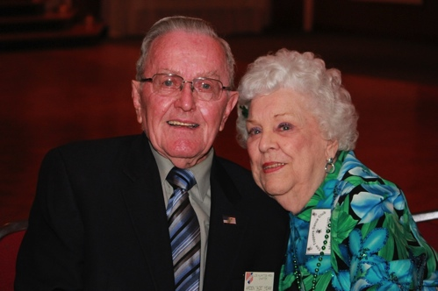

Ace & Martha Yeam

What A Great Dance!

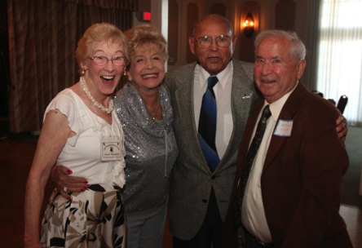

New Friendships

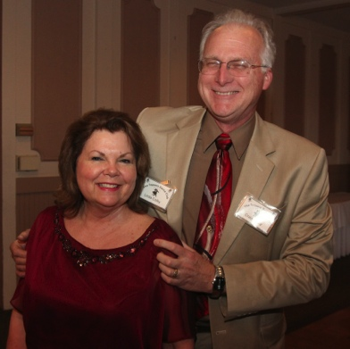

The Colby’s - Miles of smiles

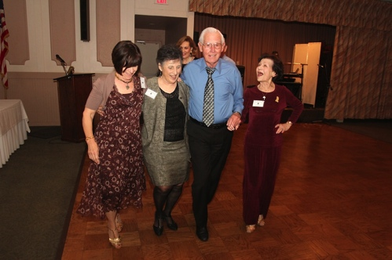Ten step polka, anyone??

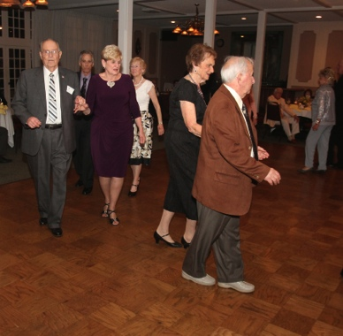  
The Mixer is always popular

The Summer Break Cometh…

June, July, and August are “dark” months for the Topper’s. We get to rest and brush up on some new dance steps! See you in September… Sounds like a great title for a song!

Remember to email the Liles’ with any tidbits about the summer break so they can be put into the next newsletter.

Thank You Volunteers!

We needed to fill two officers jobs and we had volunteers step right up to assist. The membership will get to approve the new board in September.

Vicky Kuhn has offered to be the Membership Officer taking over from Bob Potthast.

Joyce Rothrock has done a super job and providing us a roster but she is ready to move on and Donnis Weygandt has volunteered.

Thoughts About Summer

“Because it’s summer and the memories are just waiting to happen.” ~ Unknown

# About Our Website

We keep a history of our dances “on-line” so we can go back in time and visit the good times.

Remember you can send the link you your non-member friends and family to show them what you are up to and how much fun they are missing.

Just Google “Toppers Dance Club” and our site is first on the searchlist!

# Upcoming Dance Schedule

9/20/2013 – Back from our summer break and ready to dance!

# Our Guests!



John and Ernie Schulte

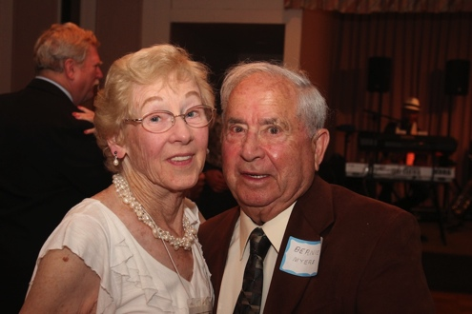

Donnis invited Bernie Myers as a guest

Please consider inviting friends to our future dances as we want to meet new people.