# *Presidents Message…*

Watch out for the Leprechauns! They take the form of an old man, clad in a red or green coat, who enjoys partaking in mischief . . . Sounds like a lot of us! It is rumored that they like to dance at Topper’s.

May your blessings outnumber  
The shamrocks that grow,  
And may trouble avoid you  
Wherever you go.  
~Irish Blessing

Remember to visit our website at: http://www.lilesnet.com/toppers/index.htm

See you on the 15th and be ready to dance to The Time Machine.

*Larry Isham,  
 President*

*Remember This Tune…*

When Irish eyes are smiling, sure 'tis like a morn in spring.  
In the lilt of Irish laughter you can hear the angels sing,  
When Irish hearts are happy all the world seems bright and gay,  
And when Irish eyes are smiling, sure, they steal your heart away.

~Chauncey Olcott and George Graff, Jr. (lyrics), Ernest R. Ball (music)



Saint Patrick’s Day Is Here



Remember our last dance?

Figure 1Sea

Figure 2 We danced in a sea of red

# Policy Notes

There are no refunds for cancellations made after the Tuesday before the dance as the arrangements are finalized Tuesday evening.

If you desire to sit with someone please note it with your check so we can attempt to satisfy your seating desires!

# What You Need To Know

The March 15th dance will be at the Petroleum Club and will feature the Time Machine.

The cost is $74/couple (includes tax/tip).

No-host cocktail time is at 6 pm and great dance music until 10 pm.

Dress code is semi-formal

Toppers Dinner Menu

Fresh Green Garden Salad w/ Dressing

Chicken Fajitas or Fish of the Day or Vegetarian with Mixed Vegetables and Spanish Rice

Caramel Custard

Hot bread and butter, coffee and tea.

# Mail your checks made out to “Toppers Dance Club” With Dinner Selections on the checks To

Diane Schmitz   
3475 Lilly Ave

Long Beach Ca 90808

Never iron a four-leaf clover, because you don't want to press your luck.

# Your Board

President Larry Isham  
Vice President Dean Fronk  
Past President Jerry Ellis  
Secretary Lori Fronk  
Treasurer Diane Schmitz  
Hospitality Neil/Nita Woolston  
Membership Bob Potthast  
Roster Joyce Rothrock  
Newsletter Paul/Sue Liles  
Members At Large Gigi Isham, Dennis Schmitz, Nancy Ellis, and Jack Taylor.

The Executive Board meets at 5:30 p.m. before each dance. Need a Toppers name badge, let Neal Woolston know!

**Prepare To Be Greeted**

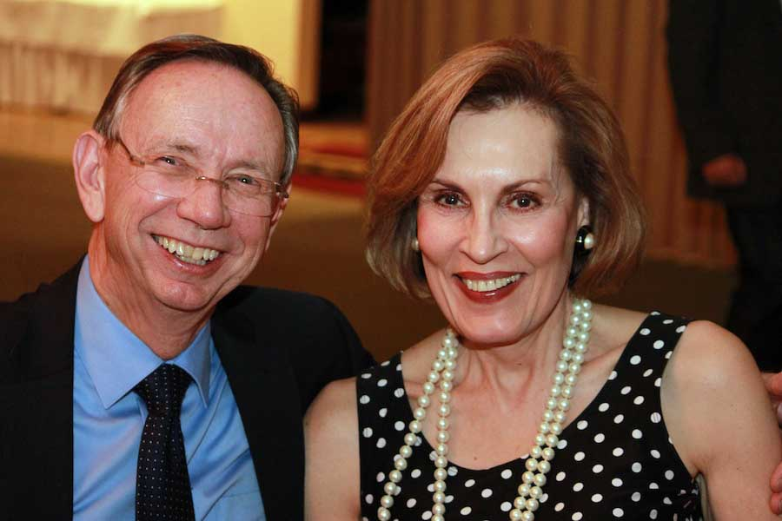

Tom and Kathy Berg

What A Great Dance!

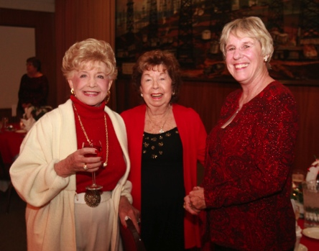

Valentine’s Day Reds

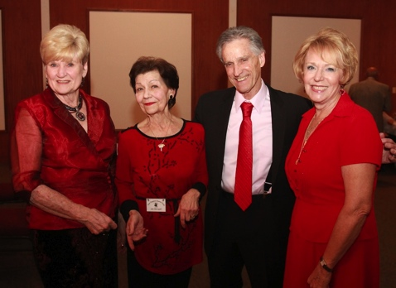

Miles of smiles

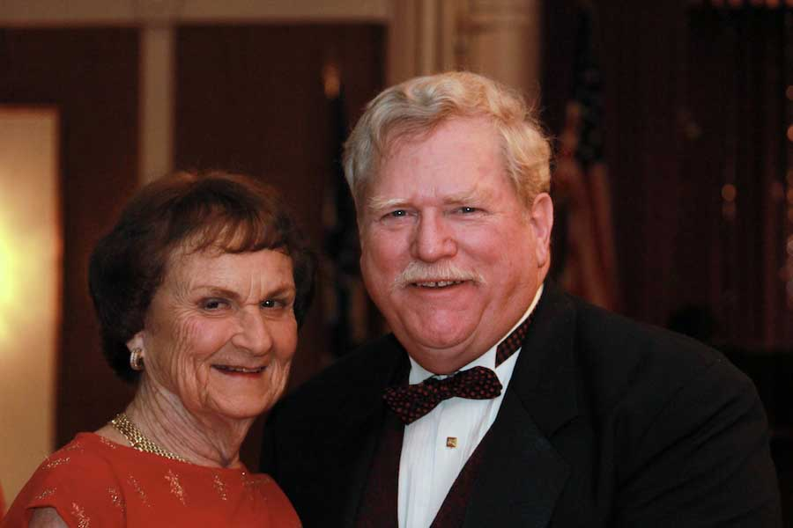Guests Marion and Gary Gray

  
OK guys! Let’s dance

How Interesting!

Saint Patrick was born to Catholic parents about 385 in Britain. His father was a nobleman and a deacon. But Saint Patrick's privileged life came to an end at age 16 when he was captured by slave raiders from Ireland. With a large group of prisoners, Saint Patrick was transported to the then pagan island.

Sold as a slave to a king in the northeast, Saint Patrick had the lonely task of tending the pigs and sheep. In the midst of these harsh living conditions, Patrick's faith flourished as he turned to God in prayer.

After being held captive for six years, Saint Patrick heard a voice in his sleep say, "Soon you will go back to your homeland." A short time later, he heard the same voice say, "Your ship is ready."

Trusting in God, Saint Patrick set out on a 200-mile journey through unknown territory. When he arrived at the ship, the captain at first refused to take him. But Patrick prayed to God for help, and the captain changed his mind. Then began a lifetime of dedicating his life to becoming a priest. He envisioned returning to Ireland to teach the Irish about Christianity. Saint Patrick died a natural death on March 17, 461.

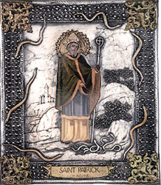

Saint Patrick

# Bits And Pieces

Paul & Sue Liles visited and had lunch with Angie Erceg. She is doing just fine and asked about everyone.



Please consider inviting friends to our future dances as we want to meet new people.

We hope our guests return: Wally and Ghesliene Rodecker, Dori Miller and Roy Maybee, Marianne Hanlon and Craig Goll, and Marion and Gary Gray.

# Upcoming Dance Schedule

4/19/2013 – Tony Carinio