It’s Time For Thanksgiving Already

# *Presidents Message…*

Time seems to be flying at a rocket’s pace! It’s already time for Thanksgiving and Christmas is less than two months away! In ten weeks it will be 2013!

You know what that means…. Time to dance with the Topper’s.

Bring some friends to the dance and let’s see if we can increase our membership over these holidays! New members mean new friends and opportunities to share.

Thanks to Joyce Rothrock for the fine job in putting together the membership booklet!

*Larry Isham,  
 President*

# ***Thanksgiving Thoughts****…*

As we express our gratitude, we must never forget that the highest appreciation is not to utter words, but to live by them. ~John Fitzgerald Kennedy

Thanksgiving dinners take eighteen hours to prepare. They are consumed in twelve minutes. Half-times take twelve minutes. This is not coincidence. ~Erma Bombeck

**



Remember our last dance?

Figure 1Sea

Figure 2 We danced in a sea of red

# Policy Notes

There are no refunds for cancellations made after the Tuesday before the dance as the arrangements are finalized Tuesday evening.

If you desire to sit with someone please note it with your check so we can attempt to satisfy your seating desires!

# What You Need To Know

The November 16th dance will be at the Petroleum Club and will feature the Tony Carinio Band.

The cost is $70/couple (includes tax/tip).

No-host cocktail time is at 6 pm and great dance music until 10 pm.

Dress code is semi-formal.   
  
Toppers Dinner Menu

California mixed green salad with dressing on the table.

Roast turkey breast with dressing, mashed potatoes, vegetables, and cranberry sauce or Fish of the day or Vegetarian dish.

Hot bread and butter, dessert, Coffee and tea.

# Mail your checks made out to “Toppers Dance Club” With Dinner Selections on the checks To

Diane Schmitz   
3475 Lilly Ave

Long Beach Ca 90808

Autumn is a second spring when every leaf is a flower.  ~Albert Camus

# Your Board

President Larry Isham  
Vice President Dean Fronk  
Past President Jerry Ellis  
Secretary Lori Fronk  
Treasurer Diane Schmitz  
Hospitality Neil/Nita Woolston  
Membership Bob Potthast  
Roster Joyce Rothrock  
Newsletter Paul & Sue Liles  
Member At Large Gigi Isham, Dennis Schmitz, Nancy Ellis, Jack Taylor, and Meretta Potthast

The Executive Board meets at 5:30 p.m. before each dance. Need a Toppers name badge, let an officer know!

**Prepare To Be Greeted**

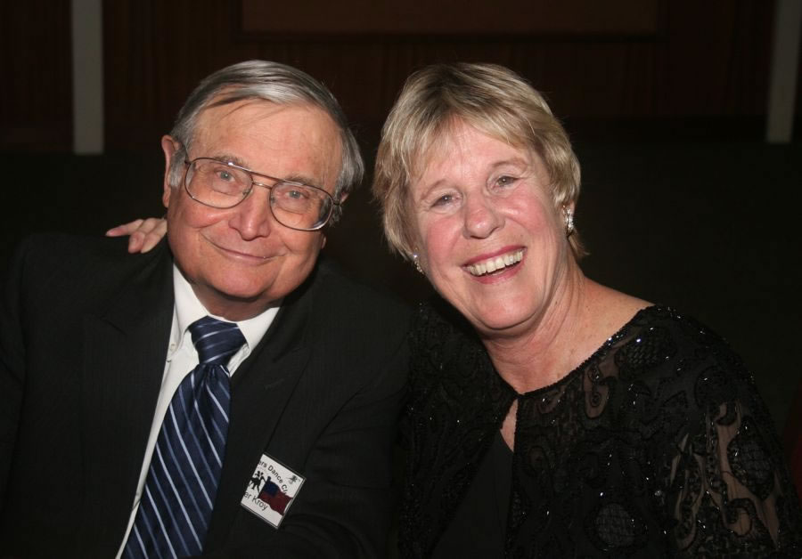

Walter and Terey Kroy

What A Great Dance!

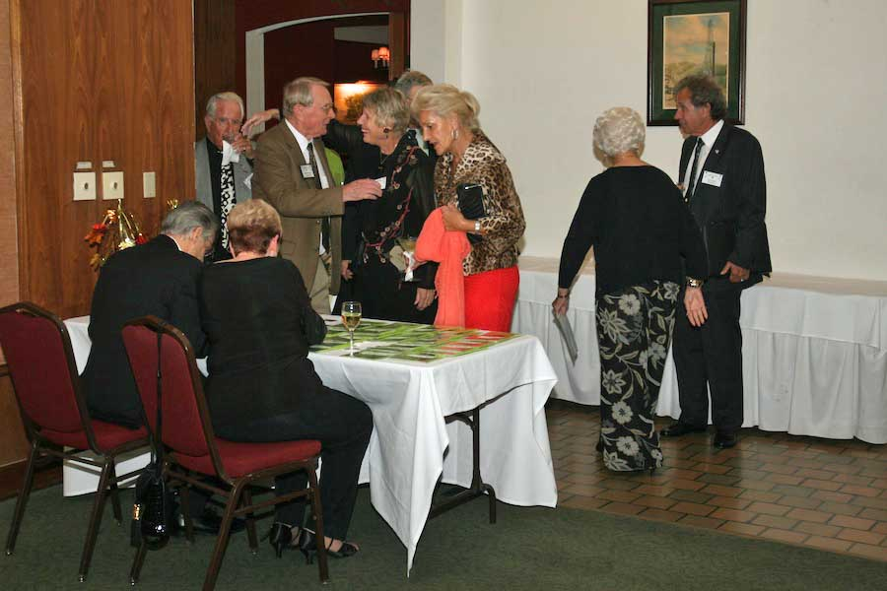

Greeters were busy

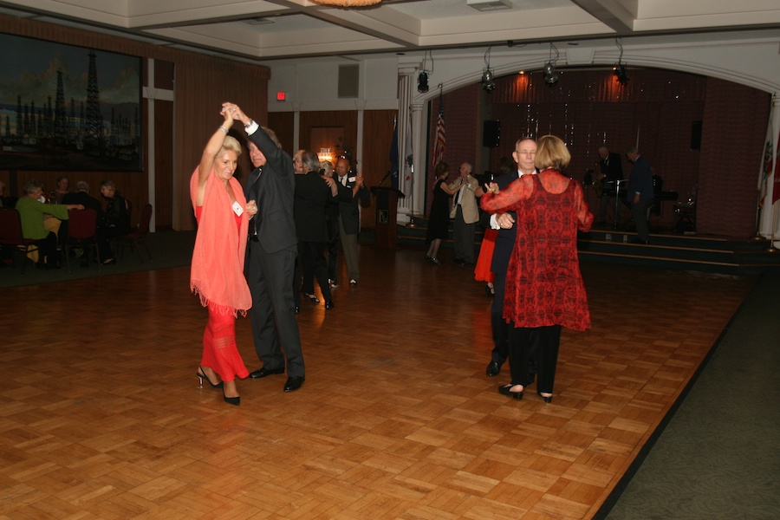

Turn turn turn

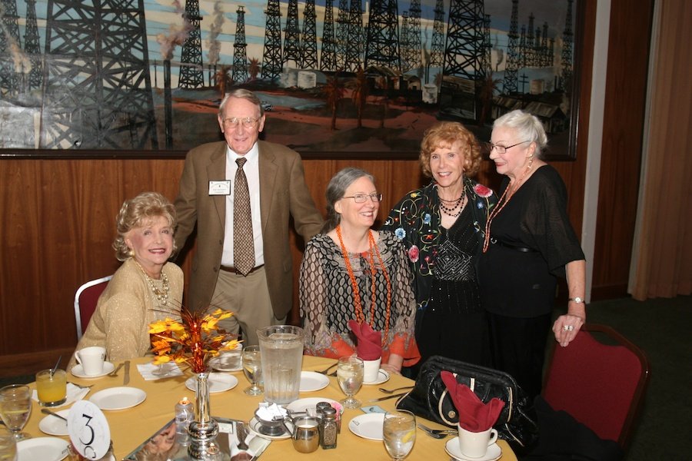Visiting begins!

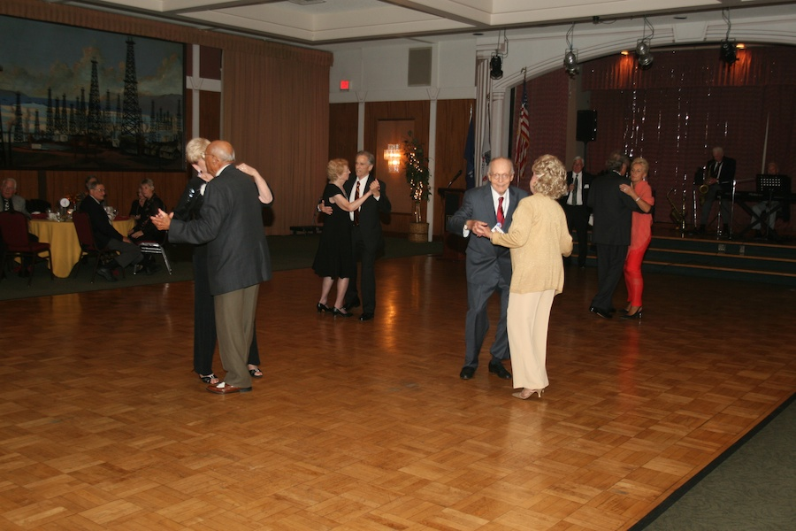Kicking up our heels

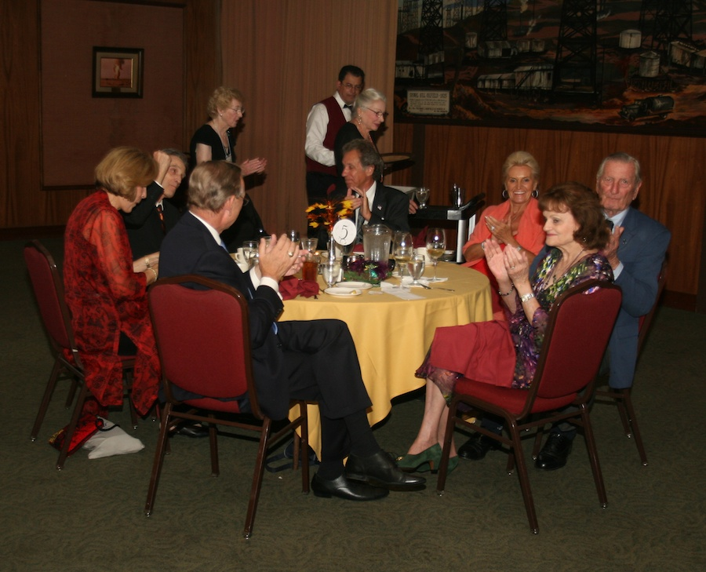

Must be announcements...

November? How Interesting!

November is the 11th month of the year in the Julian and Gregorian Calendars and one of four months with the length of 30 days. November was the ninth month of the ancient Roman calendar. November retained its name (from the Latin novem meaning "nine") when January and February were added to the Roman calendar.

November is a month of spring in the Southern Hemisphere and autumn in the Northern Hemisphere.

November starts on the same day of the week as February in common years, and March every year. November ends on the same day of the week as August every year.

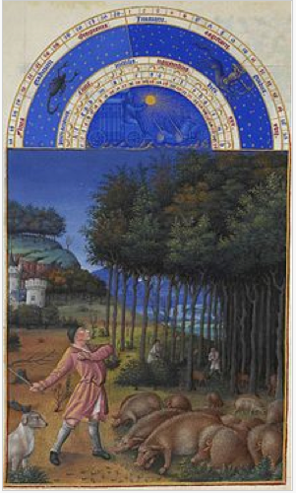

November, from the Très Riches Heures du Duc de Berry



# Bites & Pieces

The Constitution and ByLaws have been revised and approved and have been mailed to all our members

We are sad to announce that Sam Pierce, partner of Irene Johnson, passed on in October.

New rosters were provided at the last dance… If you don’t have yours let Joyce know. Please provide corrections to the Liles’ and Joyce Rothrock.

# Upcoming Dance Schedule

12/14/2012 – Mistletoe Ball