Presidents Message…

It’s that time of year… Summer is almost gone and the leaves are beginning to turn! We have Halloween, Thanksgiving, Christmas, New Years, Easter just ahead of us! It’s time to dance again!

We will see everyone on September 14th and dance to the music of the xxxxxxxxxxxxxx.

Gigi and I hope you had a wonderful summer and are ready to share your vacation time with your dance friends.

We will see you in a few short weeks!

Larry Isham,
President

Summertime Is Coming…

The foliage has been losing its freshness through the month of August, and here and there a yellow leaf shows itself like the first gray hair amidst the locks of a beauty who has seen one season too many. ~Oliver Wendell Holmes
Deep summer is when laziness finds respectability. ~Sam Keen.

Winter is an etching, spring a watercolor, summer an oil painting and autumn a mosaic of them all. ~Stanley Horowitz



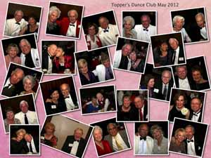
Remember our last dance?

Figure 1Sea

Figure 2 We danced in a sea of red

A New Dance Season Is Upon Us!

Policy Notes
There are no refunds for cancellations made after the Tuesday before the dance as the arrangements are finalized Tuesday evening.

If you desire to sit with someone please note it with your check so we can attempt to satisfy your seating desires!

What You Need To Know
The May 18th dance will be at the Petroleum Club and will feature the Howard Solomon Band!

We are having the US Marines present the colors in honor of Memorial Day.

The cost is $80/couple (includes tax/tip).

No-host cocktail time is at 6 p.m and the great dance music until 10 p.m.

Dress code is semi-formal.
Toppers Dinner Menu

Prime Rib of Beef with mashed potatoes, Fish of the Day or Vegetarian and ice cream with raspberry sauce for dessert.

Mail your checks made out to “Toppers Dance Club” With Dinner Selections on the checks To
Diane Schmitz
3475 Lilly Avenue
Long Beach, CA
90808

  - Everyone must take time to sit and watch the leaves turn. ~Elizabeth Lawrence

Prepare To Be Greeted
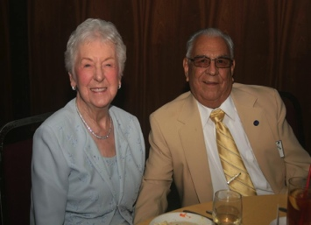
Joe Ramos (Long Beach) and Ella Jolly (Harbor City)

Be prepared to be welcomed with a big smile by Joe and Ella.

Where Is Harbor City?
Harbor City is part of the Los Angeles region known as the South Bay. Harbor City is located at the foot of Palos Verdes and the suburb of Torrance; but also borders the city of Lomita and the communities of Wilmington and San Pedro.

May? How Interesting!
May is the fifth month of the year in the Julian and Gregorian Calendars and one of seven months with the length of 31 days.

May is a month of autumn in the Southern Hemisphere and spring in the Northern Hemisphere. Therefore May in the Southern Hemisphere is the seasonal equivalent of November in the Northern Hemisphere and vice versa. No other month begins or ends on the same day of the week as May in any year.

The month May was named for the Greek goddess Maia, who was identified with the Roman era goddess of fertility, Bona Dea, whose festival was held in May. Conversely, the Roman poet Ovid provides a second etymology, in which he says that the month of May is named for the maiores, Latin for "elders," and that the following month (June) is named for the iuniores, or "young people"
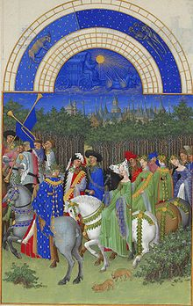
May, from the Très Riches
Heures du Duc de Berry

Memorial Day May 28th
Formerly known as Decoration Day, it originated after the American Civil War to commemorate the fallen Union soldiers of the Civil War. Southern ladies organizations and southern schoolchildren had decorated Confederate graves in Richmond and other cities during the Civil War, but each region had its own date. Most dates were in May.

By the 20th century Memorial Day had been extended to honor all Americans who have died in all wars. Memorial Day is a day of remembering the men and women who died while serving in the United States Armed Forces.

We welcome our Marines to the dance and thank them for presenting the colors!



Your Board

President Larry Isham
Vice President Dean Fronk
Past President Jerry Ellis
Secretary Lori Fronk
Treasurer Diane Schmitz
Hospitality Neil/Nita Woolston
Membership Bob Potthast
Roster Joyce Rothrock
Newsletter Paul & Sue Liles
Member At Large Gigi Isham, Dennis Schmitz, Nancy Ellis, Jack Taylor, and Meretta Potthast

The Executive Board meets at 5:30 p.m. before each dance. Need a Toppers name badge? Call Earl Eakle at 310-375-8134.

Spotlight On A Topper
Special thanks to Vicky Kuhn for efforts needed to develop the “Spotlight On A Topper” section of the newsletter. Her efforts make it a “cut and paste” for the editors!

So, What Does The Board Do?
The Board meets ahead of each dance and conducts the business of the club.

We must arrange for the entertainment by contracting with the bands, select the menu’s for each dance, work on growing the club, send notes of our members who are not feeling well, manage the finances, set the dance dates, and many other activities!

It’s fun to work with our members and get to know them perhaps better than just on the dance floor.

Interested? Contact Larry and he can tell you more!

Our Dance Schedule
5/18/2012 – Howard Solomon

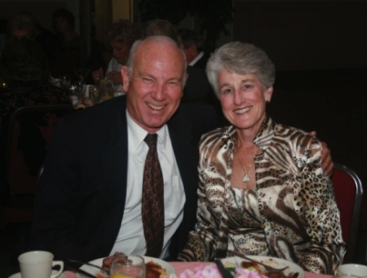
Dennis and Diane Schmitz
As reported to Vicky Kuhn

Dennis and Diane met at Bob’s Big Boy Restaurant after a football game when they were Seniors at
Mayfair High School in Bellflower, CA.

They married four years later and spent their first year of married life completing their Bachelors Degrees at CSULB. After graduation, Diane went to work with L.A. County in the Welfare Department and Dennis landed a job as an insurance adjustor, and later, a real estate appraiser.

After obtaining his MBA, Dennis began his career in the mortgage banking business. When their daughter, Heather, was born, Diane retired from the County.

Three years later, Diane began preparing income taxes. Diane retired two years ago, after thirty-four years in the business. Dennis retired a few years ago but got bored and returned to work part
time. He is getting ready to give retirement another try.

They will have been married forty-four years this August - Dennis says, “seven of them have
been great!”

Their daughter and her husband have blessed them with three wonderful grandchildren, Ella, 8, Ben, 5, and Keira, 3. They live in Potsdam, New York, where their son-in-law is a Political Science Professor and Heather teaches at SUNY Potsdam Child Care Center.
Dennis and Diane say they feel very fortunate to share a wonderful life filled with terrific family and friends. Dennis loves to play golf and Diane plays tennis three to four times a week.

They both enjoy reading, crossword puzzles, and playing bridge. They are both Life Masters in Duplicate Bridge, but rarely play as partners. They love traveling and have toured many countries and gone on several cruises.

They travel to Potsdam twice a year and Orlando once a year to be with Heather, Rob, and the children. They will be here for five weeks this summer.

June will find Dennis and Diane in France for a riverboat cruise from Paris to Normandy. Left on their “bucket list” are an African Safari, trips to Egypt, Jordan, Israel. Australia, and New Zealand.

They started dancing when Heather and Rob married in 1999 and Dennis realized he would have
to do the “Father/Daughter” dance. They have been working on our “rhythm” ever since!

They thoroughly enjoy their fellow dancers and friends in Toppers and Diane enjoys being on the Board as Treasurer.

The Rumba
The ballroom rumba derives its movements and music from the “son” (another Latin dance), just as do the salsa and mambo. The Peanut Vendor was the first recording of Cuban music to become an international hit: it was incorrectly described on the label as a rumba, perhaps because the word “son” would not be understood in English.

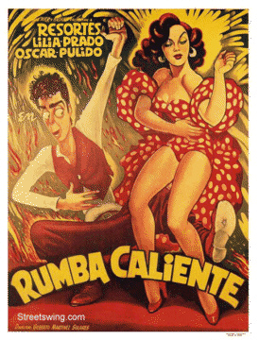

The label stuck, and a rumba craze developed through the 1930s. This kind of rumba was introduced into dance salons in America and Europe in the 1930s, and was characterized by variable tempo, sometimes nearly twice as fast as the modern ballroom rumba.

Aging and memory
When brain cells die and synapses weaken with aging, our nouns go first, like names of people, because there's only one neural pathway connecting to that stored information. If the single neural connection to that name fades, we lose access to it.

So as we age, we learn to parallel process, to come up with synonyms to go around these roadblocks. (Or maybe we don't learn to do this, and just become a dimmer bulb.)

The key here is Dr. Katzman's emphasis on the complexity of our neuronal synapses. More is better. Do whatever you can to create new neural paths. The opposite of this is taking the same old well-worn path over and over again, with habitual patterns of thinking and living our lives.

When he was studying the creative process as a grad student at Stanford, he came across the perfect analogy to this:

The more stepping stones there are across the creek, the easier it is to cross in your own style.

The focus of that aphorism was creative thinking, to find as many alternative paths as possible to a creative solution. But as we age, parallel processing becomes more critical. Now it's no longer a matter of style, it's a matter of survival — getting across the creek at all. Randomly dying brain cells are like stepping stones being removed one by one.

Those who had only one well-worn path of stones are completely blocked when some are removed. But those who spent their lives trying different mental routes each time, creating a myriad of possible paths, still have several paths left.

The Albert Einstein College of Medicine study shows that we need to keep as many of those paths active as we can, while also generating new paths, to maintain the complexity of our neuronal synapses. More to come…

What Are you Doing This Summer???
We plan to get our ace reporter Vicky Kuhn to work with you and develop some stories about your summertime adventures…. Where did you go? What did you do? How much trouble did you get into?



Our Great Military
The history of the United States Armed Forces dates to 1775, even before the Declaration of Independence marked the establishment of the United States.

The Continental Army, Continental Navy, and Continental Marines were created in close succession by the Second Continental Congress in order to defend the new nation against the British Empire in the American Revolutionary War.

These forces demobilized in 1784 after the Treaty of Paris ended the War for Independence.

The Congress of the Confederation created the United States Army on 3 June 1784, although the founding of the Army is celebrated as occurring on 14 June 1775.

The 1787 adoption of the Constitution gave the Congress the power to "raise and support armies," "provide and maintain a navy," and to "make rules for the government and regulation of the land and naval forces," as well as the power to declare war and gave the President of the United States the responsibility of being the military's commander-in-chief.

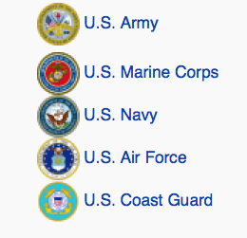

The April Dance!
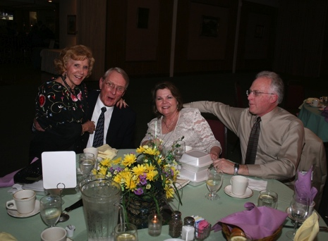
Time to visit
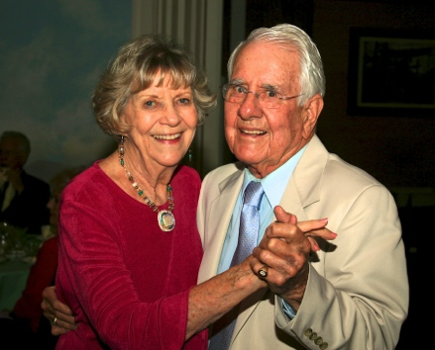
Kicking up the heals
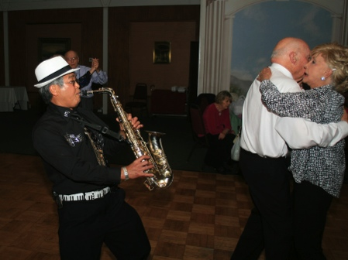
Joining the dancers
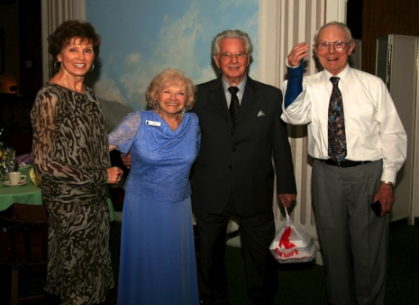
Dr. Strangelove shows his arm

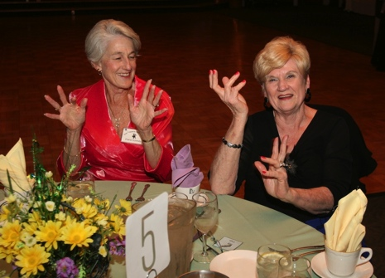
Doing the Hand Jive

