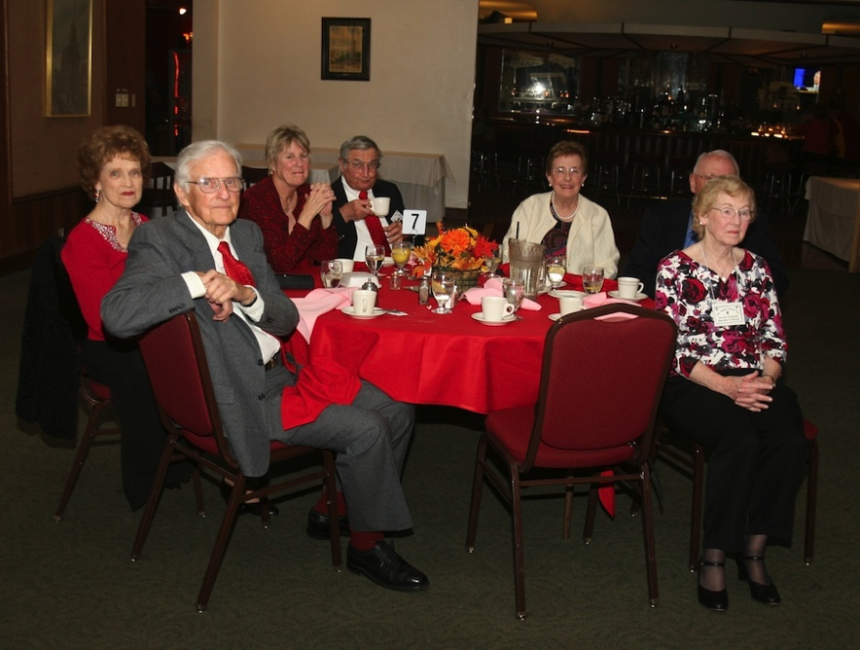
Figure 1Sea

Figure 2 We danced in a sea of red

Presidents Message…

It’s time to go green…. Saint Patrick’s Day is upon us! Time to wear something green.

Welcome Paul and Barbara Rutkowski as our latest guests to the club.

It was nice to see Helene & Steve Smith back and we hope they continue to join us in the future

We will see everyone on March 16th and dance to the music of the Phil Anthony Band.

Remember - “Never iron a four-leaf clover, because you don't want to press your luck. ”

Larry Isham
President

Wearing Of The Blue?

Originally, the color associated with Saint Patrick was blue. Over the years the color green and its association with Saint Patrick's Day grew.

Green ribbons and shamrocks were worn in celebration of St Patrick's Day as early as the 17th century.

Saint Patrick is said to have used the shamrock, a three-leaved plant, to explain the Holy Trinity to the pagan Irish, and the wearing and display of shamrocks and shamrock-inspired designs have become a ubiquitous feature of the day.

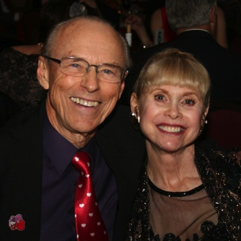
Paul & Barbara Rutkowski
guests of Paul & Sue Liles

What You Need To Know
The March 16th dance will be at the Petroleum Club and will feature the Phil Anthony Band!

The cost is $75/couple (includes tax/tip).

No-host cocktail time is at 6 p.m. and the great dance music until 10 p.m. Dress code is semi-formal.
Toppers Dinner Menu

Green Salad with dressings on the table
Roast Tri-Tip and Chicken Breast Combo or Fish of the Day or Vegetarian
Potatoes and Vegetables

Hot bread and butter,
coffee and tea.

Vanilla Ice Cream with Chocolate Sauce

Mail your checks made out to “Toppers Dance Club” With Dinner Selections on the checks To
Larry Isham
2023 Ruhland Ave
Redondo Beach CA 90278

  - “Dancing with the feet is one thing, but dancing with the heart is another.” ~Author Unknown

St. Patrick’s Day Is Almost Here…
Prepare To Be Greeted
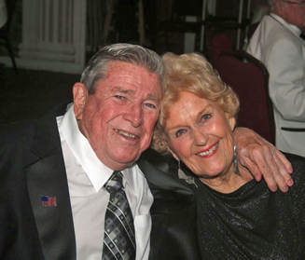
Joe Maloney and Ginny Rodhner

Be prepared to be welcomed with a big smile by Joe and Ginny.

March? How Interesting!
March starts on the same day of the week as November every year and February in common years only. March ends on the same day of the week as June every year. In leap years, March starts on the same day as September and December of the previous year. In common years, March starts on the same day as June of the previous year.

The name of March comes from ancient Rome, when March was the first month of the year and named Martius after Mars or Ares, the Greek god of war. In Rome, where the climate is Mediterranean, March was the first month of spring, a logical point for the beginning of the year as well as the start of the military campaign season.

January became the first month of the calendar year either under King Numa Pompilius (c. 713 BC) or under the Decemvirs about 450 BC (Roman writers differ). The numbered year began on March 1 in Russia until the end of the 15th century.

Great Britain and its colonies continued to use March 25 until 1752, which was when they ultimately adopted the Gregorian calendar. Many other cultures and religions still celebrate the beginning of the New Year in March is called luty or лютий, meaning the month of ice or hard frost.

March, from the Très Riches Heures du Duc de Berry

Night Club Two Step
Nightclub Two Step (Nightclub Two-step, NC2S, sometimes Disco Two Step or California Two Step) was initially developed by Buddy Schwimmer in the mid-1960s.

The dance is also known as "Two Step" and was "one of the most popular forms of contemporary social dance" as a Disco Couples Dance in 1978. It is frequently danced to mid-tempo ballads in 4/4 time that have a characteristic Quick-Quick-Slow beat. A classic example is the song Lady In Red.

Your Board

President Larry Isham
Vice President Dean Fronk
Past President Jerry Ellis
Secretary Lori Fronk
Treasurer Diane Schmitz
Hospitality Neil/Nita Woolston
Membership Bob Potthast
Roster Joyce Rothrock
Newsletter Paul & Sue Liles
Member At Large Gigi Isham, Dennis Schmitz, Nancy Ellis, Jack Taylor, and Meretta Potthast

The Executive Board meets at 5:30 p.m. before each dance. Need a Toppers name badge? Call Earl Eakle at 310-375-8134.

Spotlight On A Topper

Our Club Started In 1946
The Topper's Dance Club was formed in 1946 in Long Beach and has been in operation ever since. What was going on in 1946?

The first meeting of the United Nations is held in London.

Project Diana bounces radar waves off the Moon, measuring the exact distance between the Earth and the Moon, and proving that communication is possible between Earth and outer space, effectively opening the space age.

ENIAC (for "Electronic Numerical Integrator and Computer"), an early general-purpose electronic computer, is unveiled at the University of Pennsylvania.

Tokyo Telecommunications Engineering (later renamed Sony) is founded with about 20 people.

Our Dance Schedule
4/20/2012 – Tony Carinio
5/18/2012 – Howard Solomon

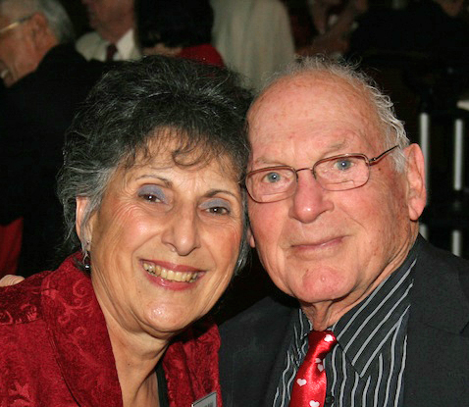
Irene Kosmetatos and Herb Silverstein
As reported to Vicky Kuhn

Irene was born and raised in Kenosha, Wisconsin. She attended a one room school that had students from 1st to 8th grade. At her high school, enrollment was 450 with 80 of those students in her class. Irene was a vibrant cheerleader plus Class Secretary for the 4 years she attended high school. In addition to those activities, she worked from age 6 until she graduated from college at her parent’s Greek restaurant. Even today, Irene will knock out a great Greek dish with almost no effort.

Irene attended the University of Wisconsin in La Crosse and again was a cheerleader for 2 years. She loved her years in college having being involved in the college gymnastics team (Jr. & Sr. year), 4 years in the Modern Dance Club and was Secretary of her Senior Class. In addition, she developed a sports event spectator FLASH CARD section.

Yes, the classic type where each person in the bleacher stands holds an assigned special giant card and raises it, flipping it at a precise moment to create elaborate pictures or designs. Imagine doing that today without the use of computers or cell phones. Irene graduated in 1957 with a B.A. in Physical Education and Dance & Health. She was honored to be listed in the Who’s Who in Universities & Colleges.

After college graduation, Irene was a teacher for 2 years in Random Lake, Wisconsin where she had broken the ‘males only’ gym teacher barrier and was the first woman Physical Education teacher there. Needless to say, she designed new programs to include more female students P.E. programs. Irene developed and taught the new woman’s dance program. She later taught in Racine, Wisconsin during the late 1950s and late 1960s.

Irene and her fiancé’ Jerry, who was a member of the National Guard had planned on getting married in Oct. of 1961. Plans changed as President Kennedy activated Jerry’s military unit due to the Cuban Missile Crisis on their planned wedding date. So they ended up marrying in September instead. Jerry was sent to Fort Lewis in Washington where Irene would eventually be reunited with him and ‘home’ would be the military base.

Irene could not be employed as a teacher when she became pregnant with their daughter Maria as ‘pregnant teachers were forbidden to teach.’ Eventually Jerry, Irene and baby Maria, who would be their only child, and ‘the light of their eyes’ would return to Wisconsin. Once back in Wisconsin, Irene was employed by the YWCA as their Health and Physical Education director for 5 years. Actually, she worked at various times at the YWCA and YMCA.

The family decided that ‘sunny California’ was for them and they moved here in 1970. They lived in the South Bay area, then in Fullerton, and now in Long Beach. Sadly, Jerry died in 1991 but leaving Irene with 30 years of wonderful memories of their married life.

Irene continued with her advanced education attending Pepperdine University extension classes to get her California Teaching Credential and an Art degree minor in one year. She did this while she taught during the day at Pasadena High School. Her classes included not only P.E. but Modern dance, Art classes, coaching softball, volleyball, water polo, Track & Field and Dance Production in her last 3 years before retiring in 1993 after teaching there for 24 years.

Irene and Herb met in 2000 at a Big Band Bash Dance and he asked her to dance. Needless to say, he didn’t know she was a former dance teacher. Their style of dancing together ‘clicked’ and there was ‘chemistry’ in the air. In that same night they met, a woman asked them “How long have you two been dancing together? You’re great dancers!” Fast-forward to the present and you’ll see that they’ve been together ever since that night! They are true believers in that old Danny Kaye song, ‘The Best Things Happen When You’re Dancing.”

Irene is very proud of her daughter, Maria who is a Nurse Practitioner in Portland, Oregon and enjoys visiting her often. Maria has been a joyous HIGHlight in Irene’s life. Like most people, life has given Irene many ‘ups and downs.’ She even chose one of her ‘up’ moments when she decided for her 65th birthday that she wanted to get high…up in the sky that is, and did tandem sky-diving AND aerobatic flying. She loved it!

Irene continues to fill her day with many activities that include visiting her dear friends, entertaining, playing a mean-hand of numerous poker games, has Lady Luck on her side when she does a little casino gambling, attends ‘wine tastings’, playing tennis and golf, occasionally ‘subs’ at local schools which keeps her youthful and ‘in the know’, plus frequently goes social dancing at various locations with Herb and their friends. She enjoys being a member of Toppers and has made many new friends.

Herb was born in 1927 in San Francisco and has one sister, an attorney who lives nearby. When Herb was 4 years old, he went to school that had an accelerated program and graduated from high school when he was 15. While attending high school he ‘lettered’ in football and baseball.

Herb entered Stanford University at 15 and enlisted in the U.S. Navy at 16, serving as a U.S. Naval aviator in the Pacific during WW2. He served honorably for almost 2 years. Of the airplanes he flew, one was a TBF torpedo bomber and commented that war is not exciting but terrifying to actually be in it and was grateful to return home.

After his military service, in the late 1940s Herb designed and manufactured the equipment for processing raw fiber such as wool, jute, cotton, nylon etc. Think of 1793 and Eli Whitney’s cotton gin machine, travelling into the future taking his ‘ginned’ fiber into the next 1000 stages to make finished products. Yarn, paper, chemicals and other items are what these new units produced from the raw fiber. As these units were being installed in most industrialized countries,

Herb was required to travel extensively, travelling 100 thousand miles or more per year. He was ‘on the go’, all business, having his ‘home base’ be an airplane, that he didn’t have time to sight-see and kept refocusing on his mission.

Herb married in 1951 and he and his wife had 3 children, Andy, Ellen and Michael. Herb decided that he wanted to spend more time with his children and again refocused on his career goals to make that possible.

Now, in another field that Herb became involved in was that he developed and implemented the soft film wrapping system that is used in supermarkets today for raw meat and produce. Next time you go to the market and see that plastic film protecting the food, know that the man responsible for it is none other than our own Topper member, Herb Silverstein.

Along with this system, Herb developed quality assurance programs for procurement of raw material…systems that provides standards, within accepted parameters and acceptability for the buyer & seller.

Retired? After 60 plus years in the business of manufacturing, retail, food science and distribution… Herb is still involved in the food industry business. He counsels private and government regulators on food borne illnesses and counsels our U.S. Congress on terrorist suppression related to food distribution.

Herb divorced after 37 years of marriage and is proud of his 3 children. His only daughter Ellen and her husband live nearby in Santa Monica. Every now and then, Ellen will join Herb & Irene for a dance event. Dancing is naturally part of her DNA too, as she was a teacher to children who have special needs such as autism and she has applied creative arts such as music, dance and movement in their lives.

In his spare time, Herb loves to play golf, tennis, play poker and go dancing with Irene. As Herb put it as he spoke, that of all the things he has done in his 80 plus years, the one thing that has been and is consistent in his life is ‘change’ because when you refocus, there is ‘change.’ Unlike most people, he is not afraid of ‘change’, in fact he thrives and excels with it.

They have been members of Toppers for about two years and enjoy the very pleasant people and special friendships in this wonderful club. Keep on dancing!

The February Dance!
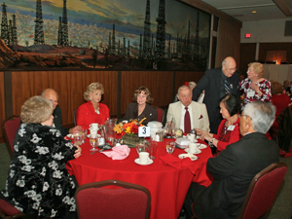
Time to visit
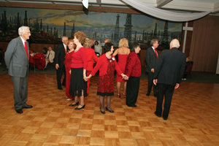
Circle the wagons
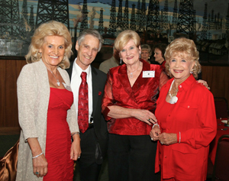
A sea of red this evening
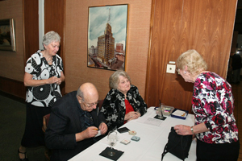
Checking in

