# From Our President…

I'm pleased to report that for several years Toppers attendance has well exceeded the minimum agreed upon with the Petroleum Club.  This has resulted in our being able to continue to hold our events at reasonable costs.  It simply is a fact that this couldn't happen without a supporting group of loyal members regularly attending our dinner-dances.

In addition to our sustaining membership, there are two other groups also important in contributing to our Club’s well-being.  Let’s not under estimate the benefits enjoyed through the fine services provided by (1) the Petroleum Club’s kitchen and front office staff, and (2) the ongoing work and dedication of Toppers’ Board of Directors who meet regularly to shape and administer the Club’s programs and policies.

With reference to the Board, if you’ve ever wondered about its purpose and work, and have not done so in the past, Board members would be happy to have you visit one of their monthly sessions.  You are invited to experience the “behind the scenes” planning of the group in action that has contributed to Toppers’ success over the years.  Meetings are efficient and brief (held to a limit of 30 minutes). If you would like to attend, simply mention it to any member of the Board, and a convenient time will be set for your visit.

Nancy and I will be hoping to see you when it’s time to again enjoy Phil Anthony’s band on the 18th.

Jerry Ellis

  
It's always time to dance!

# 2010-2011 Dance Season

Remember to keep these future dates on your calendar!

April 22nd (Tony Carinio)

May 20th (Howard Solomon)

# What You Need To Know

The March dance will be at the Petroleum Club on Friday the 18st of March.

The cost is $72/couple (includes tax/tip). No-host cocktail time is at 6 p.m.

Phil Anthony will be providing great dance music until 10 p.m. Dress code is semi-formal.   
  
Toppers Dinner Menu

Chicken Cordon Bleu or

Fish of the Day

Green Salad with Ranch &

Italian dressings on the table.

Scalloped Potatoes

Fresh Veggies of the day

Pasta by request

Mint Chip Ice Cream

Warm Bread and Butter

Coffee or Tea

There are short-cuts to happiness, and dancing is one of them.  ~Vicki Baum

*Red was everywhere during Valentines week!*

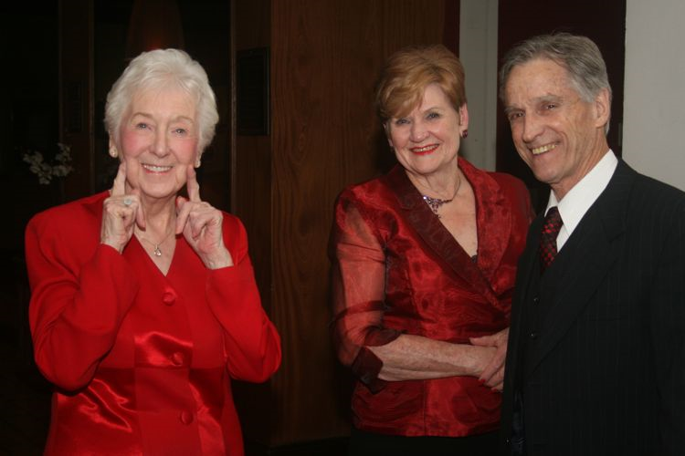

February Dance Was A Sea Of Red!

# Your Board

President Jerry Ellis  
Vice President Ray Ashcroft  
Past President Earl Eakle  
Secretary Mary Ruth Ashcroft  
Treasurer Bill Morgan  
Hospitality Terey & Walter Kroy  
Membership Bob Potthast  
Roster Joyce Rothrock  
Historian Martha & Ace Yeam  
Newsletter Paul & Sue Liles

The Executive Board meets at 5:30 p.m. before each dance. Need a Toppers name badge? Call Earl Eakle at 310-375-8134.

# Prepare To Be Greeted

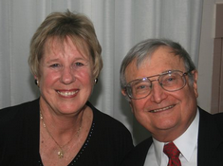

Terey & Walter Kroy

Be prepared to be welcomed with a big smile by Terry & Walter Kroy who are standing in for the Weygandts who are recovering from surgery (see page four). They come all the way from Santa Ana to join us this evening!

**Did You Know?** Members of the Tongva and Juaneño/Luiseño nations long inhabited the area. The Tongva Indians called the Santa Ana area "Hotuuk."

After the 1769 expedition of Gaspar de Portolá out of Mexico City, then capitol of New Spain, Friar Junípero Serra named the area Vallejo de Santa Ana (Valley of Saint Anne, or Santa Ana Valley).

# The Waltz Was Provocative

In the 1771 German novel Geshichte des Fräuleins von Sternheim by Sophie von La Roche, a high-minded character complains about the newly introduced waltz among aristocrats thus:

*"But when he put his arm around her, pressed her to his breast, cavorted with her in the shameless, indecent whirling-dance of the Germans and engaged in a familiarity that broke all the bounds of good breeding—then my silent misery turned into burning rage."*

# Future Greeters Identified

In April our greeters are Ed Weyer and Natalie Emory and in May Bob and Edith Daley!

# Wearing Of The Green

Originally, the color associated with Saint Patrick was blue. Over the years the color green and its association with Saint Patrick's Day grew.

Green ribbons and shamrocks were worn in celebration of St Patrick's Day as early as the 17th century. He is said to have used the shamrock, a three-leaved plant, to explain the Holy Trinity to the pagan Irish, and the wearing and display of shamrocks and shamrock-inspired designs have become a ubiquitous feature of the day.

In the 1798 rebellion, in hopes of making a political statement, Irish soldiers wore full green uniforms on 17 March in hopes of catching public attention. The phrase "the wearing of the green", meaning to wear a shamrock on one's clothing, derives from a song of the same name.



"We dance for laughter, we dance for tears, we dance for madness, we dance for fears, we dance for hopes, we dance for screams, we are the dancers, and we create the dreams."

# Spotlight On A Topper

# Welcome Guests

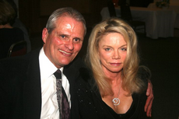

Craig Goll and Marianne Hanlon were guests of Paul & Sue Liles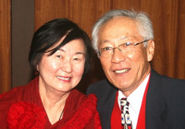

Joan & Frank Kawase were guests of Ray and Mary Ruth Ashcroft



# CORRECTION For Kuhns

Please note, in the latest Toppers directory the phone number for Vicky and Del Kuhn is incorrect. Change the last four digits from 1138 to 1128

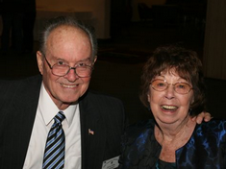

*Jerry & Nancy Ellis*  
 Submitted To Vicky Kuhn by the Ellises

In early December 1948 Jerry and Nancy first met. For six months following high school while Jerry had been away from home working in Alaska, his family moved from their small farm to a location near downtown Riverside. There are several things Jerry will never forget about the day he arrived at this new home. Still fresh in mind was first meeting the little dark-haired high school girl who lived across the street.

Having been raised to be proud of his Scotch-Irish heritage (the McClures of Scotland), it didn’t take long for him to find much in common with his new friend, Nancy, of the McElhannon family. He soon learned that Nancy’s ancestors came to this country from Ireland in the late 1800’s settling in Georgia. Eventually, her immediate family moved to Phoenix where Nancy was born, finally moving to Riverside in 1942.

For the next few years, as Nancy finished high school and spent a year working in Texas while living with relatives, she and Jerry kept in touch. But they both soon realized the separations were too often and too lengthy. Alaska remained a calling for Jerry, fulfilling his dreams since childhood of living in the far North he had read about in books by those such as Jack London, Robert Service, and James Oliver Curwood. So, for a while, he continued returning in the spring to work in the gold fields, and then home again when the camps closed for winter.

In 1952, the two were married, and Nancy left her work at the local bank in Riverside to be with Jerry at Andrews Air force Base in Washington D.C. where he was completing his second year as an Aircraft Mechanic and Radio Repairman in the Air Force. The following year she was leaving her bank job in Washington to join Jerry, back in Alaska where the Air Force had sent him to Ladd Air Force Base near Fairbanks. The Bank of Fairbanks welcomed Nancy, as her banking experience made it a comfortable move to her new job. Though there is much she can relate about the things she enjoyed about life in Alaska, the winters aren’t among them. She remembers well the long, cold winters, when her thoughts were often of the warm, summer days she remembered of Southern California.

Following Jerry’s military discharge and another year in Alaska with a local airline, the “Luck of the Irish” again presented itself, and to the wonder and delight of his parents, on St. Patrick’s Day, March 17, 1956, in the little town of Fairbanks, baby John Ellis was born. A few months later, with John tucked away in the backseat of the car the family was on the move again. This time headed down the Alaska Highway for San Luis Obispo and college.

Jerry graduated with an Engineering Degree from Cal Poly in 1961, and in the same year, John’s brother, Michael was born. Time to move again and it was decided to return to Southern California with its moderate weather and near relatives and friends of earlier years.

After 31 years with Southern California Gas Company, Jerry retired in 1992. Most years had been spent in field operations, mainly pipeline corrosion control and facilities design and construction. After 25 years with S&J Chevrolet Dealership in Cerritos, Nancy retired in 2010. Their sons received their Engineering Degrees from Long Beach State and are nearing retirement. Both have engineering careers similar to that enjoyed by their dad; John and family in the Bishop area, Mike and family here in Long Beach.

Nancy and Jerry have enjoyed 'R-V-ing' for over 40 years, and these days the two of them and their dog Charley still get away on an occasional road trip. Since retirement they are spending more time than ever with their families and say that belonging to Toppers, with wonderful friends, complete with the fine dinners and memorable dance music, are among the latest worthwhile activities being enjoyed to the fullest.

# Breaking News

Donnis Weygandt went into Long Beach Memorial Hospital Feb. 23 rd. for a Lumbar Laminectomy. She expects to be home by Feb. 28th. for further recovery and therapy.  She and Clark will not be able to attend the March Topper's event, but hopes she and Clark be able to join Toppers in April.

Laminectomy is a spine operation to remove the portion of the vertebral bone called the lamina. There are many variations of laminectomy. In the most minimal form small skin incisions are made, back muscles are pushed aside rather than cut, and the parts of the vertebra adjacent to the lamina are left intact.

**Meet Joe Barile From The Phil Anthony Band**



Joe at work behind the drums

Joe Barile...drummer, vocalist, guitarist and published songwriter, is a native of Ischia, an Island off the coast of Naples, Italy.  He has been performing since the age of fifteen.  His career has taken him to Japan and many Euorpean countries, and had a lengthy stint performing and recording with The Ventures and Shango.

He has written many songs for these groups that have been recorded and released worldwide. Joe has been collaborating with numerous songwriters over the past few decades including sax man Tony Giaimo and Phil Anthony and Nina Beck.

Joe's rich, thought-provoking melodies conjure up equally deep, meaningful lyrics by his co-writers, and Joe writes some fine lyrics of his own as well, in the "future standard" and Italian ethnic categories. When not performing, Joe enjoys cooking.



# Our Valentines Dance



The Harringtons and Bergs

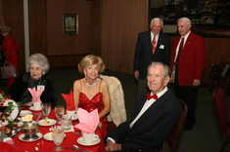

It was a sea of red this evening

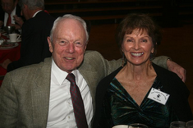

What? No red??

# A Little Irish Humor

Walking into the pub, Patrick said to the bartender, "Pour me a stiff one, Sean. I just had another tiff with the little woman."

"Oh yeah," said Sean. "And how did this one end?"

"Well I'll tell ya now when it was over," Patrick replied, "herself came to me on her hands and knees, she did."

"You don't say? Now that`s a switch! What did she say?"

She said, "Come out from under that bed, you gutless weasel!

# A Call For Volunteers

The board will be changing again this year and we currently have openings for President (Jerry Ellis), Vice-President (Ray Ashcroft) and Secretary (Mary Ruth Ashcroft).

These hard working members who make the club a success need some time off to refresh! If you are interested, please call Jerry Ellis!

It’s easier than you might think and you will have the current board to assist you in the new job!

# Stepping Up

Our Hospitality board member (Terey & Walter Kroy) has also decided to step down after years of performing so well. We are very lucky to have Neal & Nita Woolston volunteering.

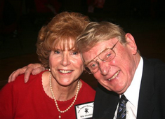

Neal & Nita Woolston

# On The Web

You are on the web! Try this URL:

[**http://tinyurl.com/4khvwm6**](http://tinyurl.com/4khvwm6)for pictures from the February 2011 dance!

# Mistletoe Ball 2011

Surprise! The Mistletoe Ball is planned for Friday, December 16th 2011. It is NOT on the usual Saturday evening this year! Please mark your calendar.