To watch us dance is to hear our hearts speak.  ~Hopi Indian Saying

Stifling an urge to dance is bad for your health - it rusts your spirit and your hips.  ~Terri Guillemets

It is with sadness we have to report that **Frank Inga**, a member for seventeen years, has passed away. Our prayers go out to Maryann and her family.

# From Our President…

Nancy and I want to express our sincere appreciation for all who sent messages and cards with good wishes following her recent visit to our local hospital. The final diagnosis for her several weeks of occasional dizziness and lack of energy was lung congestion causing a shortage of oxygen in her system. Fortunately, as a result of the excellent care she has been receiving from our medical experts she is rapidly improving.

Only a few weeks until the time changes and spring will be upon us.

Nancy and I both plan on enjoying the next Dinner-Dance on February 18th, and look forward to seeing you then.

Jerry Ellis



*Mixing it up during the mixer!*

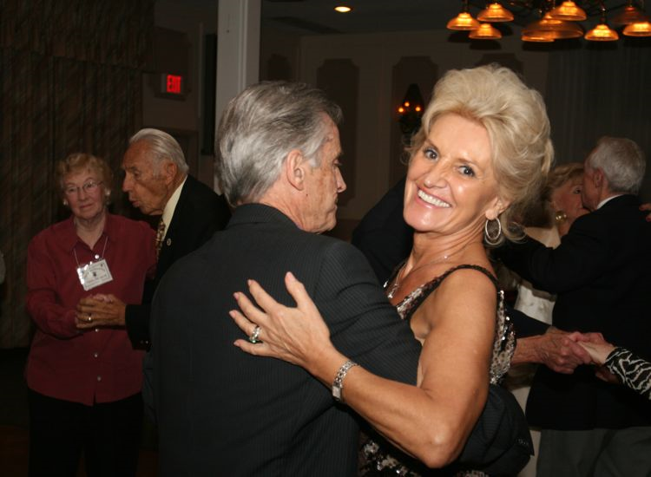

January Dance Was A Full House!



It's always time to dance!

# 2010-2011 Dance Season

Remember to keep these future dates on your calendar!

March 18th (Phil Anthony)

April 22nd (Tony Carinio)

May 20th (Howard Solomon)

# What You Need To Know

The February dance will be at the Petroleum Club on Friday the 18st of February.

The cost is $78/couple (includes tax/tip). No-host cocktail time is at 6 p.m.

Sam Conti will be providing great dance music until 10 p.m. Dress code is semi-formal.   
  
Toppers Dinner Menu

New Your Cut Steak, Fish of the Day or Veggie Pasta

Green Salad w/ Ranch and Italian Dressing on the Table

Baked Potatoes

Fresh Veggies of the Day

Warm Bread & Butter

Apple Pie a’ la Mode

Coffee or Tea

You can dance anywhere, even if only in your heart.  ~Author Unknown

# Your Board

President Jerry Ellis  
Vice President Ray Ashcroft  
Past President Earl Eakle  
Secretary Mary Ruth Ashcroft  
Treasurer Bill Morgan  
Hospitality Terey & Walter Kroy  
Membership Bob Potthast  
Roster Joyce Rothrock  
Historian Martha & Ace Yeam  
Newsletter Paul & Sue Liles

The Executive Board meets at 5:30 p.m. before each dance. Need a Toppers name badge? Call Earl Eakle at 310-375-8134.

# Prepare To Be Greeted

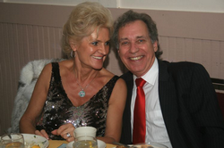

Larry and Gigi Isham

Be prepared to be welcomed with a big smile by **Larry and Gigi**. All the way from Redondo Beach they will assure you are welcomed, checked in and prepared for another delightful evening!

# The Rumba

The word Rumba is a generic term, covering a variety of names (i.e., Son, Danzon, Guagira, Guaracha, Naningo), for a type of West Indian music or dancing. The exact meaning varies from island to island. The word "rumba" comes from the verb "rumbear" which means going to parties, dancing, and having a good time.

As recently as the second world war, the "Son" was the popular dance of middle class Cuba. It is a modified slower and more refined version of the native Rumba.

The American Rumba is a modified version of the "Son". The first serious attempt to introduce the rumba to the United States was in 1913. Ten years later band leader Emil Coleman imported some rumba musicians and a pair of rumba dancers to New York

Real interest in Latin music began about 1929. In the late 1920's, Xavier Cugat formed an orchestra that specialized in Latin American music. He opened at the Coconut Grove in Los Angeles and appeared in early sound movies such as "In Gay Madrid". Later in the 1930's, Cugat played at the Waldorf Astoria Hotel in New York. By the end of the decade he was recognized as having the outstanding Latin orchestra of the day.

# Valentine Trivia



15% of U.S. women send themselves flowers on Valentine's Day.

73% of people who buy flowers for Valentine's Day are men, while only 27 percent are women.

About 1 billion Valentine's Day cards are exchanged each year. That's the largest seasonal card-sending occasion of the year, next to Christmas.

About 3% of pet owners will give Valentine's Day gifts to their pets.

Alexander Graham Bell applied for his patent on the telephone, an "Improvement in Telegraphy", on Valentine's Day, 1876.

During the late 1800s, postage rates around the world dropped, and the obscene St. Valentine's Day card became popular, despite the Victorian era being otherwise very prudish. As the numbers of racy valentines grew, several countries banned the practice of exchanging Valentine's Days cards. During this period, Chicago's post office rejected more than 25,000 cards on the grounds that they were so indecent, they were not fit to be carried through the U.S. mail.

# Spotlight On A Topper

# Welcome New Members

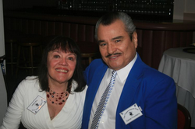

Pat Aitken and Daniel Fountains



# It’s Now February So We Have Three Dances Remaining This Season

Go Toppers Go!

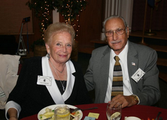

*Sal Mazzella and Jean Engedal*  
 Submitted To Vicky Kuhn by Jean Engedal

Salvatore (Sal) immigrated from Ponza, Italy, a small island just off the coast of Rome. He was only 5 years old when he arrived in the United States.  On September 30, 1924 there was no room at the inn so Sal was actually born in a cave. Most of the homes on this small island are caves as the island is one big rock. Just a few years ago Sal and Jean returned to the island and stayed in the same cave in which Sal was born.  By this time the cave was quite different! It was thoroughly modern, air conditioned and with all modern conveniences.  Isn’t that amazing?

Sal moved to New York City in 1929.  He began his career with the Pennsylvania Railroad as a brakeman.  In 1964 he worked his way into the Computer Age and advanced to become a hardware specialist. This was in the early days when the computer wasn’t even talked about. Sal continued in this profession until his retirement at the age of 62. Sal married Gia Conda in 1947 and had 3 sons. When Gia passed away in 2000 they had been married 53 years.

Jean was born in the rural farming town of Chester in South Dakota on December 12, 1920.  While in South Dakota, Jean received her college education and graduated as a Registered Nurse in 1951.  As soon as she graduated she left the country for the 'big city' and never returned except to visit.

Jean married Svend Husted Engedal in 1956 and they had three sons.  After Jean and Svend divorced, Jean raised the boys with help from her mother and continued with her nursing career. While raising her boys was a big job, she worked her way into the Vice Presidency of a nursing services corporation and traveled extensively for many years.

Jean’s early years involved all aspects of clinical nursing but later on she ventured into the administrative arena of the medical profession.  She received her Master Degree in Business.

One of her assignments was a six month stay in Saudi Arabia where she developed a patient education system.  During the big change in health care administration she made many trips to Hawaii assisting the nursing directors in meeting the new strict staffing guidelines. Her education as a Registered Nurse provided many varied and interesting experiences which included her assignment as the Private Duty Nurse for John F. Kennedy who was then the Senator of Massachusetts.

Jean remembers that”JFK was charming, charismatic and lit up the room when he entered. Quite a ladies’ man.” Jean was honored to meet the entire Kennedy Clan.

Sal and Jean met in Long Beach through mutual friends of his son.  For one year they had a long distance relationship between Long Beach and New York.

Sal chose to move to Long Beach and share their lives together. They are happy, healthy, enjoying life together traveling, cruising and enjoying Toppers Dance Club!

**Our Last Dance**

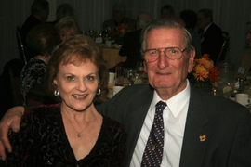

Hey You All from Bettie and Hal Rankin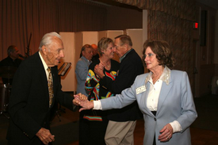The mixer is always fun!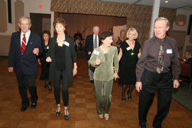Beware, line dancers at work!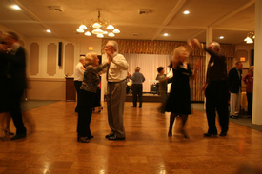Dancing the night away

Please E-Mail your photos to Paul & Sue Liles

*Jan Mongell* also likes to greet our members.

Recent members *George and Edith Meier* are welcomed by the Toppers members!

Visiting continues until the end. The *Harringtons, Bergs, Fronks* sharing moments

*Ace and Martha Yeam* celebrating their tenth anniversary. Martha makes the announcement while Ace blushes,

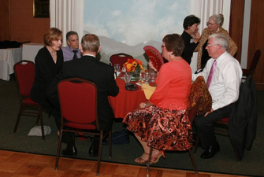

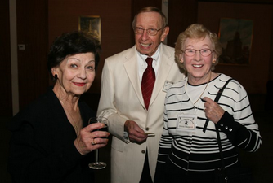

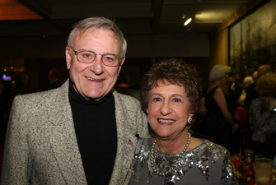

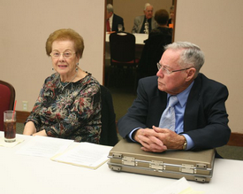

Serious work at the Board Meeting

# 

# Thanks To Our Future Greeters!

March 18 Clark and Donnis Weygandt

April 22 Ed Weyer and Natalie Emory   
May 20 Bob and Edith Daley