*Ruth Stone and Bill Condit* join the Mixer

# From Our President…

Season’s greetings to everyone!  With the end of this year just ahead, I hope you plan to attend our last dance of 2010. As I’m sure you are aware, our December dinner-dance will be sponsored by the Petroleum Club.  As guests of the Petroleum Club, our routine program activities such as recognizing birthdays and anniversaries, and the mixer dance will be dispensed with.  As in the past, for the ‘Mistletoe Ball” the large ballroom will be appropriately decorated by the members and staff of the Petroleum Club.

 As we look back on this past year, we can be pleased with Toppers’ accomplishments and current status.  We’ve been fortunate in being able to welcome several new couples which has resulted in a net gain in membership. All events have been well attended.

 Your Club’s busy Board of Directors now has a slightly different look than it had a year ago. The two who replaced retiring members have taken on their duties with dedication and enthusiasm. Toppers can be both thankful and proud of the results of their efforts: *J*oyce *Rothrock’s* updated, newly designed Toppers Handbook, and *Paul and Sue Liles’* expanded, beautifully illustrated TOPICS newsletter.

 Nancy and I look forward to seeing you all at the Mistletoe Ball on the18th!

Jerry Ellis

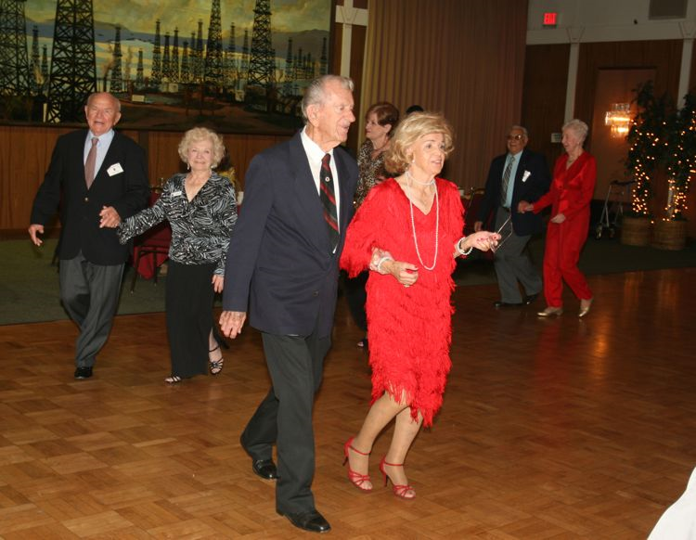

When we recall Christmas past, we usually find that the simplest things - not the great occasions - give off the greatest glow of happiness.  ~Bob Hope

It’s Getting To Look A Lot Like Christmas!

# Mistletoe Ball Time

# 2010-2011 Dance Season

Remember to keep these future dates on your calendar!

December 18th (Phil Anthony)

January 21st (Howard Solomon)

February 18th (Sam Conti)

March 18th (Phil Anthony)

April 22nd (Tony Carinio)

May 20th (Howard Solomon)

# What You Need To Know

The December dance will be at the Petroleum Club on Saturday **evening** the 18th.

The cost is $113/couple (includes tax/tip). No-host cocktail time at 6 p.m.

Phil Anthony will be providing great dance music until 10:p.m. Dress code is formal.   
  
Your choice of entrees:

**Bacon Wrapped Filet Mignon** or **Fish (Orange Roughy)**

Caesar Salad, Baby Carrots, Twice Baked Potatoes, Cheesecake with Raspberry Sauce

Warm Bread and Butter

Coffee or Tea

He who has not Christmas in his heart will never find it under a tree.  ~Roy L. Smith

# Your Board

President Jerry Ellis  
Vice President Ray Ashcroft  
Past President Earl Eakle  
Secretary Mary Ruth Ashcroft  
Treasurer Bill Morgan  
Hospitality Terey & Walter Kroy  
Membership Bob Potthast  
Roster Joyce Rothrock  
Historian Martha & Ace Yeam  
Newsletter Paul & Sue Liles

The Executive Board meets at 5:30 p.m. before each dance. Need a Toppers name badge? Call Earl Eakle at 310-375-8134.

# The Mistletoe Ball Greeters

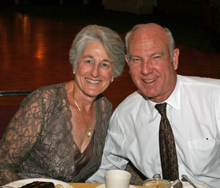

Diane and Dennis Schmitz

Be prepared to be welcomed by *Diane and Dennis Schmitz* of Long Beach. Members since 2004, they will enjoy meeting you, checking you in, and assuring your arrival will be the start of a fantastic evening.

# We Have Lost A good Friend

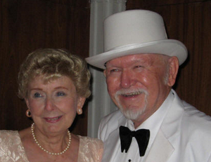

Barbara Schultz & Robert Von Fliss in 2008

We were notified by Barbara that Bob passed on November 22nd at his home in Fullerton after a long illness. Bob always came to our dances in great attire and he was not afraid of color and enjoyed his collection of themed hats.

Before his wife passed on many years ago, Bob and she played Santa Claus in many venues.

Bob has TV credits including a 1995 role as “The Masked Rider” in “Ferbus’ First Christmas” and as the voice on Santa Claus in the famous “Power Ranger” children’s programs.

# Mistletoe Ball Time

Get you best bib and tucker on as it is time to go formal at the Mistletoe Ball! So, what is a “bib and tucker”?

This term originated not in any figurative sense, but literally - both bibs and tuckers were items of women's clothing from the 17th to late 19th centuries.

Early bibs were somewhat like modern day bibs, although they weren't specifically used to protect clothes from spilled food as they are now. Tuckers were lace pieces fitted over the bodice - sometimes called 'pinners' or 'modesty pieces'.

About The Newsletter  
  
Hats off to *Nick Thomas*! After four editions we now know and better appreciate all the work he did! It takes about three hours of “production” time to generate the mailing labels, print the paper, stuff the envelopes and lick the stamps (we really do not lick them!) It’s another 2-3 hours to put the paper together (and would be more except for our ace reporter *Vicky Kuhn*) and the good material we pick up while visiting!

# Mistletoe Can Be Useful

The sticky juice of mistletoe berries was used as adhesive to trap small animals or birds. In South Africa it is called "Bird lime" in English and *voelent* in Afrikaans. A handful of ripe fruits are chewed until sticky, and the mass is then rubbed between the palms of the hands to form long extremely sticky strands which are then coiled around small thin tree branches where birds perch. When a bird lands on this it gets stuck to the branch and is then easy to catch by hand.

Spotlight On A Topper

# The Mistletoe Ball Encourages Everyone To Dance… Almost Everyone!



Happy Christmas

# Welcome New Members

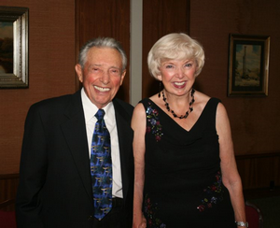

Tony and Frances Grosso

George and Edith Meier, Jr.



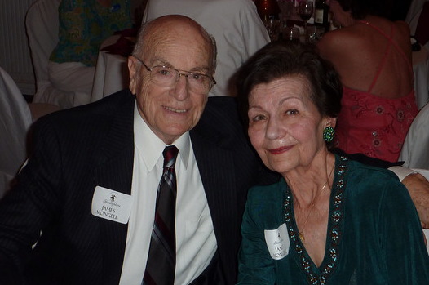

Figure Jim and Jan Mongell

James (Jim) and Janet (Jan) Mongell hail from Pennsylvania.  They came to Southern California in 1972. Jim was a Corporate Director with Ford Aerospace and was transferred to the Ford Aeronutronics Division in Newport Beach.  It was an opportunity (or a directive) they could not refuse.

Janette Constance Paolini was born in Conshohocken, Pennsylvania.  She was born into a musical family.  Her father was the leader of an eight piece band and her brother was a professional singer and piano player.  Jan, at an early age was musically inclined, learning to play piano (mostly self-taught) and writing and transposing music for her father’s band.  Being so busy with school activities and music, she still had time to study modeling, ballet and tap dancing.  To top that off, she became Miss Conshohocken her first year out of high school.

Jim was born and raised in Southwest Philadelphia, not very far from many famous stars.  His neighborhood was very much like the neighborhood portrayed in movies like, “The Godfather”.  He would tell you it was a learning experience to say the least.  There were nine children in his family, two brothers and six sisters.

Jim also had some musical experience playing solo clarinet in a concert band when he was 14-17 years of age.  While attending Naval Training School at Miami University in Ohio, he played in the Navy Marching Band.

Jim served in the U.S. Navy for three years during WWII, in the Atlantic and European operations.  He remained in the Naval Reserve for eight years.

When asked about his service and any particular incident he could remember, he replied, there were many, as any service man can attest.  There was one experience he recalled which he described as one of the worst nightmares of his life.  It was surviving a major hurricane at sea which caused extreme anxiety, damage and injuries.  He said it was worse than the time when his ship, a surrendered Italian ocean liner, converted into a troop ship, missed a floating mine by inches.  This ship was operating under the U.S. Army Transport Command and was transporting over 1,000 troops to Europe.

In 1959, Jim and Jan met at the Burroughs Corporation in Paoli, Pennsylvania.  It was a magnetic attraction – the beginning of a lifelong romance.

When they arrived in California, their three children were six, eight and nine years of age.  It was an emotional and difficult move from their families.

Jan lost no time in becoming active.  Involvement with schools, church choir, den mother, St. Joseph’s auxiliary and a Congressman’s state representative kept her very busy.  Besides her academic education, Jan studied culinary arts under professional chefs and became a certified chef.  With that expertise, she wrote and published five cookbooks.  She also was certified as a food stylist and floral designer.

She then became an entertainer using her culinary background.  She appeared on food talk radio shows with professional chefs.  At the same time, she became a regular TV chef appearing on The Trinity Broadcasting Network’ “Joy” program for ten years.

For nineteen years, Jan was the Orange County Fair’s in-house chef and culinary judge.  Each year, as a volunteer, she performed on the fair’s kitchen stage.  She was referred to in a feature newspaper article as the “Fair’s Martha Stewart”. Jan also was Cuisinart’s Coordinator for all of Southern California, and manufacturer’s representative for kitchen products.

Dancing always was a major part of her life.  Her early dance training was a step toward becoming a ballroom dance instructor.  She became a certified Arthur Murray Dance Instructor, and to this day teaches ballroom dancing and line dancing.

Being interested in entertainment and arts, Jim and Jan were involved with community theatre for 21 years.  Jan was a featured actress in numerous plays and also was a producer with Jim.  Jim was an Assistant Director, Director, Stage Manager and actor.  Jim appeared in the movie, “The Day of the Locust”.

Jim made a career in Aerospace.  During the sixties and seventies, he traveled world-wide for Ford Aerospace International Operations.  He had offices in Thailand and Iran and also conducted business through company operations in Germany, Japan and Vietnam.

He took early retirement from Ford Aerospace and joined Northrop.  He was a Corporate Director when he retired in 1995.

Jim and Jan are so very grateful for the many wonderful friends they have.  They feel blessed to know so many wonderful people.

# 

Christmas is right around the corner!

# Nightlighters Dance Every Other Month Near LAX

Say “Hello” to the Nightlighters Dance Club. They have been around since 1960’s and specialize in “themed formal dances” at hotels near LAX. Members come from all over the area, several staying overnight due to the distance. They are on the internet located at [*http://lilesnet.com/nightlighters*](http://lilesnet.com/nightlighters). The *Bergs, Liles*, *Harringtons,* and *Woolstons* are members of Nightlighters should you be interested in more information.

# Starlighters Dance On Alternate Months In OC

The Starlighters Dance Club meets and dances on opposite Saturdays! The Starlighters dance at varying venues: two informals, two semi- formals, and two formals a year.

They are primarily in Orange County and are found at [*http://thestarlighters.org*](http://thestarlighters.org)*.* The *Fronks, Liles, Mongells,* and *Woolstons* are Starlighters if you have any questions*.*

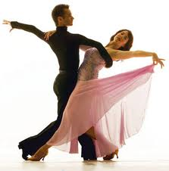

# November Dance Greeters Did A Smashing Job

# 

Joe Maloney and Ginny Rodhner

*Joe Maloney and Ginny Rodhner* were great meeting our members and guests at the door with a big smile! We appreciate their making everybody feel welcomed and also for volunteering for this great job!

# You Will Be Dancing To The Phil Anthony In Band In December

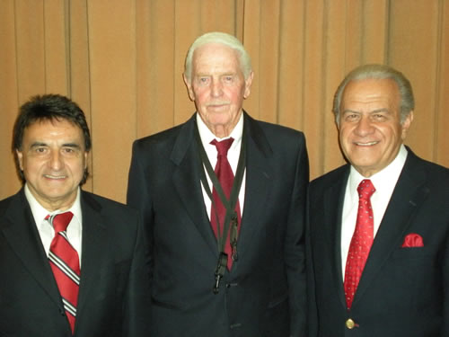

Joe, Howard, and Phil

*Phil Anthony* was born in Milwaukee, Wisconsin and had a rock band in high school called the Knight Kaps. He went on to college at the University of Wisconsin and joined a group called the Crossfires.

Phil came to California in 1965 to record with BillyJo Burnette and did some T.V. appearances. He played many clubs backing oldie groups like the Coasters, Drifters, Platters, Chuck Berry, Jerry Lee Lewis, Shirelles, and the Marvelettes.

He recorded on the Tower label for Mike Curb and then formed a band called The Portraits and did some movie soundtrack work and commercials.

He then went on the road with his band and a comedy team (Sanetti & Rueda) and played the Nevada circuit.  He returned to L.A. during the disco craze of the 70's and opened the Bonaventure Hotel and played various hotels and discos including Dillon's in Westwood.

When not performing, Phil enjoys an occasional round of golf.

We will cover Howard Crossen and Joe Barile in future newsletters.

# Toppers Nits And Bits

We have 23 members from Long Beach, seven from San Pedro, six from Los Alamitos.



Let's Dance!

# Our Guests Were Cathy and Ed Roberts…

They hail from La Mirada and know several of our members already from other dance venues. They are recently retired from the dental (Cathy) and air conditioning (Ed) industries (although Ed does work part time as his skills are in high demand). They enjoy dancing and traveling having just spent a long time in Italy!

Remember Ten Years Ago?

January 2000

Y2K

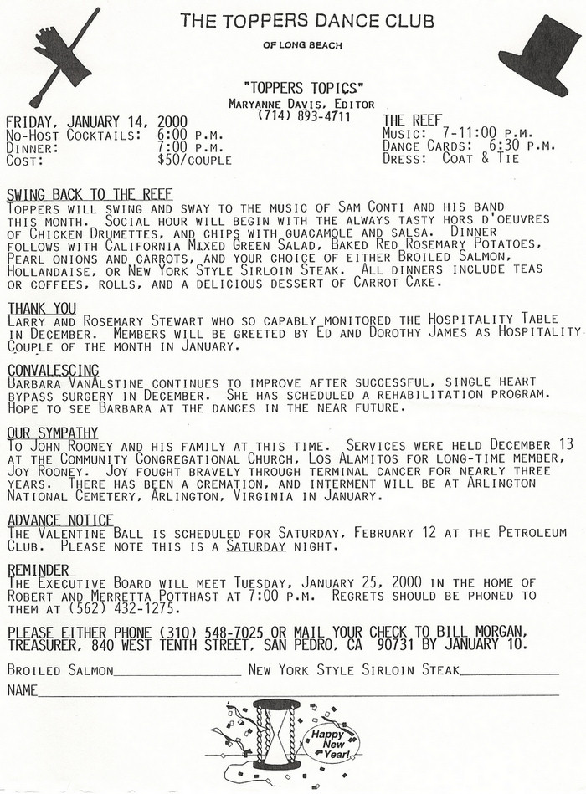

**November Dance Photos at either** [**http://tinyurl.com/27mf3uu**](http://tinyurl.com/27mf3uu) **or**[**http://www.lilesnet.com/toppers/toppers_2010_1119/index.htm**](http://www.lilesnet.com/toppers/toppers_2010_1119/index.htm) **!**

Please E-Mail your photos to Paul & Sue Liles

*Jan Mongell* also likes to greet our members.

Guests *Cathy and Ed Roberts* join right in to the festivities and we hope they come back soon!

Recent members *George and Edith Meier* are welcomed by the Toppers members!

Our greeter’s, *Joe Maloney and Ginny Rodhner*, busy at work welcoming members and guests.

Visiting continues until the end. The *Harringtons, Bergs, Fronks* sharing moments

*Ace and Martha Yeam* celebrating their tenth anniversary. Martha makes the announcement while Ace blushes,

