

Eat, drink and be scary.  ~Author Unknown

# From Our President…

If you didn’t make it to our October dance, you missed another great evening with Toppers! Along with the usual outstanding meal and service from the Petroleum Club, and excellent music by Jim Gilman’s band, we were treated to a few pleasant surprises.

For instance, it was great to see *Tom Ferguson* and *Peggy Gould* with us again, following Tom’s convalescence from recent back surgery. We’ll be hoping to see them often from now on.

Another treat was the sight of *Kay Quick* and *Nick Thomas* on the dance floor after both being absent too long.

We were pleased to recognize the Grossos and the Meiers as guests of *Larry and Gigi Isham*. Hopefully, we’ll see the Grossos and Meiers joining our ranks as Toppers in the near future.

Although not really a surprise to some of us, a highlight of the evening was the announcement that the new Toppers handbook had been published and available for all. As the evening wound down, a copy was personally presented to each attending member by Joyce Rothrock, as she graciously received well-earned compliments for her major contribution to its design and production.

Plan on another enjoyable evening on November 19th , when we again meet with our Topper friends to experience Tony Corinio’s brand of entertainment and music!

Till then,

Jerry Ellis

# 2010-2011 Dance Season

Remember to keep these future dates on your calendar!

November 19th (Next Dance)

December 18th

January 21st

February 18th

March 18th

April 22nd

May 20th

# What You Need To Know

The November dance will be at the Petroleum Club on November 19th. The cost is $76/couple (includes tax/tip). No-host cocktail time at 6 p.m. Tony Carinio will be providing great dance music until 10:p.m. Dress code is semi-formal.   
  
Your choice of entrees:

**Roast Turkey Breast** or

**Fish of the Day**

 Green Salad with Ranch &

Italian dressings on the table,

Mashed Potatoes with Gravy,

Fresh veggies of the day

Cornbread Stuffing, Cranberry Sauce, and Supreme Sauce

Pasta by request

Pumpkin Pie

Warm Bread and Butter

Coffee or Tea

# Let Us Know

Please select your entrée on the tear-off slip and send it with a check to “Toppers Dance Club”, *Bill Morgan*, 840 West 10th Street, San Pedro, 90731 for receipt by Monday, November 15th.   
  
You may call Bill at 310-548-7025. Please leave your name and message if you get the answering machine!

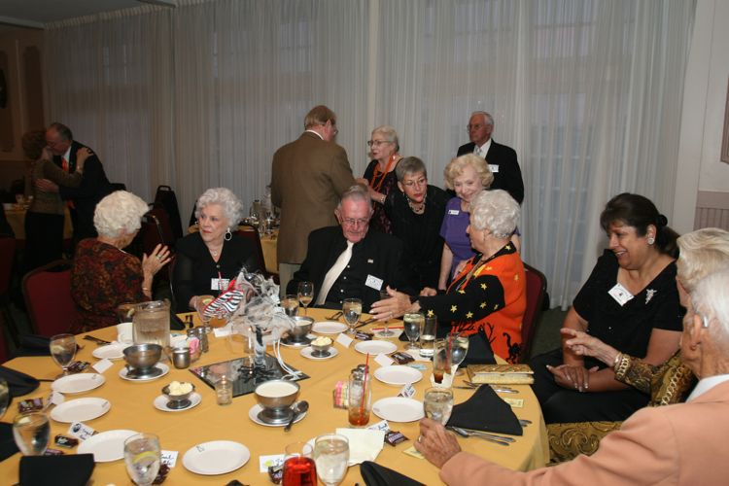October 2010 Visiting Gets Underway Immediately

Ghost And Goblin Time At Toppers!

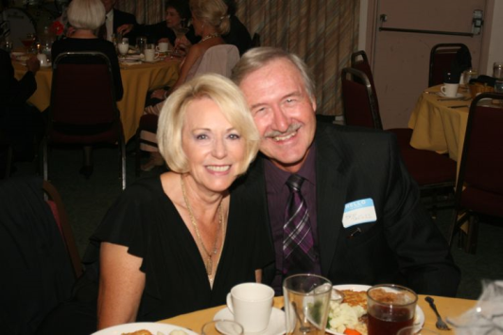

**Your Board**

President Jerry Ellis  
Vice President Ray Ashcroft  
Past President Earl Eakle  
Secretary Mary Ruth Ashcroft  
Treasurer Bill Morgan  
Hospitality Terey & Walter Kroy  
Membership Bob Potthast  
Roster Joyce Rothrock  
Historian Martha & Ace Yeam  
Newsletter Paul & Sue Liles

The Executive Board meets at 5:30 p.m. before each dance

Need a Toppers name badge? Call Earl Eakle at 310-375-8134.

# Spotlight ON NEW Toppers

A marriage made in Heaven, perhaps. A marriage made on the dance floor, definitely.

We were both born in London, England and met at a modern Jazz club. Three years later in 1968 an adventuresome young couple left for Canada. After having three gorgeous daughters, a job opportunity for Brian brought us to California in 1980. Initially we located in Visalia where the girls grew up.

We later moved to Yorba Linda where we reside today. Friends told us about a big band night at the Phoenix Club in Anaheim. We decided to give it a try and lo and behold we met *Jan and Jim Mongell*. A friendship developed and Jan became our dance teacher.

Jim felt we would enjoy dancing at the Elk’s in Santa Ana and sponsored us in joining.

Then in 2009, Jan and Jim suggested we join the Toppers. We have really enjoyed every one of the dance sessions we have attended. We’ve met so many nice people and enjoyed some really good food. Life doesn’t get much better than this.

Shirley is still very active in her staffing business of fourteen years located in Brea. Brian is semi-retired from the plastics industry, working only 2-3 days per week as a manufacturer’s representative.

Apart from dancing we enjoy playing golf and travelling (mostly cruising).

We now have five grand children and enjoy that new dimension in life. Our daughters and their husbands all like to dance and accompany us to many events. Perhaps you will get to meet them too!!

# Dancing Quotes

“Dancing is poetry of the foot. ~ John Dryden

About The Foxtrot  
  
It is often said that Foxtrot took its name from its inventor, the vaudeville actor Harry Fox, however the exact origins are unclear. The dance was premiered in 1914, quickly catching the eye of the talented husband and wife duo Vernon and Irene Castle, who lent the dance its signature grace and style.

From the late teens through the 1940s, the Foxtrot was certainly the most popular fast dance and the vast majority of records issued during these years were foxtrots. The Waltz and Tango, while popular, never overtook the Foxtrot. (Even the popularity of the Lindy Hop in the 1940s didn't dent the Foxtrot because the Foxtrot could be danced to those Lindy Hop records, as well.)

# Assistance Needed & New Features

As your new Newsletter Editors, Sue and Paul may be asking you for some “input” for the publication!

A tribute to the all important greeters and a “Nits and Bits” area to collect the latest gossip around the tables!.

Shirley & Brian Skeggs

Starlighters roster updates are provided as a tear-off… Please put into your roster to keep it up to date.

Tear off and put into your roster

# The hors o’dourves Were Interesting

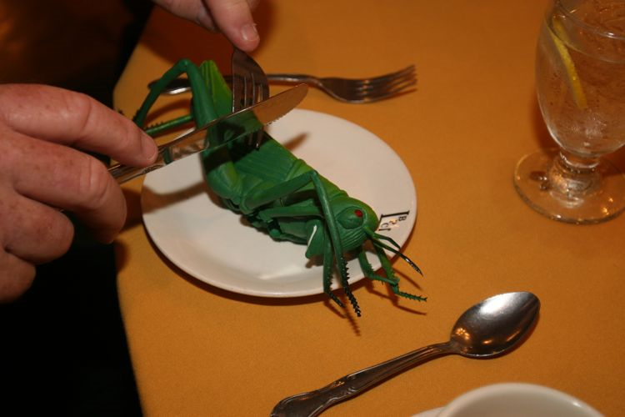

**Our Website**

Have you visited our website? Try it at the following address: **http://www.lilesnet.com/toppers**.

We have five pages of pictures from our last dance including the ones at dinner (so we capture everyone there!) Show your friends the site… Maybe they will want to join all the fun!



# A Hand For Our October Greeters

# 

Our greeters, *Al & Mickey*, work hard for the first hour or so of the dance! They assure you have your meal selection, assist with table seating, provide great smiles! Remember, they are working while the rest of us are dancing!

Volunteer to be greeters… You will meet some super people and get to know the members names quickly!

# November Dance Greeters

# cid:image001.jpg@01CB7693.57FBF030

Our greeters for November will be *Joe Maloney and Ginny Rodhner.* *Joe and Ginny* became Toppers early last year and have attended nearly every one of our events since.

As long-time members of the Petroleum Club, they say it was a natural move to eventually join many of their friends who belong to both groups.

The couple are quick to express how much they are enjoying their association with Toppers and looking forward to being first-time greeters at this coming dance.

# Unique Tie Award Goes To *Del Kuhn*

# 

What does it say? “Working is for people who do not dance!”.

# Sweater Award Goes To *Merretta*

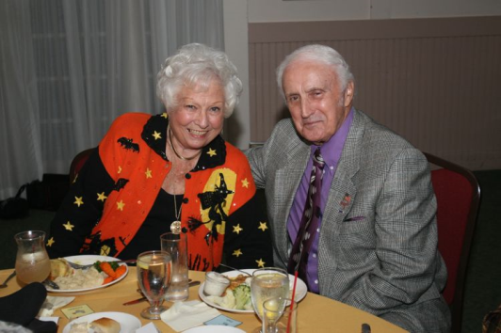  
It must be Halloween! This sweater was outstanding. *Merretta* was really into the season this evening! So Bob, where were your decorations???

# About The Rumba

Rumba refers to one of the ballroom dances which occurs in social dance and in international competitions. In this sense, Rumba is the slowest of the five competitive International Latin dances: the Paso Doble, the Samba, the Cha-Cha-Cha and the Jive being the others.

# Jim Gilman Band Was great

**Jim Gilman** was seemingly fated to play the accordion. At the age of seven, a local Chicago accordion school called his parents and offered six weeks of free accordion lessons because they had heard their son “had talent.” After resisting a high-pressure accordion salesman, private lessons were arranged.

A move to California during Jim’s high-school years seemed to halt his accordion career, but fate stepped in once more. Jim’s father actually saw in the Long Beach paper, “Wanted: Accordion player.” I ask you… how many times have you ever seen that?

Jim earned his way through college playing at Knott’s Berry Farm as a street musician. During the summer, it meant playing eight hours a day, five days a week for the princely sum of $1.85 per hour.

A college loan bought Jim his first Cordovox and he was on his way. He’s performed from the heights, playing music for a wedding in a small plane flying above Los Angeles; and to the depths, playing in a “sewer” for a KFI radio stunt and all kinds of engagements in between.

# Nits And Bits

*Buck and Bobbie* are die-hards! They were seen in the Ocktoberfest tent at the Phoenix Club Thursday evening dancing the night away….. **The Berg’s** were in San Francisco with their new grandchild…. **The Fronk’s** just returned from 16 days in Germany and Italy… We had two new guest couples who were sponsored by **Larry and Gigi**… **Jim and Jan Mongell** celebrating their 49th anniversary…

# New Rosters Available

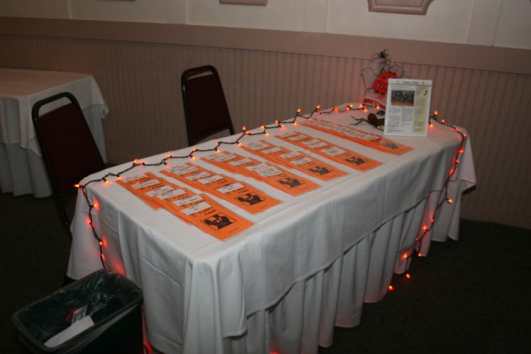

*Joyce Rothrock* did an outstanding job of getting the roster published and up to date.

*Jan and Jim Mongell* are celebrating their 49th anniversary! (But she says she is only 39?)   
*Larry and Gigi* also brought *Tony and Francis* to join in the fun!

🡪Thanks to *Nick Thomas* for being Head Nit-Picker! 🡨

**October Dance Photos at either** [**http://tinyurl.com/284enms**](http://tinyurl.com/284enms) **or**[**http://www.lilesnet.com/toppers/toppers_2010_1022/index.htm**](http://www.lilesnet.com/toppers/toppers_2010_1022/index.htm) **!**

Our greeter’s, *Al and Mickey Arauj*, did an amazing job getting everyone checked in! *Lucky and Carolyn Harrington* were the first on the dance floor this evening.

*Mickey* knows how to diet! When Al wasn’t looking she put her ice cream into his dish! No wonder they are smiling! *George and Edith* are second-time guests and soon to be members… Welcome!

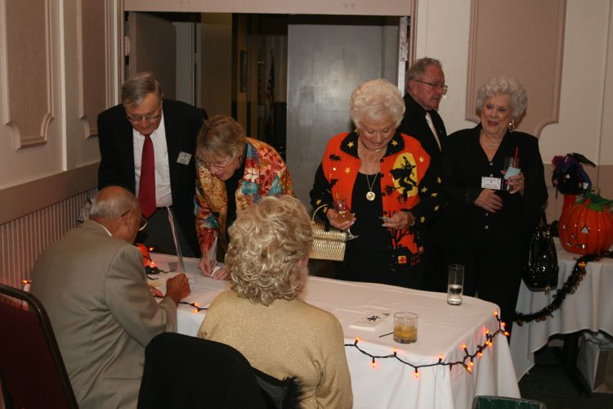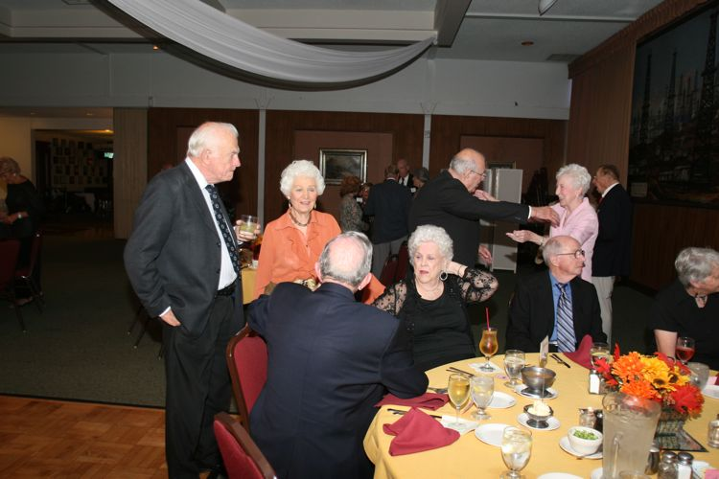  
Visiting

