

# 2010-2011 Dance Season

Remember to keep these future dates on your calendar!

October 22nd

November 19th

December 18th

January 21st

February 18th

March 18th

April 22nd

May 20th

# What You Need To Know

October dance will be at the Petroleum Club on October 22nd. The cost is $72/couple (includes tax/tip) No-host cocktail time at 6 p.m. Jim Gilman will be providing great dance music until 10:p.m. Dress-code is semi-formal.   
  
Your choice of entrees:

**Chicken Cordon Bleu** or

**Fish of the Day**

 Green Salad with Ranch &

Italian dressings on the table,

Scalloped Potatoes

Fresh veggies of the day

Pasta by request

Mint Chocolate Chip Ice Cream

Warm Bread and Butter

Coffee or Tea

# Let Us Know

Please select your entrée on the tear-off slip and send it with a check to “Toppers Dance Club”, Bill Morgan, 840 West 10th Street, San Pedro, 90731 for receipt by Monday October 18th.   
  
You may call. Please leave your name and message if you get the answering machine!

Around and around we go! Where we stop, nobody knows!!

# Who Said That???

Movement never lies.  It is a barometer telling the state of the soul's weather to all who can read it.  ~Martha Graham

# From Our President…

Thanks to a fine turnout last month for the first dance of the season, followed by the positive comments received from many of our dancers, it looks like Toppers is off to another good year!

As most of you know by now, we have replacements for two of our Board positions as we move into the dinner-dance season ahead. Our new Board members’ work will be evident by the time of our next dinner-dance October 22. By then, our new Roster Chairman, Joyce Rothrock, plans to have a revised membership booklet for 2010-2011 completed, and our new Topics Editors, Paul and Sue Liles, will have published their second issue of Toppers Topics.

Also, I’d like to remind all of the availability of the popular Toppers’ tri-fold information brochure, which outlines the purpose of Toppers and includes the dates of upcoming dinner-dances. It is primarily intended for potential and new members. We have Jacque Kurman to thank for originally designing the brochure and Earl Eakle who continues to produce it for the Club. A few of the 2010-2011 printing will be available at the sign-up table at our next dance, and additional copies upon request from Bob Potthast or me.

Nancy and I look forward to seeing you on the 22nd!

Jerry Ellis

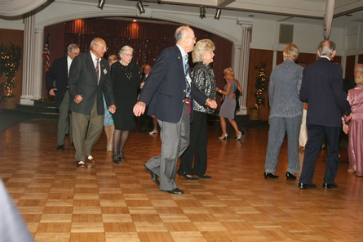September 2010 Mixer

Time To Mix It Up At Toppers!

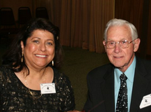

# Spotlight ON NEW Toppers

My husband Del and I are relatively new Topper members. We were invited to join the dance club by our dear friends Paul and Sue Liles, who just happen to be our immediate neighbors in the community of Rossmoor. Several years ago Paul and Sue had encouraged us to go dancing with them to the Phoenix Club in Anaheim on Thursday night with comments like “Vicky, Del, you’ll love the people, they’re all so nice.” Well, it turned out to be true, as the dancers there turned out to be very nice. One couple we really enjoyed visiting with was Jan & Jim Mongell. Now we see them once or twice weekly. So Paul and Sue used that ‘same line’ in asking us to join Toppers. “Try it you’ll like it, everyone is so nice, come as our guests.” So we joined and it turns out that Paul & Sue were right again. Everyone is really friendly. Turns out, the Mongells are also Topper members too. We've made new friends, love the intimate setting, location, dancing and we sure laugh a lot!

Del, my husband, of 32 years is from Wisconsin (apple pie with a slice of American cheese, ugh!) and served in the Navy during WW2. He competed in motorcycle racing in the late 40s and into the 50s, mostly in the desert, Catalina Island, Greenhorn Mts. and the back-breaking 140 mile Big Bear race. Recently, in a magazine article he was referred to the grandfather of moto-cross which used to be called ‘scrambles.’ He won many races, including Nationals and in 2003 he was honored to be inducted into the National Motorcycle Hall of Fame.

He joined the California Highway Patrol and retired after 32 years of service. He has always been interested in competition of some sort and drove his self restored 1935 Chevy in the cross-country antique Great American Race for 3 years. Del has been blessed with good health, has worn ‘many different hats’ throughout his life time, has ‘solid as a rock’ American values foundation and though 85 years young, he still has more chapters of his life to live…dancing among friends is one of those chapters.

I was born and raised in Los Angeles. Like my husband Del, I too, was a police officer and then later a history teacher. I retired a few years back and have enjoyed my ‘new free time.’ My interests have turned into organizing, scanning and identifying 40 years worth of family photos and documents. I am a music buff, celebrity hound, have a spoiled rotten beloved pug and have been known to cook dinner only on blue moon evenings. We enjoy going to the movies during the weekdays, go to plays and musicals and other such events. I am an Elk. Del and I have two grown children and in 2008 our daughter needed a wedding planner. Good thing I was retired. As far as dancing, I was raised dancing, did homework while dancing, did my chores dancing and knew I would someday marry someone like Fred Astaire or at least Gene Kelly. I ended up with a Steve McQueen… who had dancing learning potential. I am one lucky lady.



# Dancing Quotes

“Dancing is poetry of the foot. ~ John Dryden



About The Foxtrot  
  
it is often said that Foxtrot took its name from its inventor, the vaudeville actor Harry Fox; however the exact origins are unclear. The dance was premiered in 1914, quickly catching the eye of the talented husband and wife duo Vernon and Irene Castle, who lent the dance its signature grace and style.

From the late teens through the 1940s, the Foxtrot was certainly the most popular fast dance and the vast majority of records issued during these years were foxtrots. The waltz and tango, while popular, never overtook the Foxtrot. (Even the popularity of the lindy hop in the 1940s didn't dent the Foxtrot because the Foxtrot could be danced to those lindy hop records, as well.)



# Assistance Needed

As your new Newsletter Editors, Sue and Paul may be asking you for some “input” for the publication! We instigated the “Spotlight On Topper’s” with this edition and the Berg’s were so nice to be first!

**Your Board**

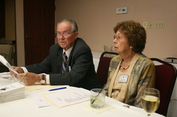

The Board Hard At Work

President Jerry Ellis  
Vice President Ray Ashcroft  
Past President Earl Eakle  
Secretary Mary Ruth Ashcroft  
Treasurer Bill Morgan  
Hospitality Terey & Walter Kroy  
Membership Bob Potthast  
Roster Joyce Rothrock  
Historian Martha & Ace Yeam  
Newsletter Paul & Sue Liles

The Executive Board meets at 5:30 p.m. before each dance

Need a Toppers name badge? Call Earl Eakle.

Vicky & Del Kuhn

# Petroleum Club Staff

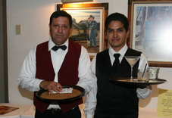

**Our Website**

Have you visited our website? Try it at the following address: http://www.lilesnet.com/toppers/.

We have almost 120 pictures from our last dance including some of the Board working hard behind the scenes! Show your friends the site… Maybe they will want to join all the fun!



**Flashback! Twenty-Eight Years Ago**

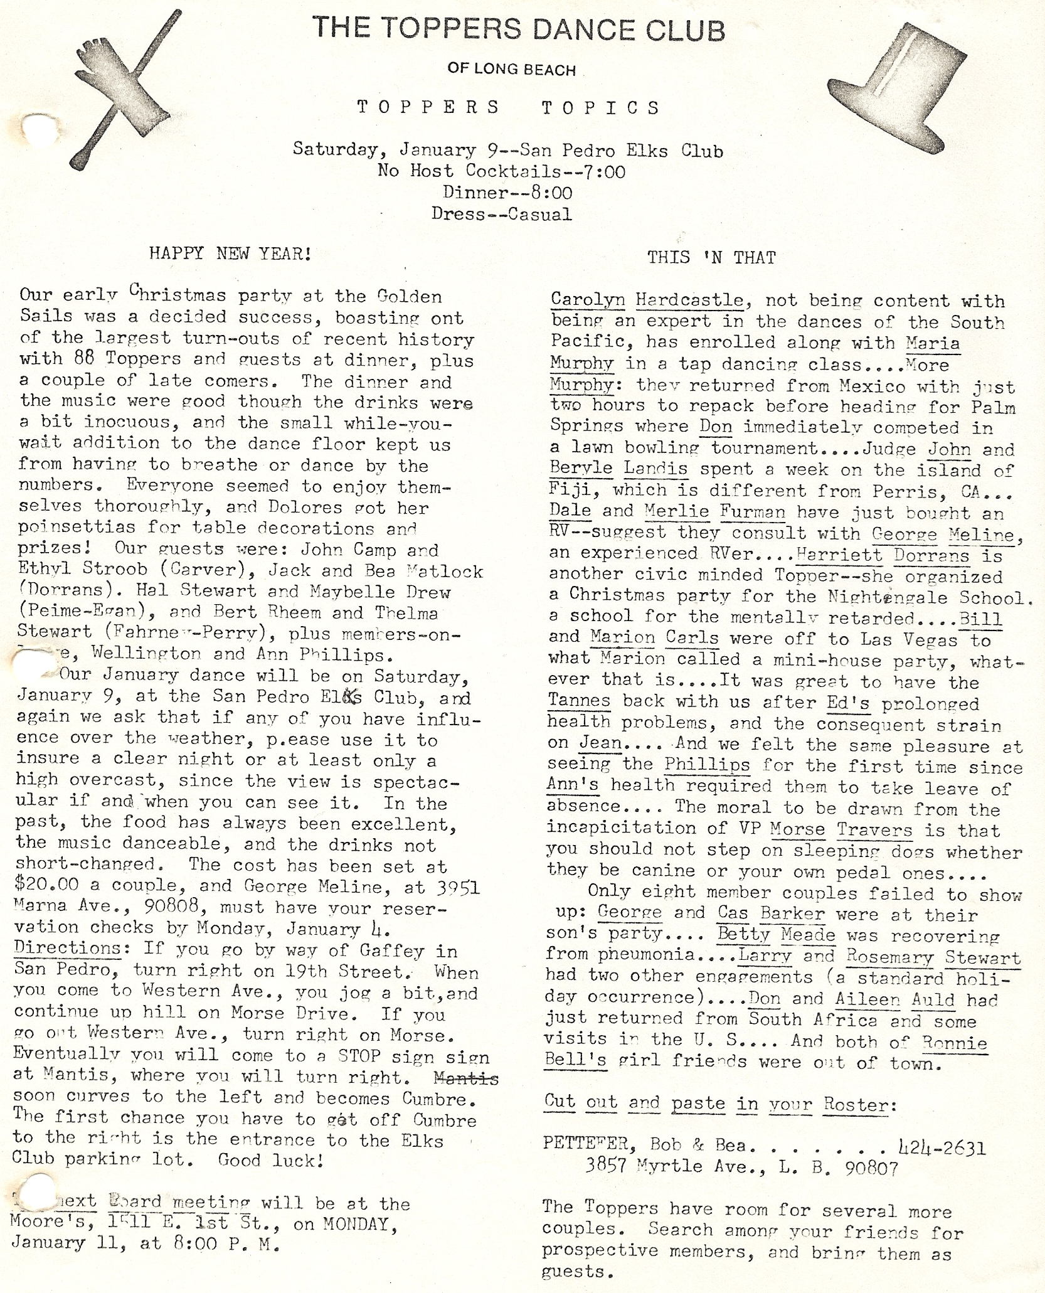

It is time for a mixer and announcements. Nita and Diane are a few of the September birthday girls celebrating at the dance

Pre-dinner visiting is always fun! Catching up on the summer’s activities could take the entire evening… Between dances that is!

The Berg’s are enjoying dinner and visiting with everybody.   
Someone made a suggestion that we add a little powder to the floor… He over achieved!!

**September Dance Photos**

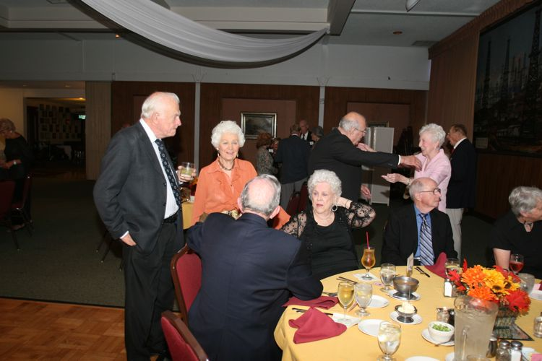  
Visiting

