

April 17, 2006,

Hi everyone! Hope you all enjoyed the dance at the Yorba Linda Country Club. We received no feedback survey’s, but all the comments to the board were very positive and everyone seemed to have a very nice time. We had five couples who paid for the dance and who were unable to attend. As a result, I thought it worthwhile to restate our refund policy. We always refund reservation money if we do not have to pay for the absent members. If the dinners must be paid for, reservations for the dance are not refunded. In the case of the March dance, the final count had been given to the venue, and we were obliged to pay for the entire count. So unfortunately, no money could be refunded. In the future, if you need to cancel, try to notify us at least a week in advance, and then we will be able to refund your reservation or apply it to the next dance.
I’m sure everyone is looking forward to our Spring Formal in May. This is one of my favorite dances and the Mesa Verde Country Club always provides excellent food, service and facilities. Devi has worked out a special deal for those of you who would prefer to bring your own wine. The club will charge a $10.00 corkage fee, including tax and tip, to open your preferred bottle of wine. Bring along a bottle or two and I hope to see you all there!
The Board voted in two new member couples last month, so please be sure to welcome Dayton and Patricia Silver, and Andrea Talbott-Clark and John Clark.
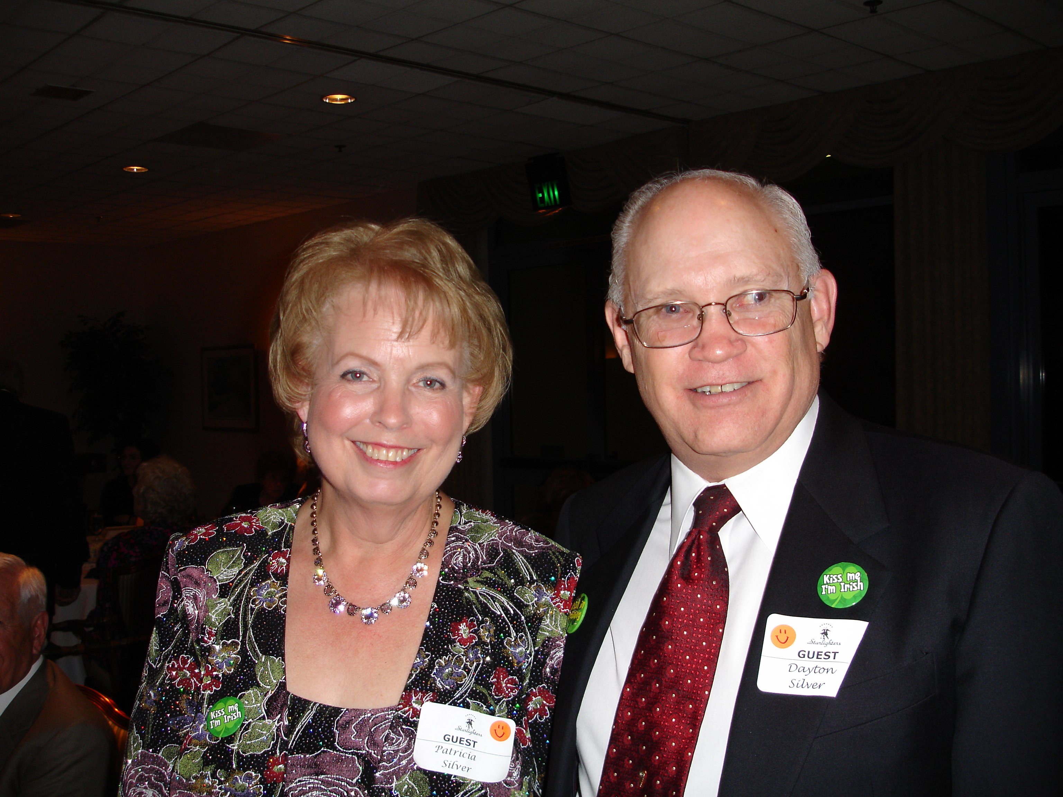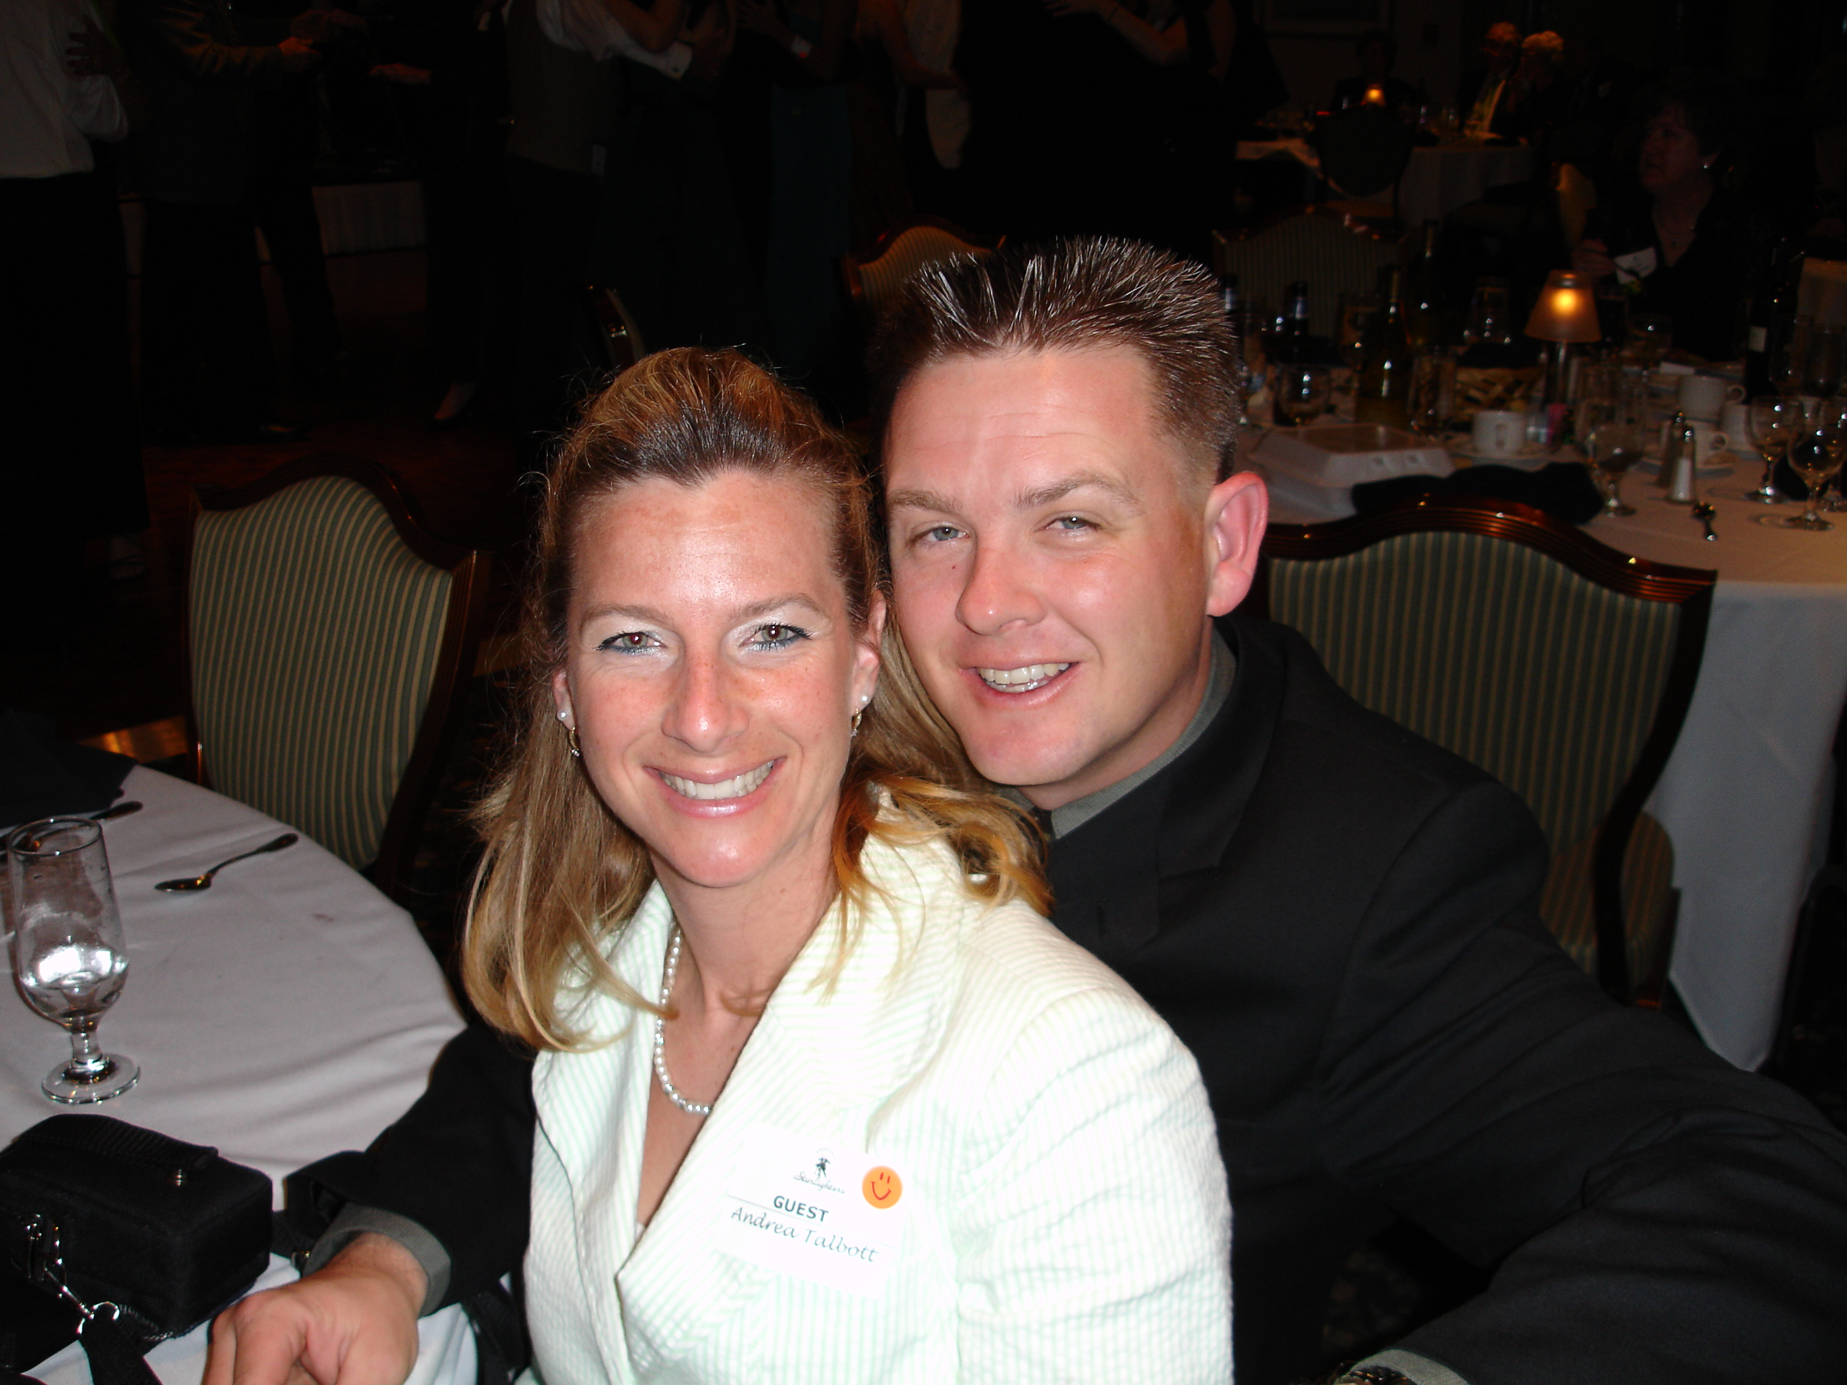
Dayton and Patricia Silver Andrea Talbott-Clark and John Clark
Last year the board implemented a policy of reserved seating for guests and their sponsors so that they have seats together, which of course is only fair to the guests. These are spread throughout the room so that guests have an opportunity of meeting additional members and vice versa. When we have a large number of guests, it means that there is at least four seats taken up at many tables, leaving fewer tables at which a large group of members can all sit together. When this happens, find seats at another table, and take the opportunity of getting to know some other members with whom you might not be so acquainted.
Last year we also set a policy of opening the doors at 6:30 pm and not allowing entry until then. There are three reasons for this. 1) The venue employee’s are usually still setting up and prefer not to have guests arriving early and getting in the way. 2) Our own hospitality people are also setting up the hospitality table and placing guest reservation cards on the tables. Their job is made more difficult by having people arrive early, coming in back doors etc. and trying to reserve seats. 3) We have had a problem in the past with folks arriving early and reserving seats and then having others in their party reserving seats for the same people. When everyone else arrives a little later, it appears that there are inadequate seats to accommodate everyone. So please, just plan to arrive at 6:30 pm and no earlier. There are always adequate seats for everyone, since seats are set for all who have made reservations plus extras.
Enough of rules and regulations. Let the dancing, fun, food and entertainment begin! See you in May at out Spring Formal!

Best Regards,

Paul Morin

