Checks should be made payable to
Starlighters’ Dance Club
In the amount of $100.00 per couple
Send in the enclosed envelope to:

Leon and Marcia Brander

941 South Jay Circle

Anaheim, CA 92808

To arrive no later than July 11th, 2009

Map and Directions to The Orange County Mining Company
1. From the Costa Mesa Freeway (55) East on Chapman 1.5 miles
2. Located at the corner of Chapman and Crawford

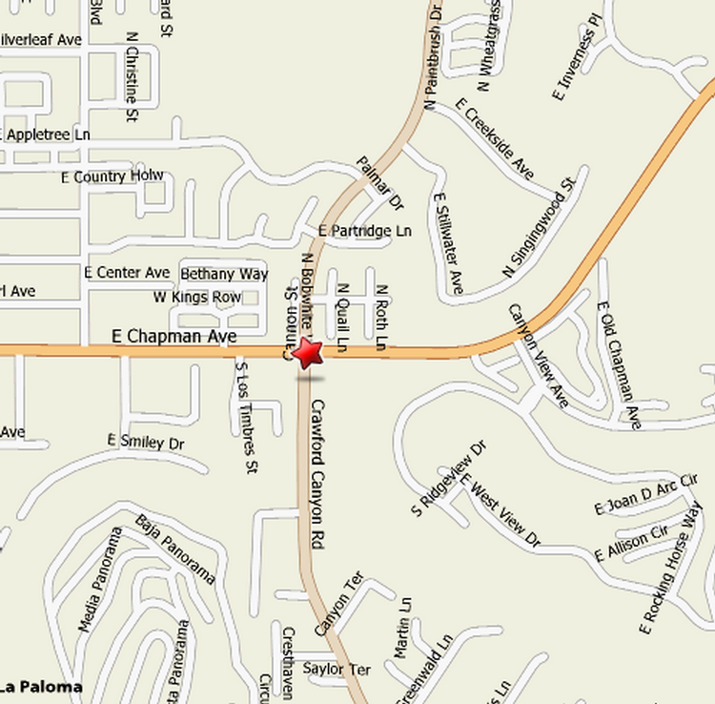

See you there!!

